Lecture 1





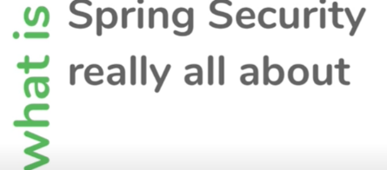

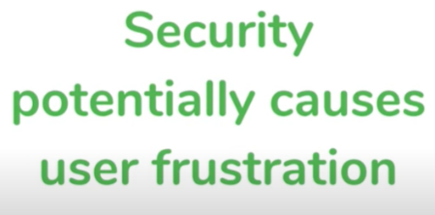

**Note :** for most application we need to implement security at application level

* What kind of functionality of application we want to allow user and to whom
* What kind of data we want to allow user and to whom

Biggest challenge :--

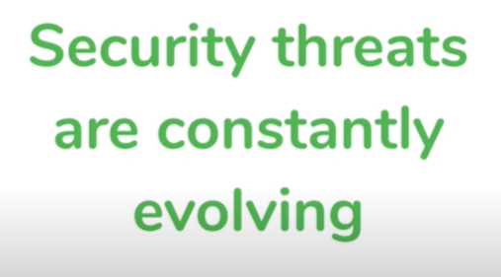

Hire a guard to secure the application

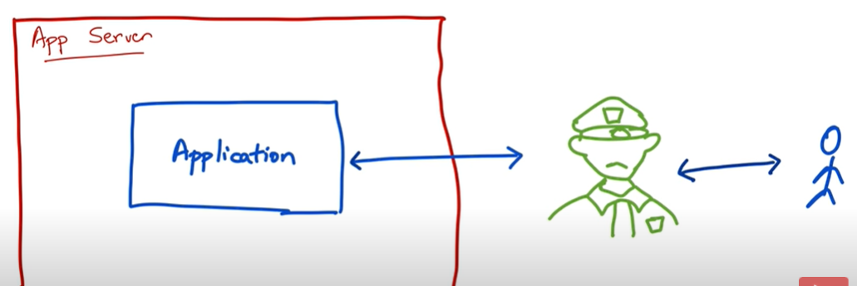

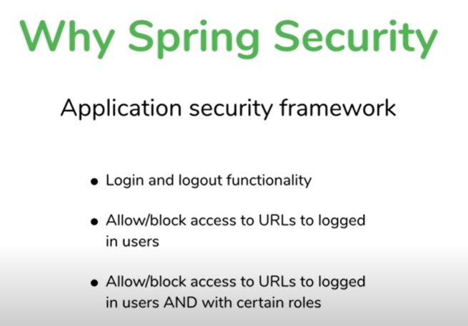

**How spring security is achieved**

**Benefits :** just by adding spring security to app we get protection from bunch of vulnerability

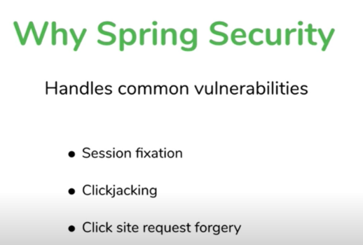

Session Fixation is **an attack that permits an attacker to hijack a valid user session**.

What is cross site request forgery with example?

[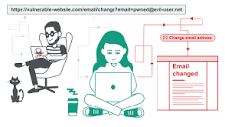](https://www.google.com/search?rlz=1C1GCEA_enIN806IN806&sxsrf=APq-WBt__3dt0pk9s15mjkInGzugQ52UwQ:1647450716544&q=What+is+cross+site+request+forgery+with+example?&tbm=isch&source=iu&ictx=1&vet=1&fir=KAr9ZPHwI04G0M%252Cc3jQB713tnypdM%252C_&usg=AI4_-kSv9y3dRTAsWZheU7wVWTFMa8hWuA&sa=X&ved=2ahUKEwjNivqVkMv2AhWBzTgGHdeyB4MQ9QF6BAgREAE#imgrc=KAr9ZPHwI04G0M)

In a successful CSRF attack, the attacker causes the victim user to carry out an action unintentionally. For example, this might be **to change the email address on their account, to change their password, or to make a funds transfer**.

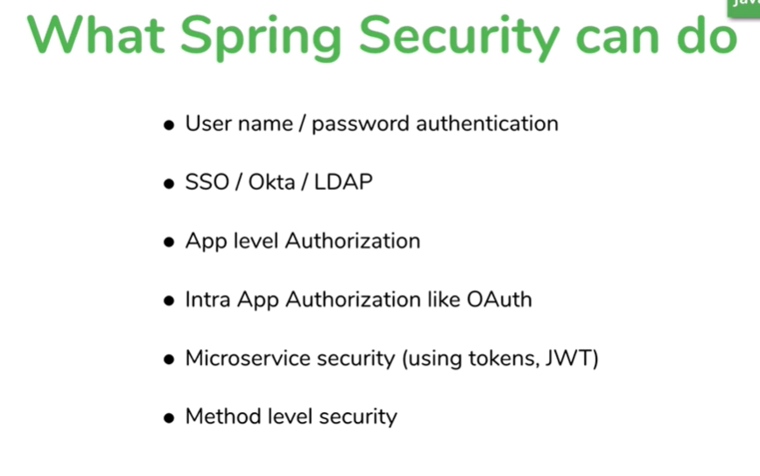

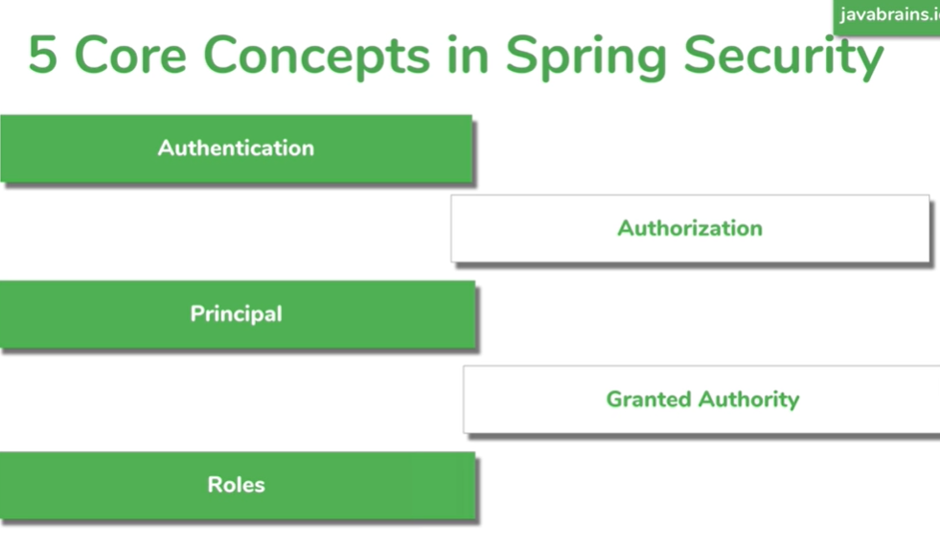

Lecture 2----5 spring security concept

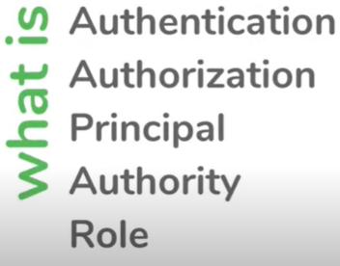

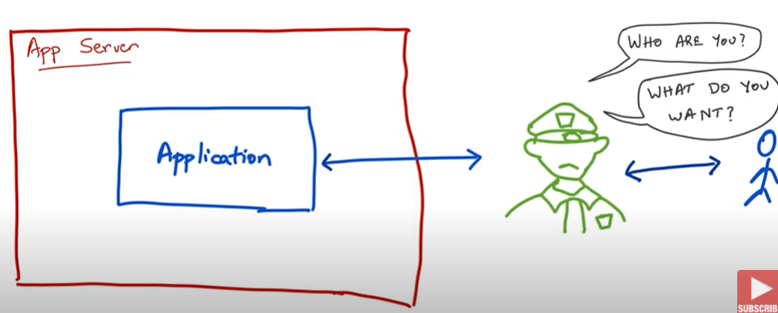

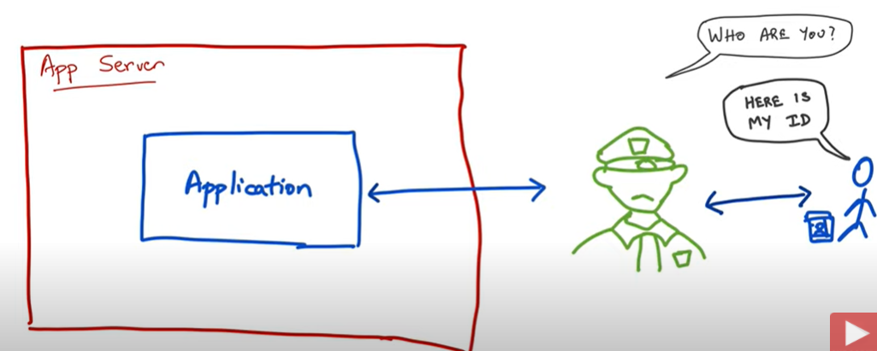

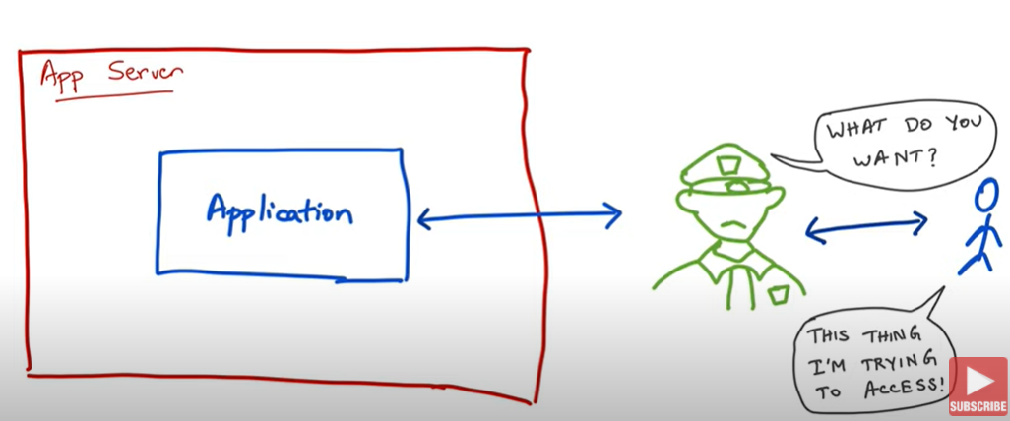

This type of authentication is called knowledge based authentication

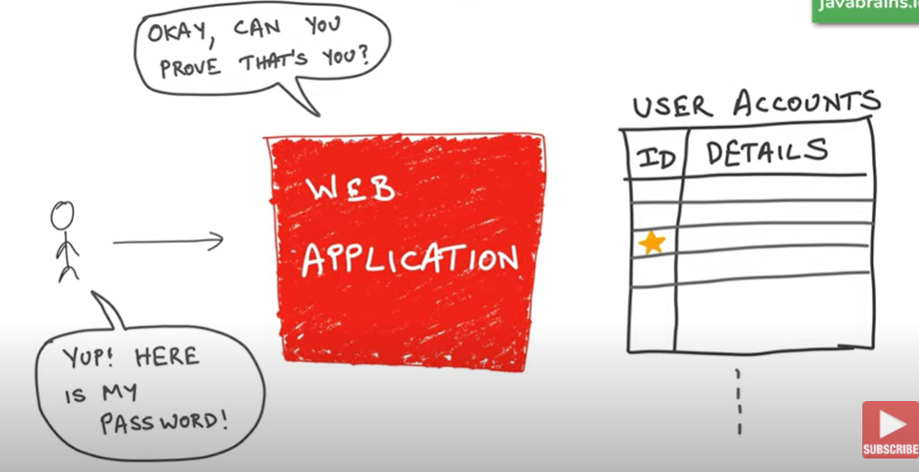

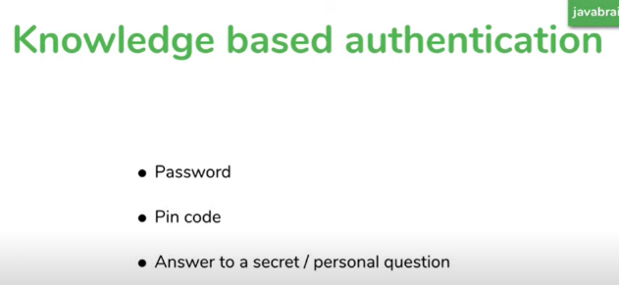

Advantage and d/a of knowledge based authentication

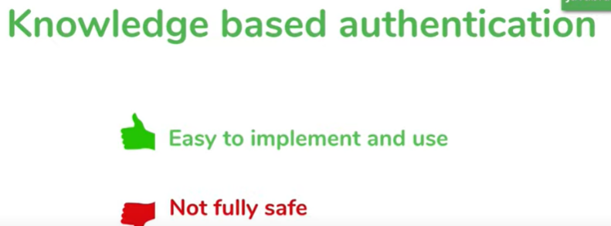

**Note: someone can steal pw**

**This is slightly better because phone is tough o steal**

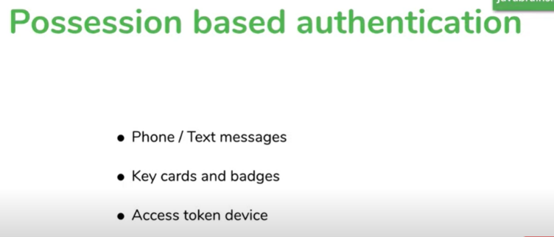

Some apps combination of both **referred as multi factor authentication**

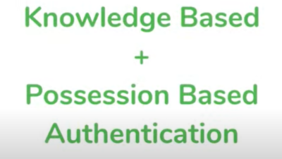

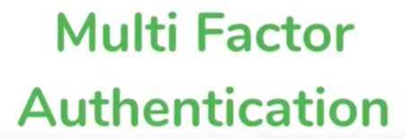

**First enter password then verify a text message**

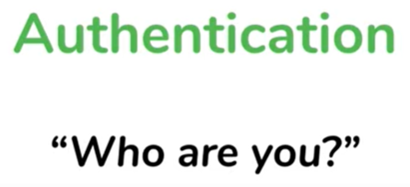

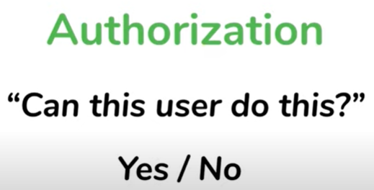

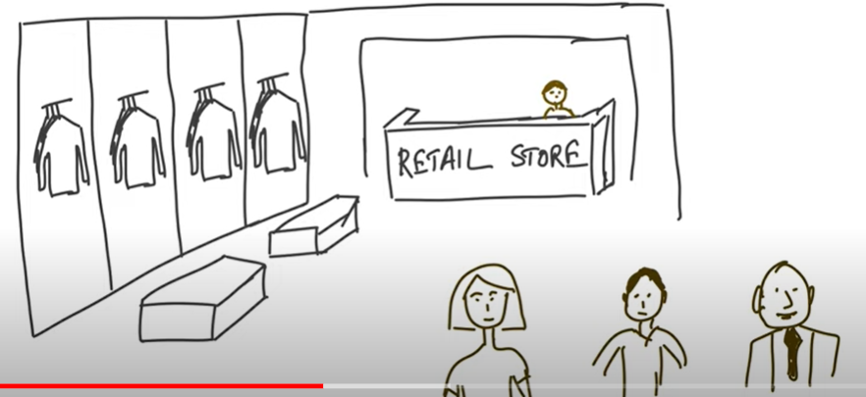

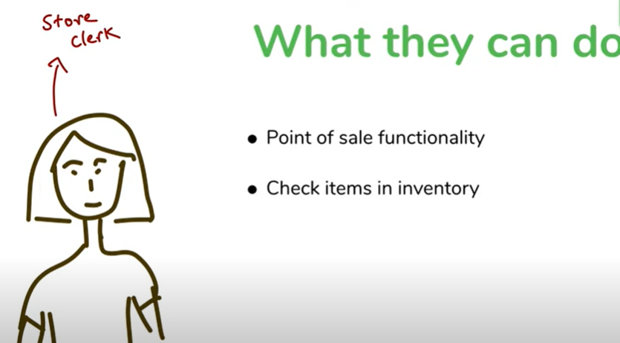

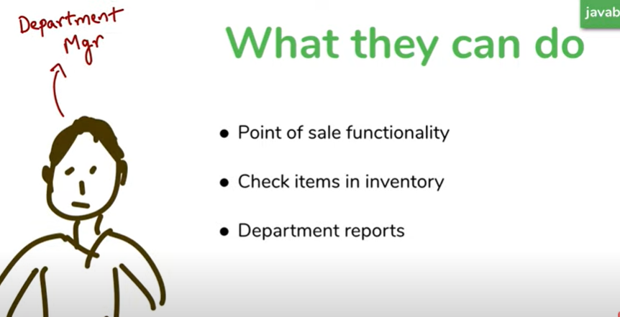

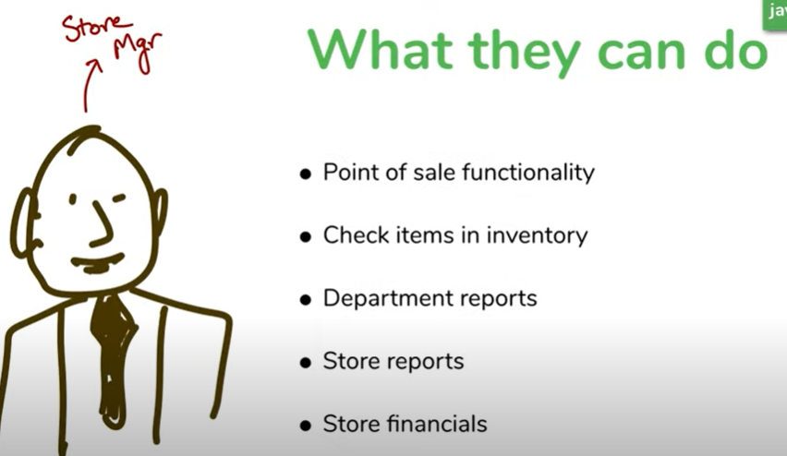

**Should I allow this user to do the application**

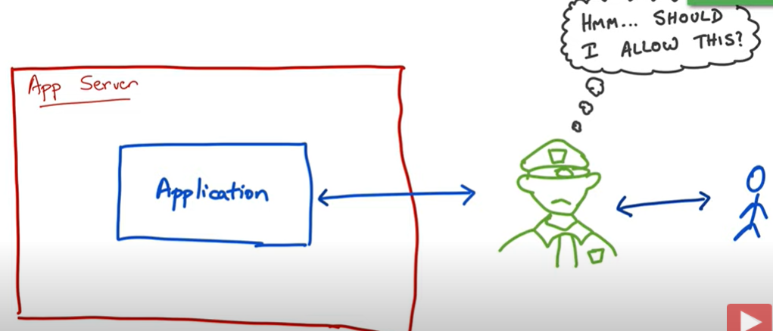

**This allow the user yes or no decision depending on who the user is and what they are trying to do is**

**Called authorization**

**NOTE:** for authorization we need authentication first

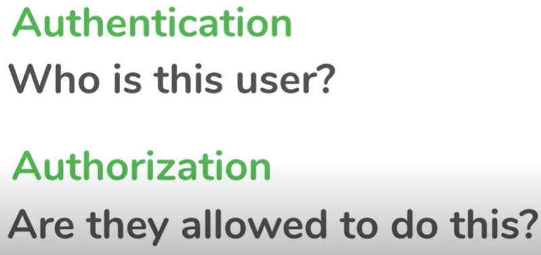

**Authentication :**- is the process of identifying a person who is trying to access the application

**Principal :-** is a person we identified through the process of authentication

**In other words** :- principal is currently logged in user or currently logged in account

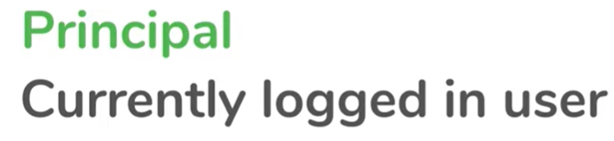

Note : principal will remember user name and PW one we authenticate , we don’t need to login everytime

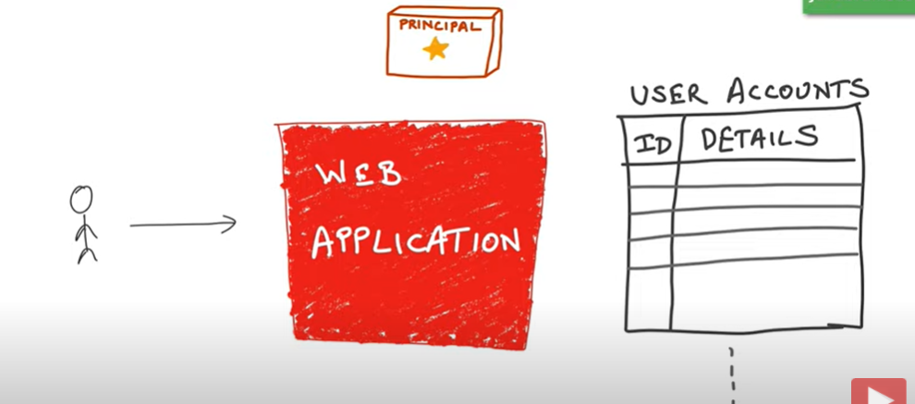

This is because app remember the logged in user in the context of application

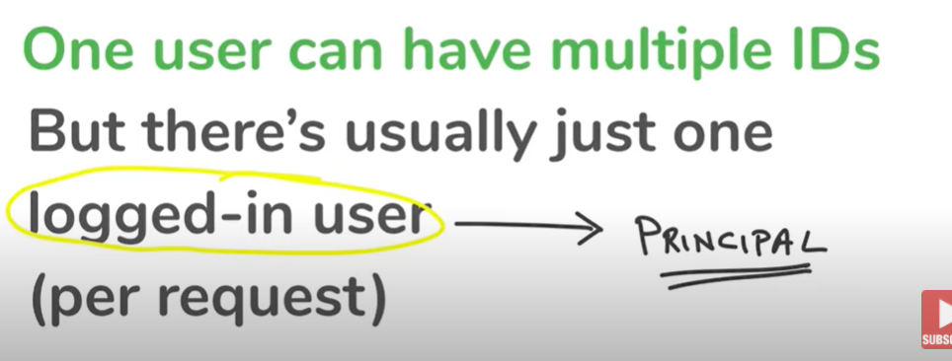



Whether to allow a particular access or not

**Note :-**  bunch of permission allow for a given user

In spring security this concept of permission is called **granted authority**

**Note:-** we can configure authority in spring security

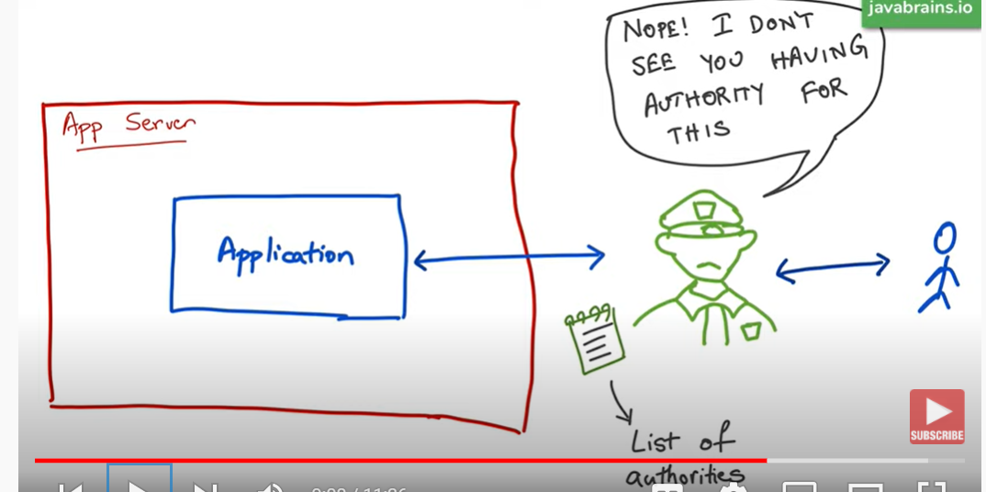

**Important :---**

**Some one should be there to assign authority this concept called roles**



**Role is like group of authorities that assign together**

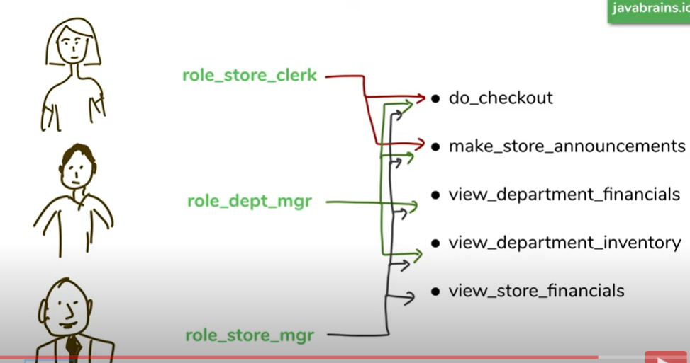

**Tutorial 3:--- adding spring security to spring boot project**

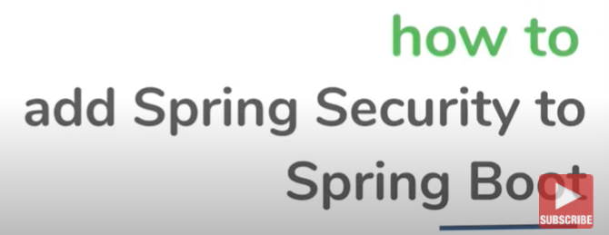

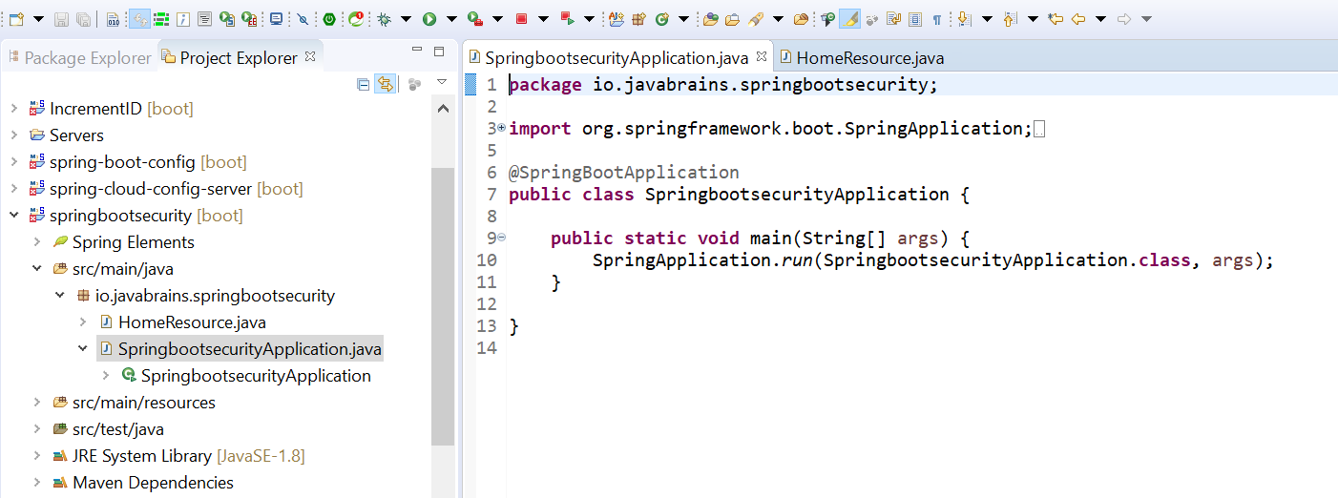

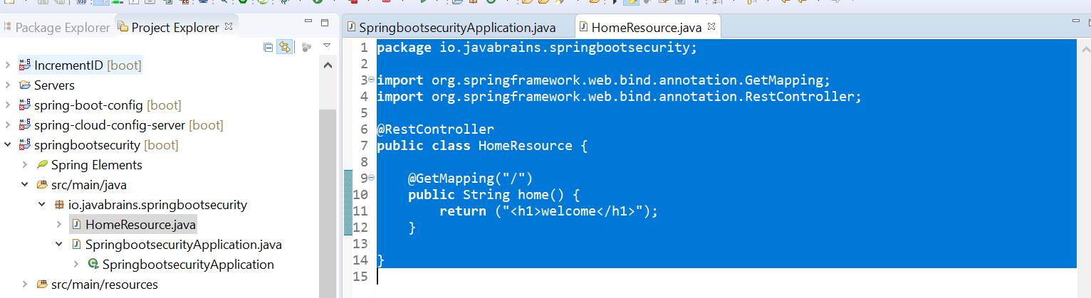

**Now how to add spring boot security**

**By adding dependency :**

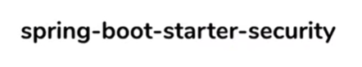

It will pull all spring security dependencies which is maven dependency

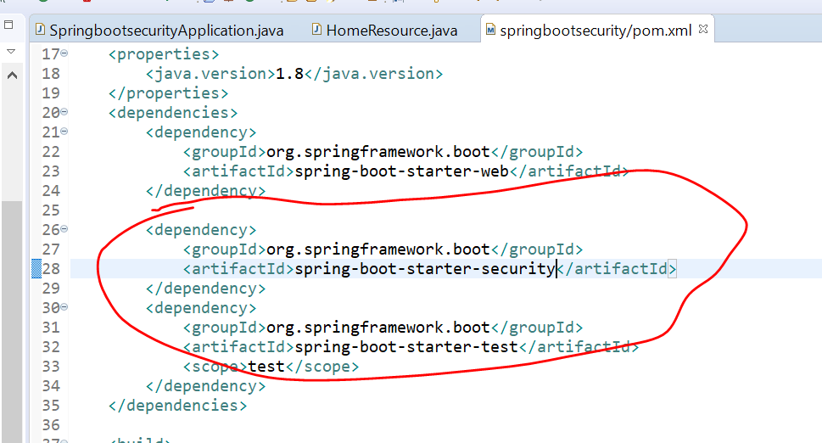

**Note ----imp :---- just by adding dependency we got sign in page ( we didn’t add this)**

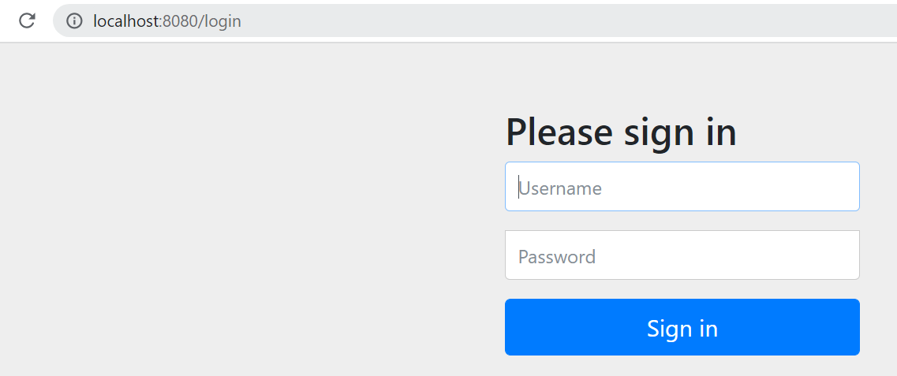

How we get this here and what is the use of sign in

**It doesn't allow to sign in**

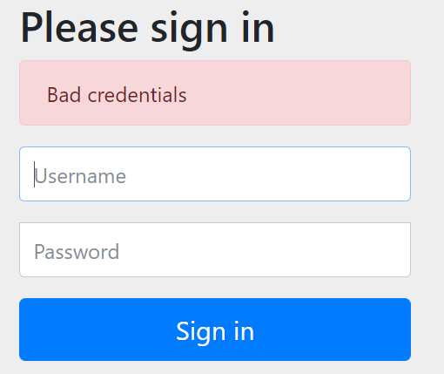

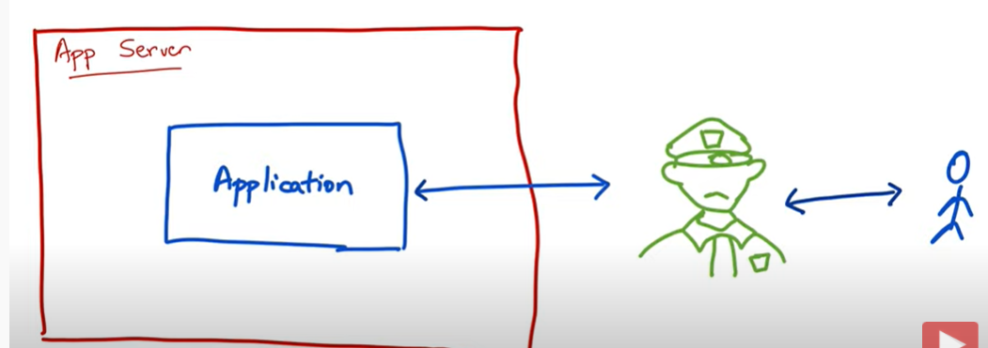

**Note: just by adding spring security in class path. It sit in front and it stopping u to access the application**

**Query :--** how does spring security do this just by adding in class path

**ANSWER :--- filter**

**Filter is the one of the core concept of servlet technology and how does it work**

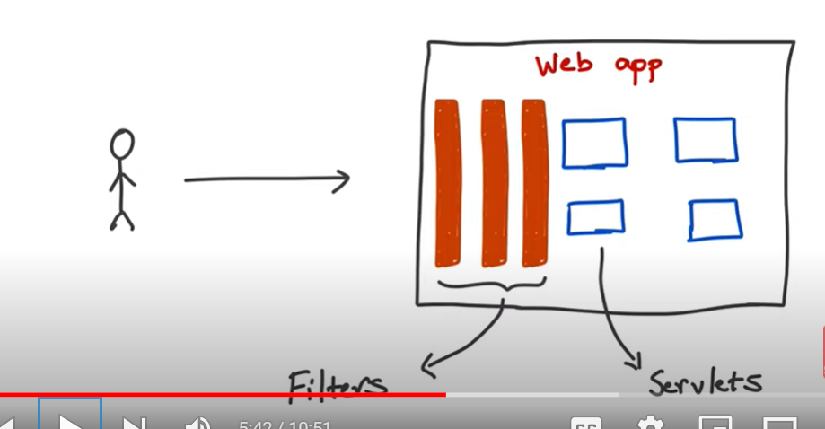

We can check using filter that every request is having header or not

Note :- **Servlet is mapped to url filter can be apply to all url**

**Spring security filter is doing exactly same thing , It putting the filter there and I m going to sit there**

**And examine all request to allow or deny the request**

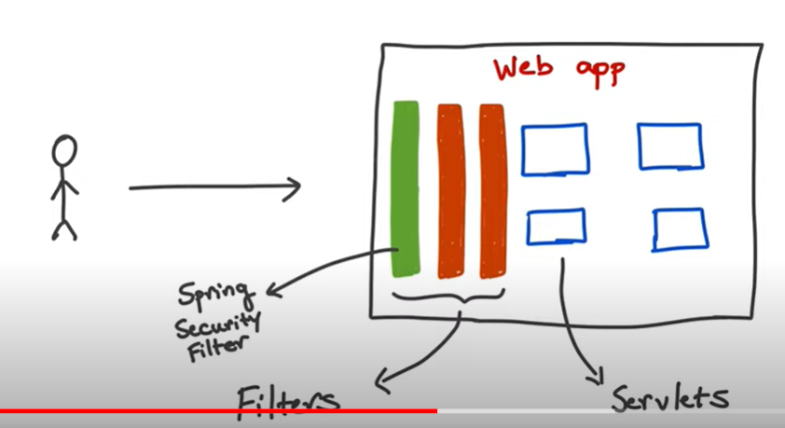

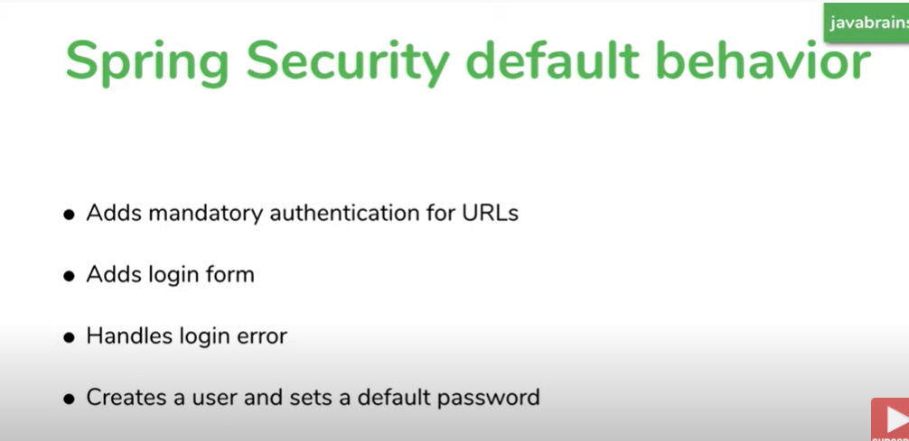

**Spring security will create password and by covention user is user**

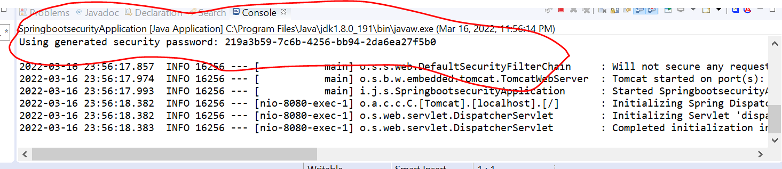

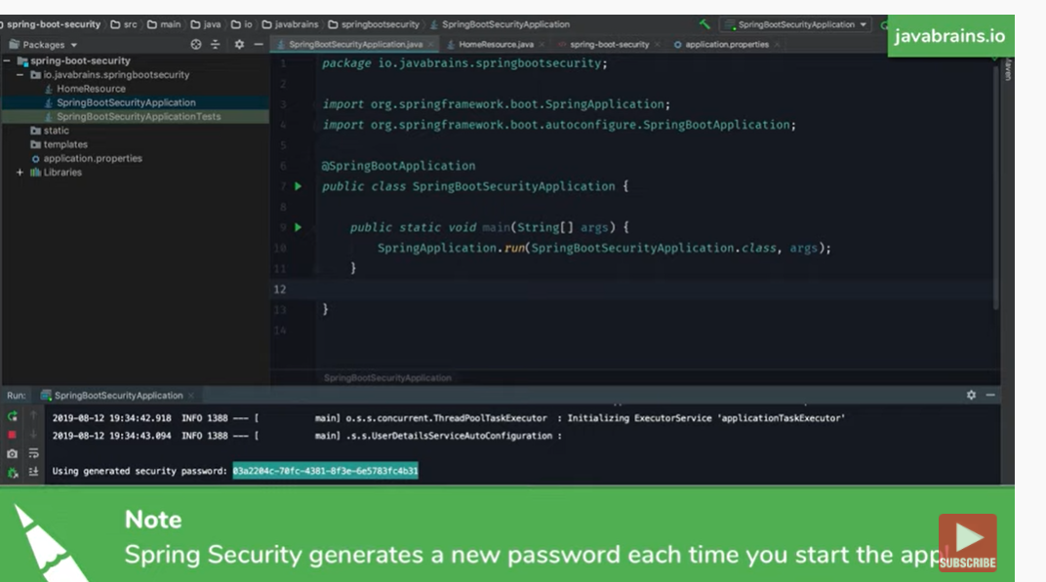

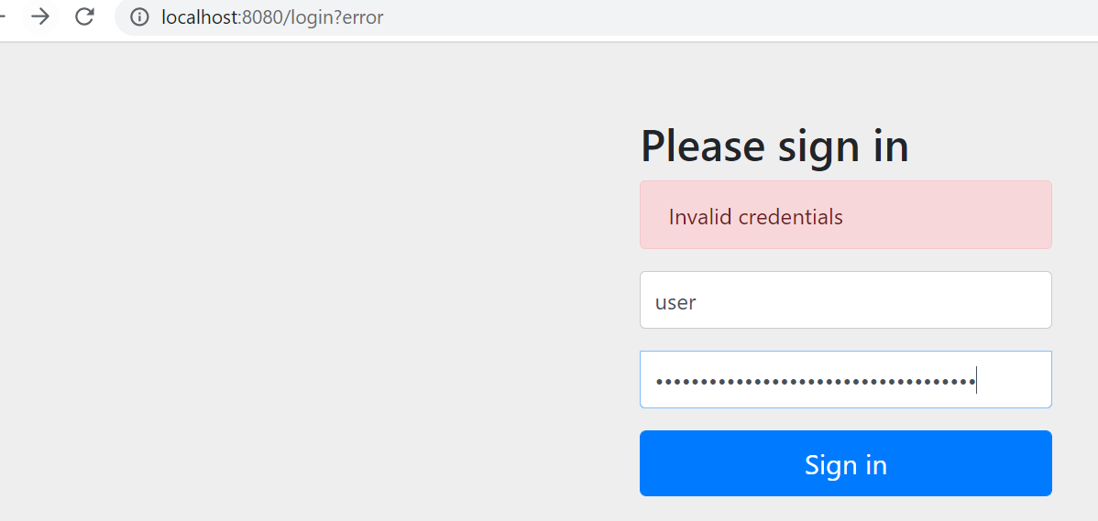

**Now click it will work so this default behaviour of spring security just by adding spring security to the class path**

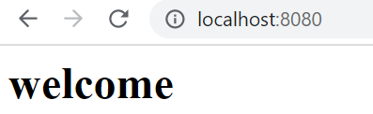

**Note :----** we can customize this go to application.properties and couple of properties in it

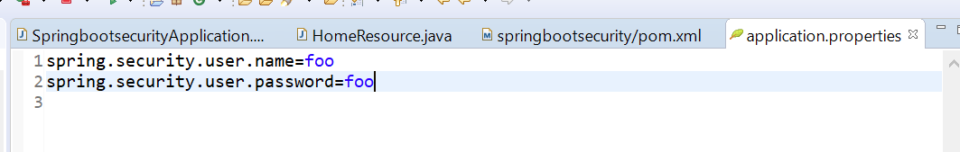

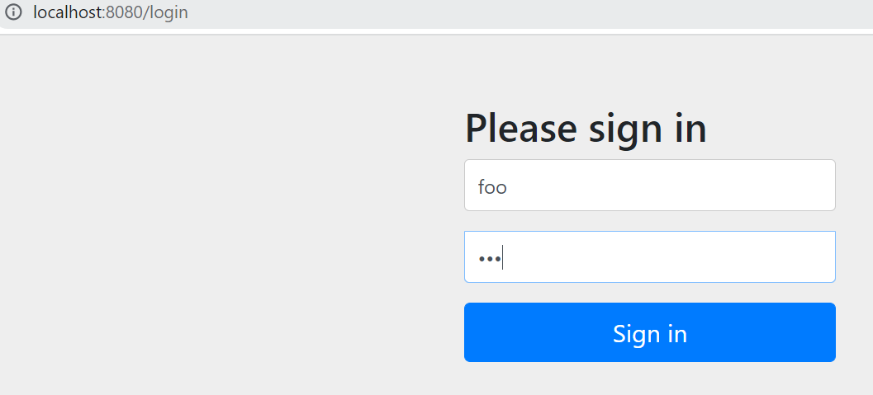

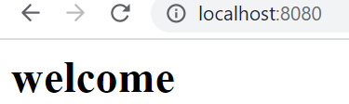

**Application.properties will overwrite the default user spring security created**

**Requirement :- how to add list of user**

**Lecture 4- how to configure spring security authentication**

**Actual authentication approaches**

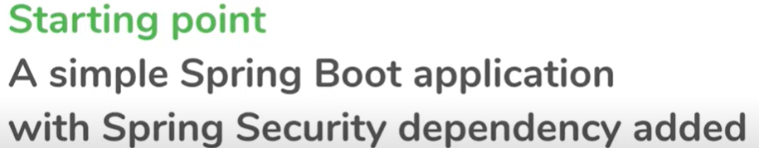

**We will hardcode 2 user and save in memory**

The way to configure authentication in spring **is called AuthenticationManager**

**AuthenticationManager :**  that manages authentication in spring security application

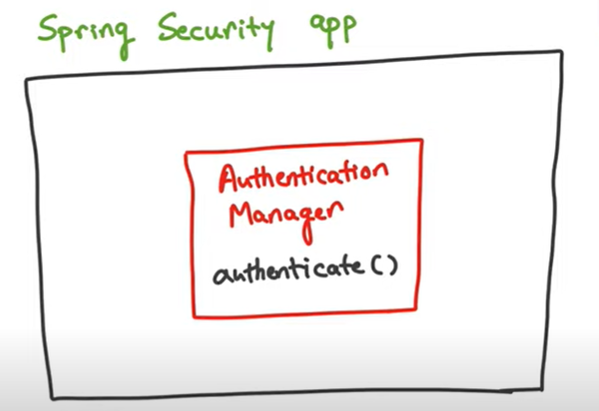



**Will use AuthenticationManagerBuilder to configure**

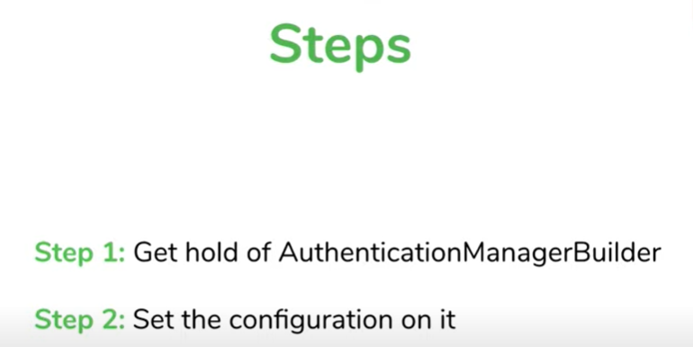

**NOTE** amb will asked et type of auth u want

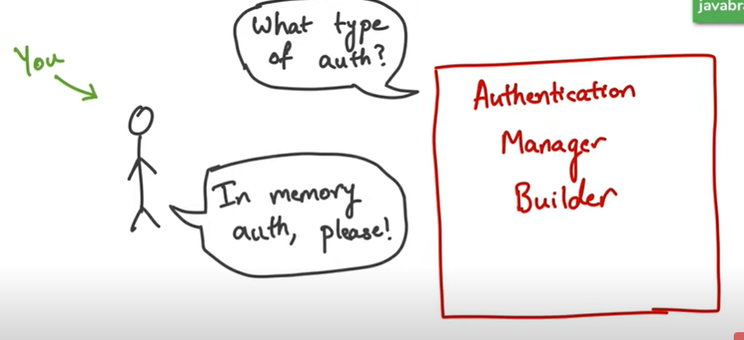

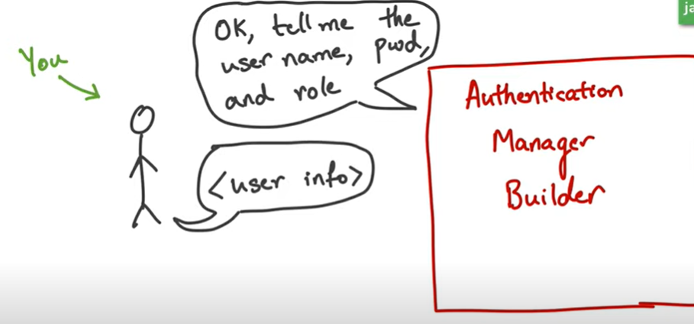

NOTE:

once we configure AMB with these properties we can imagine a new Authentication Manager

Being created somehow which has the value that u want . We are not dealing with Authentication

Manager, we are dealing with AMB

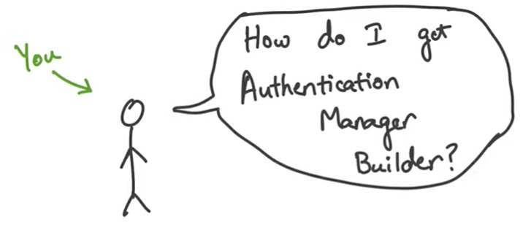

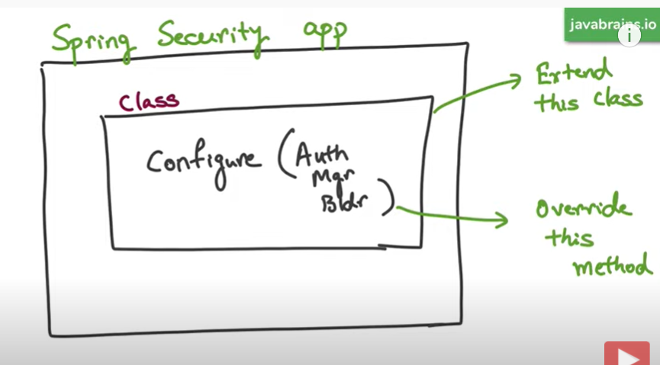

This is imp :----- configure method and it willl take arg AMB so that we can override it and customize it

**Note :----WebSecurityConfigurerAdapater** is class that is sitting in spring security app which is have configure method

AMB **:- first will tell wt type of authentication we need based on that will provide the inputs**

**@EnableWebSecurity :** it tells spring this is web security configuration

**Note** :---

we don’t want to store pw as text in any where of the application



**What we have to do for pw encoding**

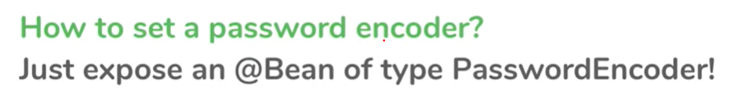

**Create a bean of type PasswordEncoder and expose it to spring security and spring security looking all**

**Available bean and if any of them is PasswordEncoder then it will uses to to encrypt password**

NoOpPasswordEncoder.getInstance()------------------it will check I m ok with the text

After this class spring security will not configure default configuration

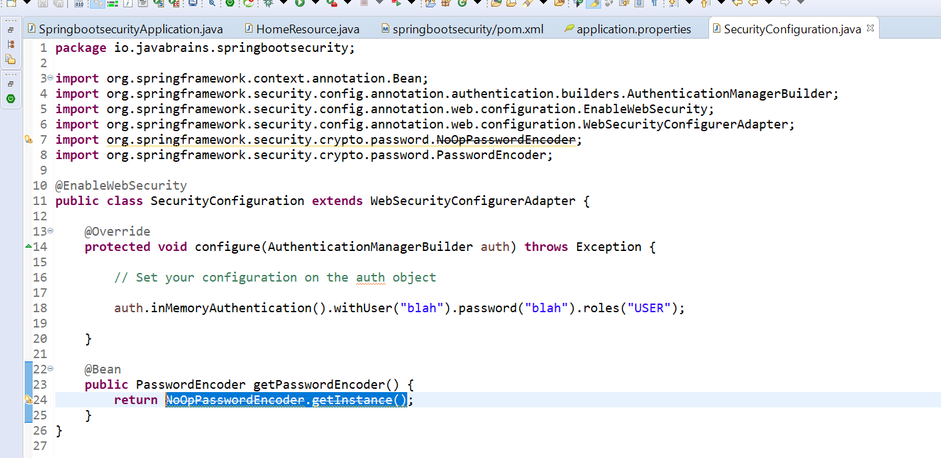

Now start main application

One user or multiple user we can add it

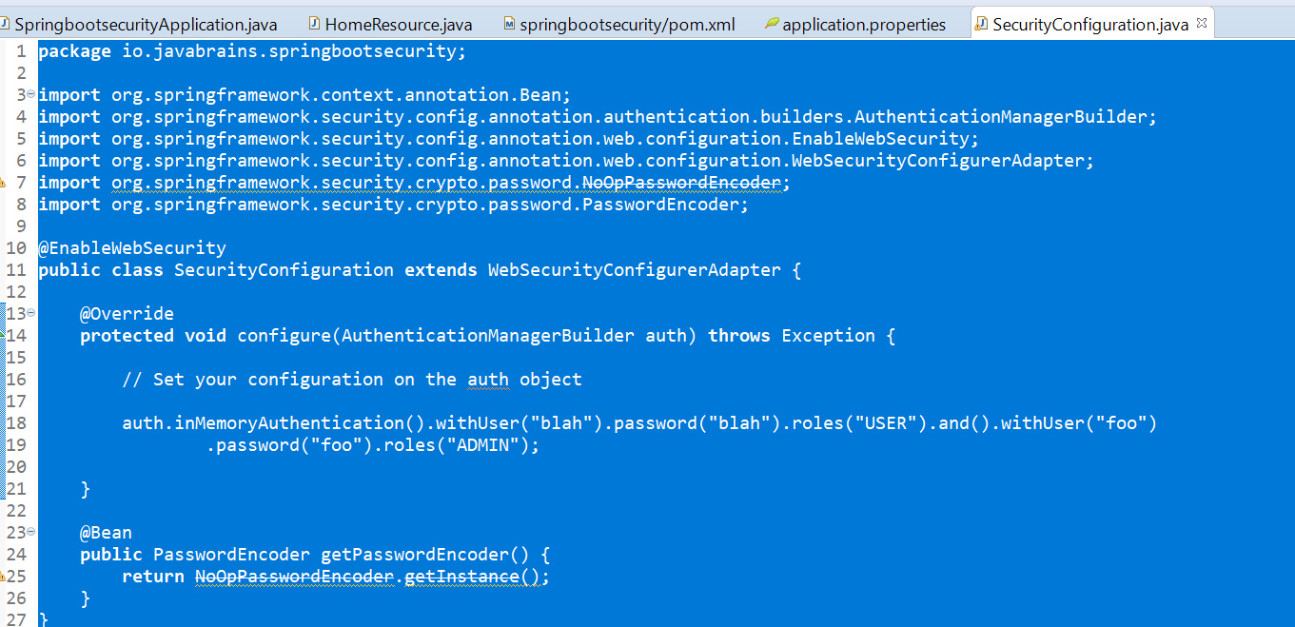

Tutorial 5:---- how to configure spring security authorization

Request has the authority to perform what it needs to do

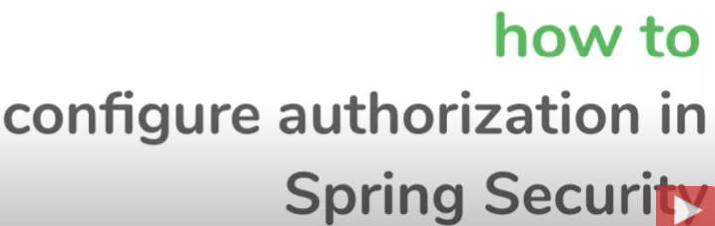

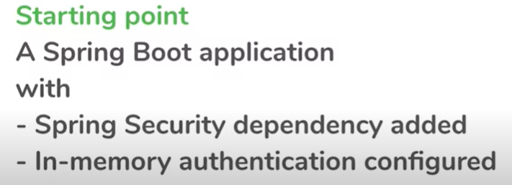

**NOTE:** we need two users with different role

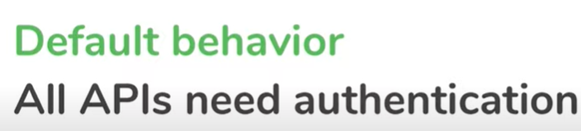

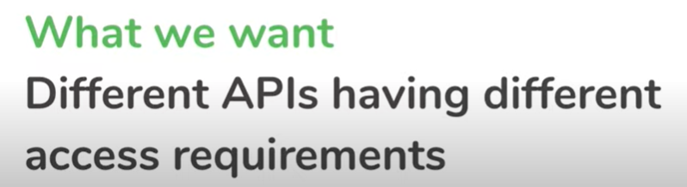

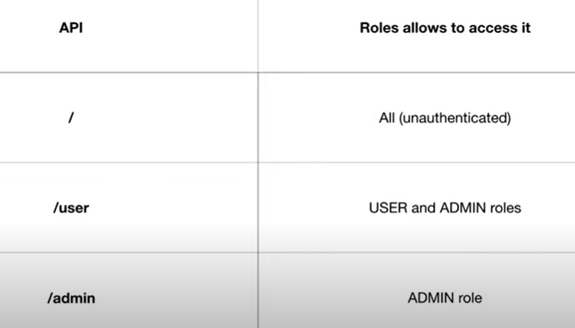

**Step 1:---** created 2 api user and admin

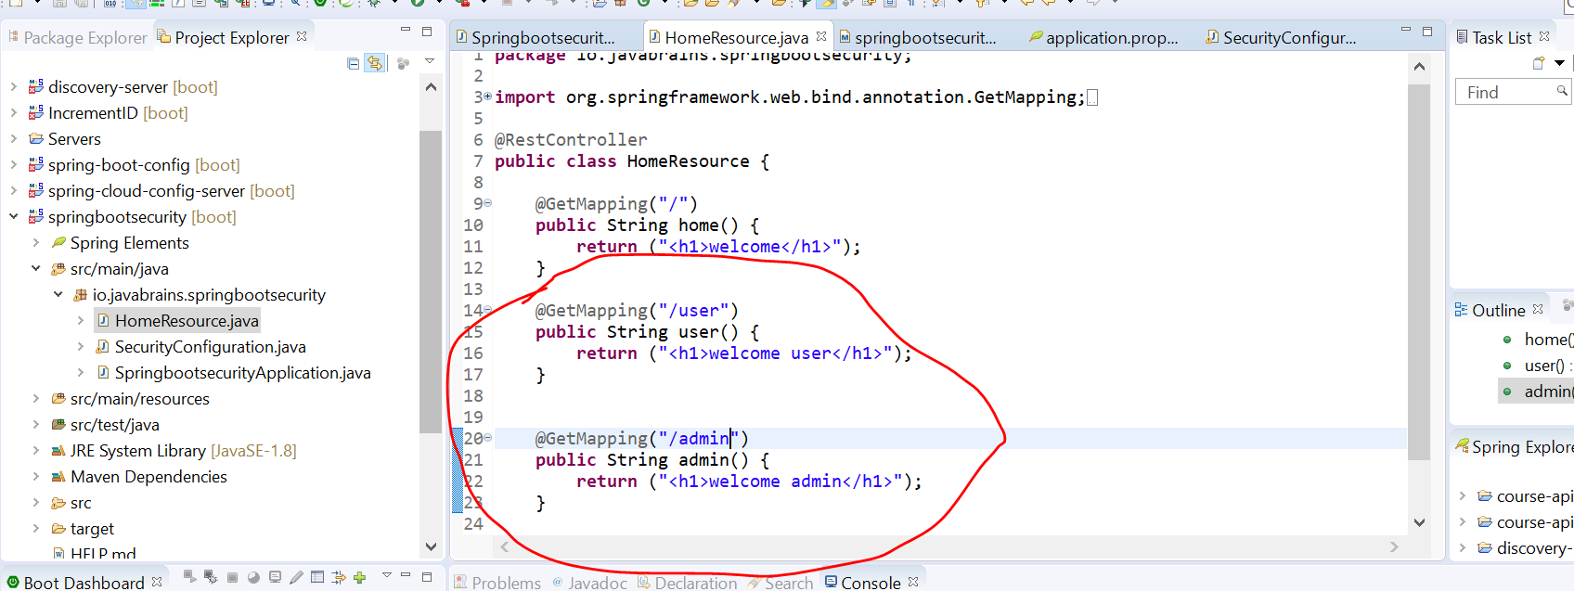

First api:----- will be access by everyone even if they didn’t log in

Second api----- will be access by log in user i.e both user and admin

Third api :- will be access by user who are having admin role

**Solution** :----- the way to do by using object of type HttpSecurity



HttpSecurity ==== will configure what are the path and access restriction for that path

**Query :**---- how to get hold of this objector how to access this object

Answer :- how we hold authentication object

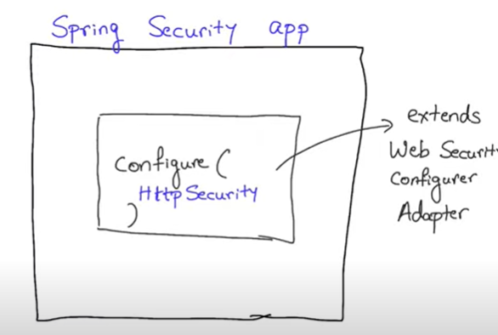

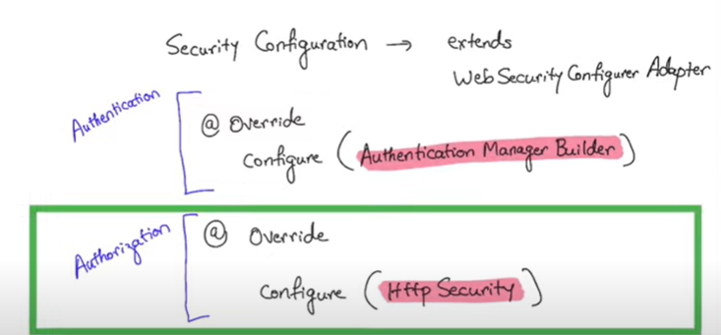

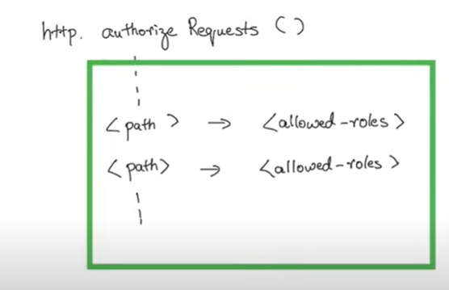

Http.authorizeRequest:-- this is where we specify mapping of path to role

antMatchers:----- will consider path by using wild cards . We don’t need to specify each individual path

because that will be tedious if we will specify individual that's why we define path using pattern

One all path matches then we need to specify what the role is having for all those path

Note:----- we can also specify type of login

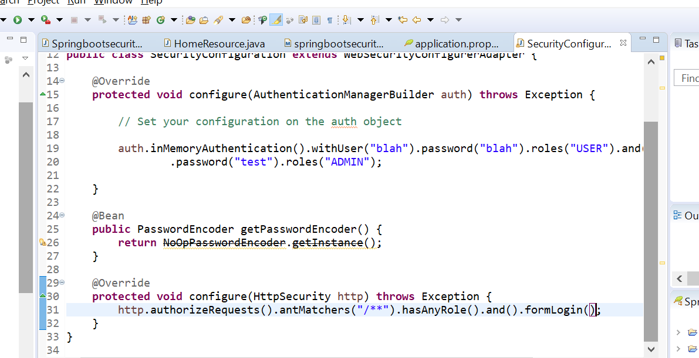

/**----- indicates all path in current level any any nested level below this

**NOTE:** formLogin default configuration for spring security

Let test it out with admin role

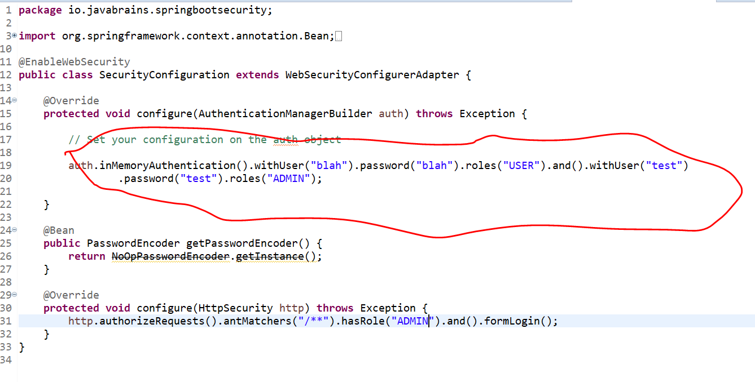

NOTE: when load the application user role not able to access it

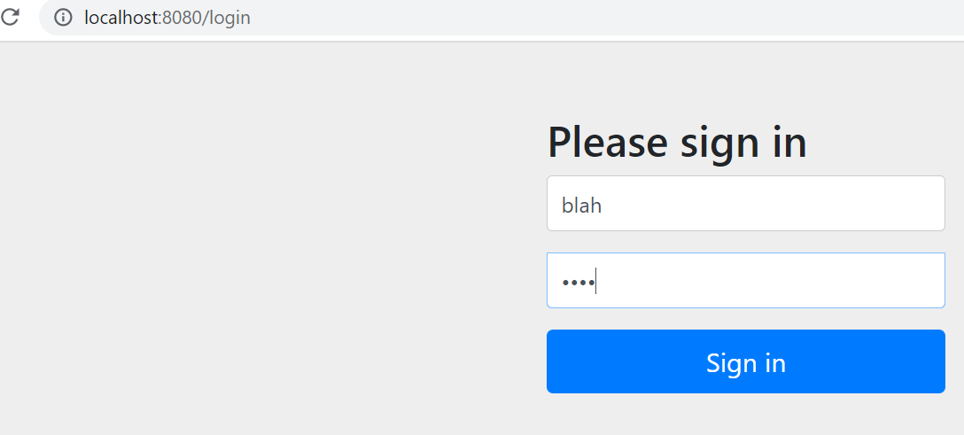

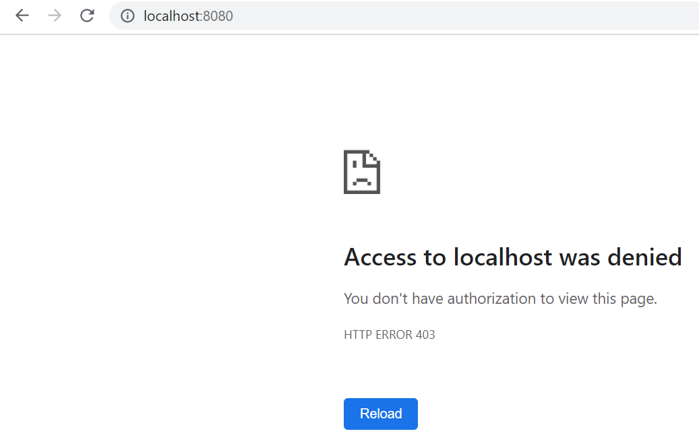

**Now problem is how to log out and try to other use**r

**Spring security also provide logout page by typing :---- localhost:8080/logout**

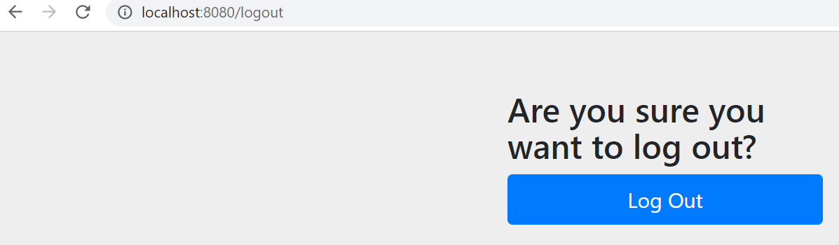

**Test/test**

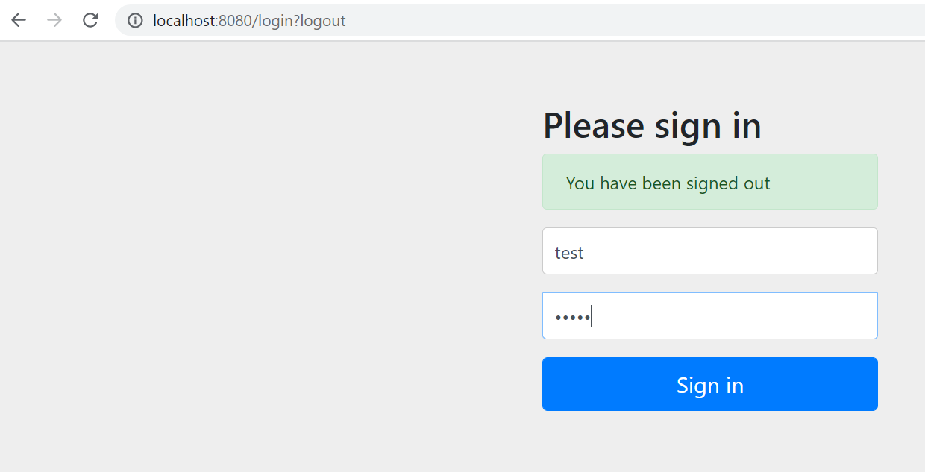

**Note :----** root is access by everyone but we want /user and /admin will be access by user and admin role resp.

**Note: it should be in order**

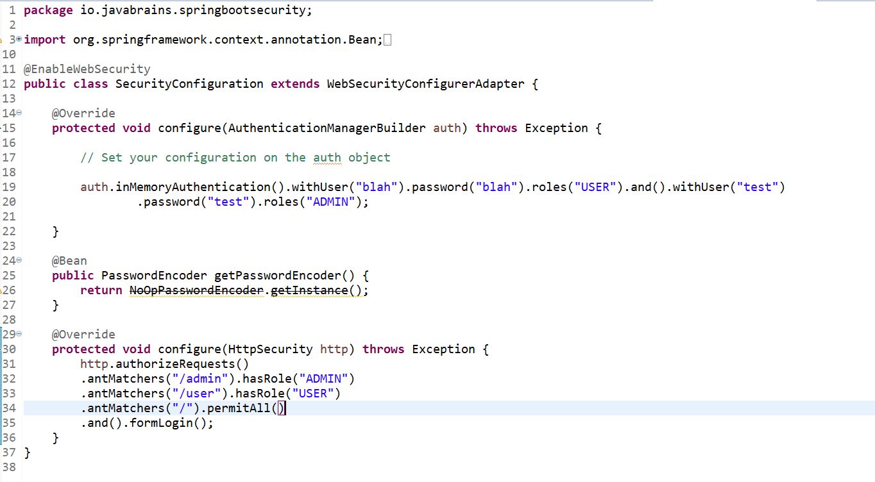

**Least restrictive we need to put at bottom**

**Login as admin**

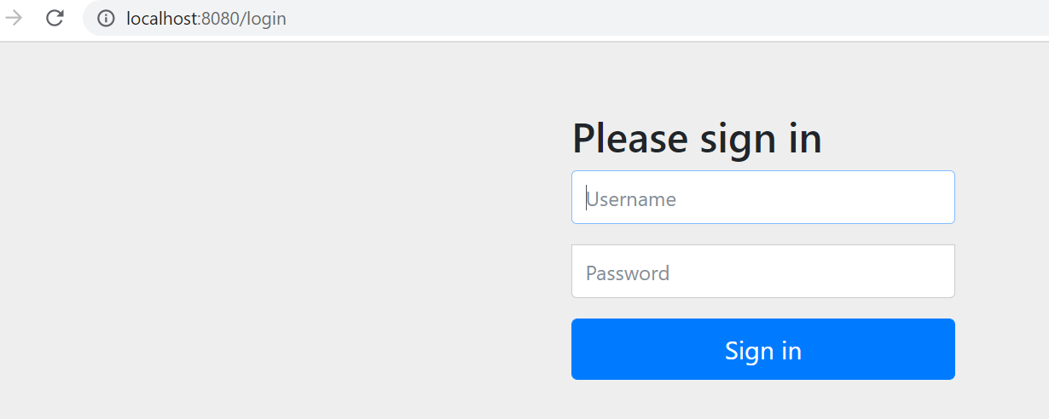

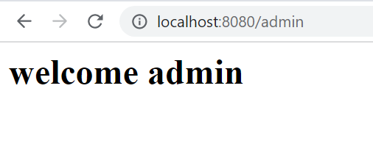

**Note imp point:--------** when we login as admin then in url will trying to access user it will not access it.

Since spring security doesn't know admin has higher priority then user.

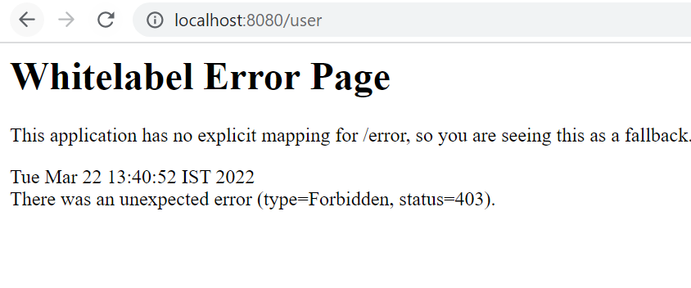

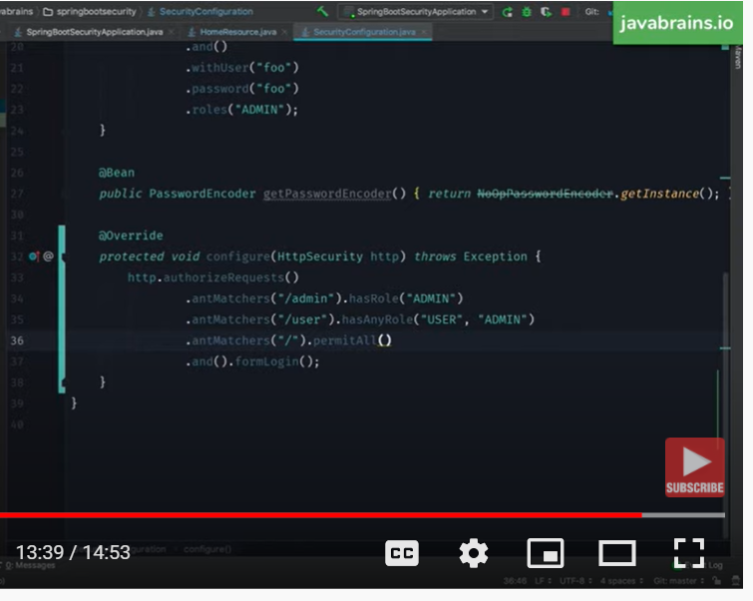

We are telling spring bean, hey spring if is user allow both admin and user role

httpSecurity:--- we can configure to access different api with different role

How spring security Authentication Works

How spring security bootstrap and authentication works



The way spring security add to the request is by using filter

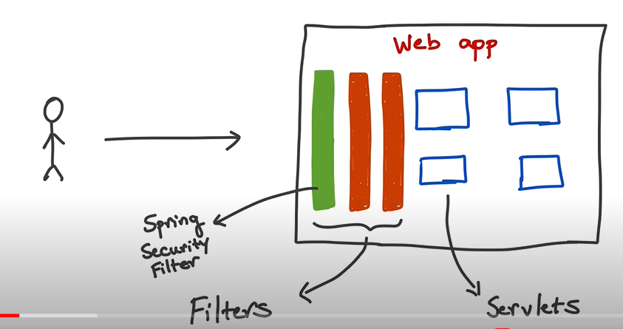

Note :---**Filter can be apply to wide range of url**

So when we add spring security dependency, spring security filter will map to all url

**Below one is web-application level**

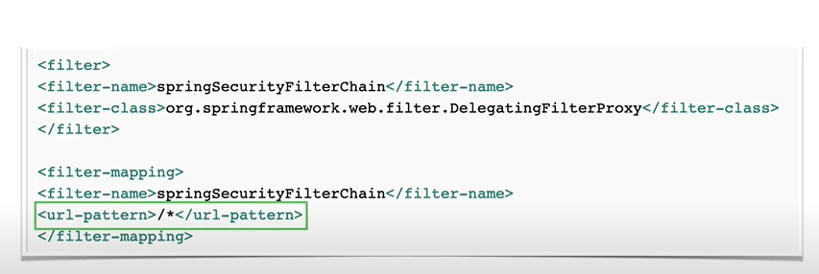

Query :---**- want to intercept only one url by spring security filter not all url**

**Answer:----** we need to intercept all url for security

Name of filter :- **DelegatingFilterProxy**

**This catch all filter that spring security add at starting point but it delegates to other spring filter**

**To do different things depending on the url**

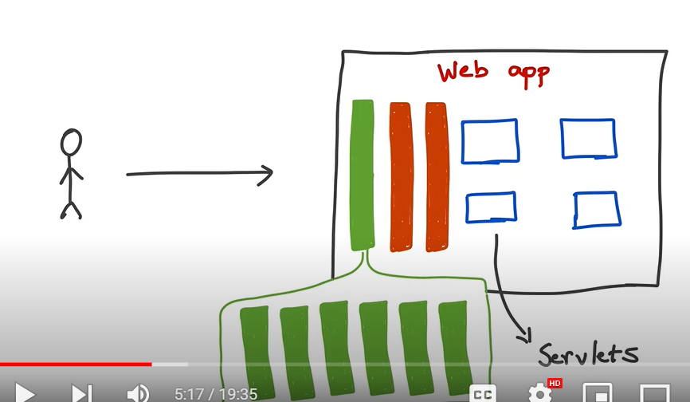

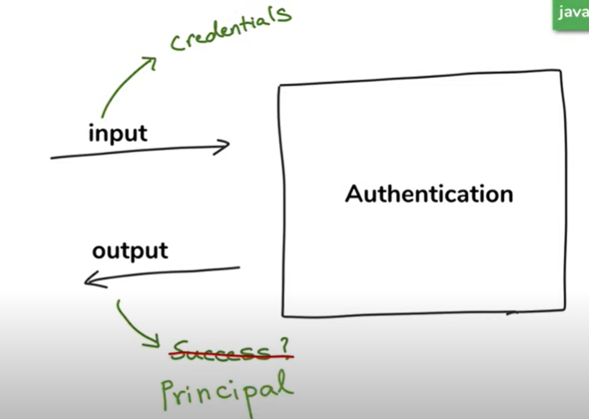

**Principal :** it return the information of logged in user

When spring security perform authentication, it keep the track of both input and output using an object

Of type **authentication**

**Authentication** is internal soring security interface and the authentication object is mean to whole credential before authentication once the user is authentication it hold the principal

These filter do various thing and of those filter is authentication filter which intercept all authentication request and initiate the authentication process

**AuthenticationProvider :**--- responsible for doing the actual authentication

**AuthenticationProvider :---** is an interface that has method called authenticate

And we have the implementation of authenticate method in application and need to tell spring security about it then security will call this authenticate method to authenticate it

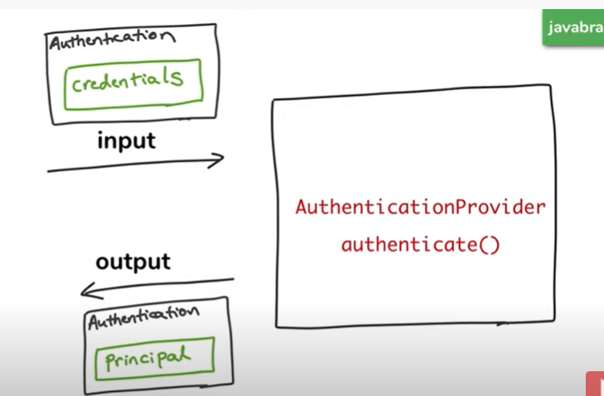

Credential will be in authentication object and then it will authenticate using authenticate method .

Once it authenticate then it will return authentication object and this will contain the info of currently

Logged in user.

**Note: single application can have multiple authentication mechanism**

Spring Security provides a variety of options for performing authentication. These follow a simple contract – **an Authentication request is processed by an AuthenticationProvider and a fully authenticated object with full credentials is returned**.

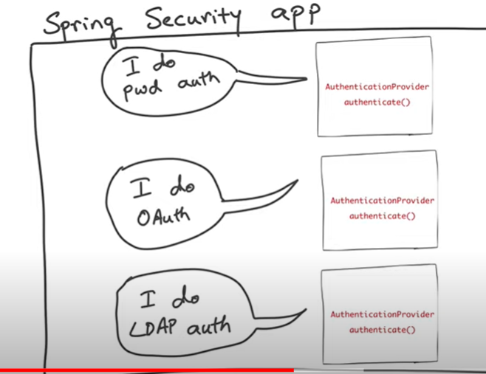

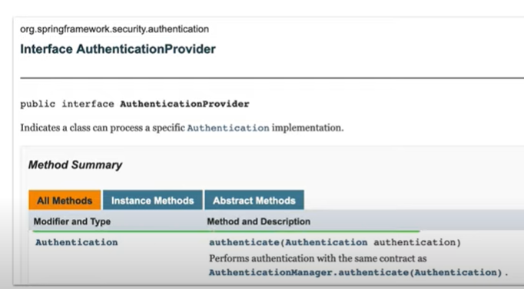

Authenticate method:---- it takes instance .of authentication and it will return instance of authentication.

**Note:** before authentication it hold the credential object and after authentication it hold the principal

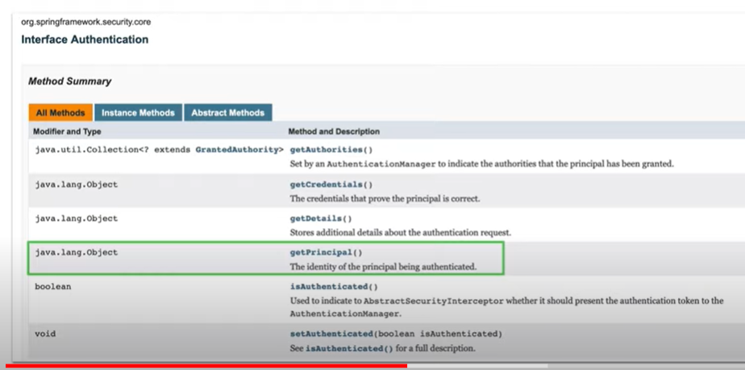

**Query :---** how do different AuthenticationProvider work with each other

**Ans :--- AuthenticationManager**

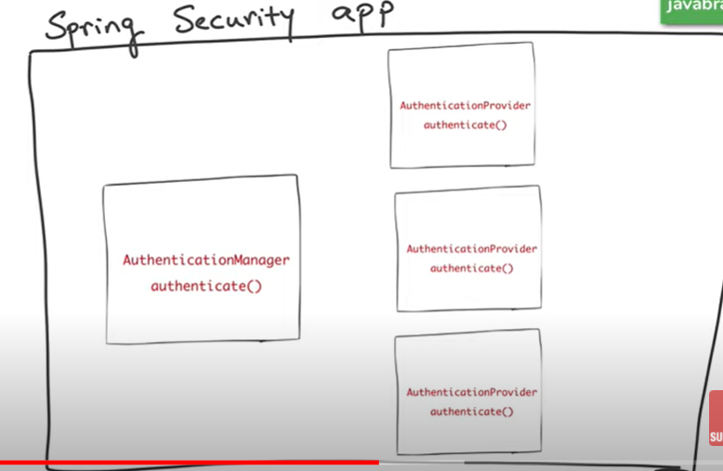

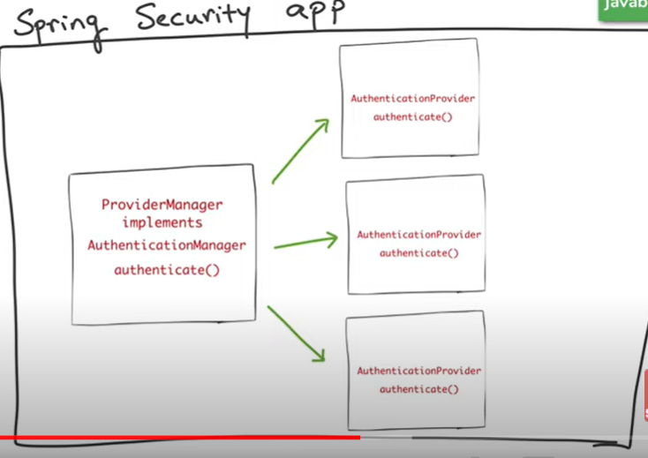

AuthenticationManager will ask to all AuthenticationProvider once it find the right provider to do the job then it will delegate the work

**Note:--**

**All** AuthenticationProvider need to tell what can I support

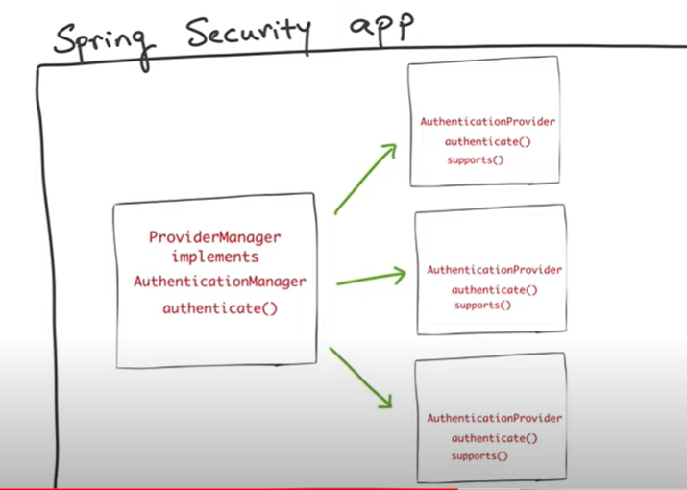

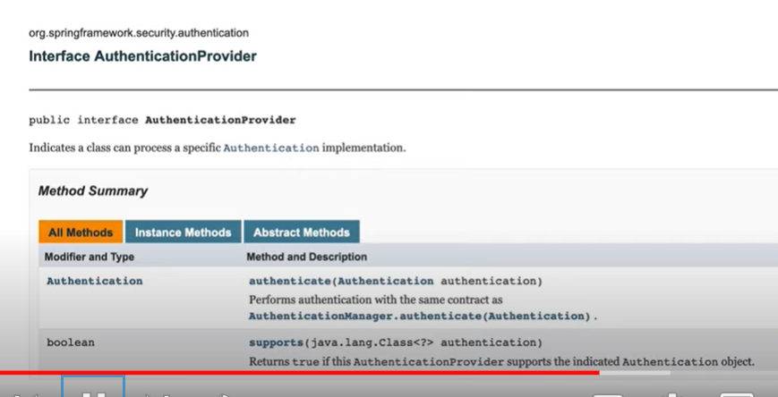

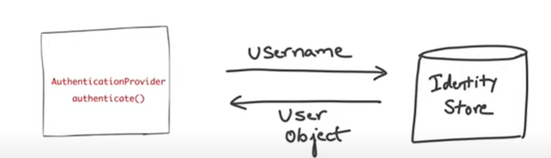

Whether ldap or database when we retrieve user object then verification of authorization is same.

Note:--

All the user information in UserDetailService

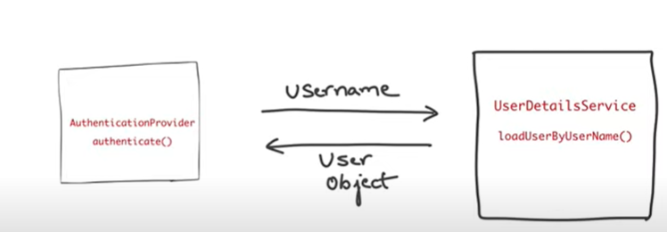

Once the user object is returned the AuthenticationProvider has everything which it need to authenticate

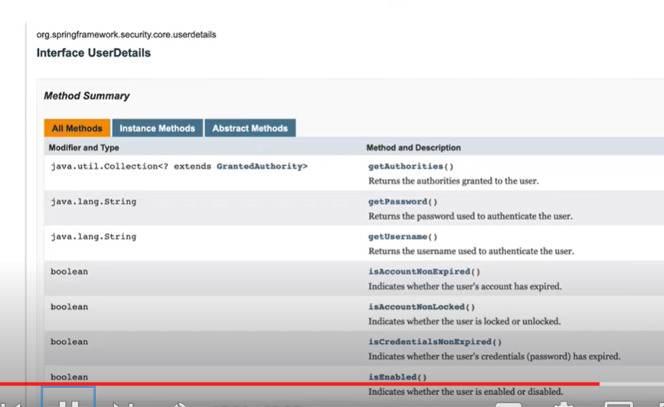

Above all info AuthenticationProvider needs which is returned by UserDetailsService.

**Imp**

AuthenticationFilter intercept the authentication request. It will create authentication object with

Credential and passes to AuthenticationManager and it will find the right AuthenticationProvider

Using supports method then the AuthenticationManager will call authenticate method on that

AuthenticationProvider and passes the authentication object. The AuthenticationProvider looks up

The corresponding user in the system by using UserDetailsService. The UserDetailsService return instance which AuthenticationProvider then verifies and then authentication happens. If the authentication is successful then the authentication object return back with principle and this authentication object goes all back to authentication filter and if authentication not successful then

AuthenticationProvider throws exception

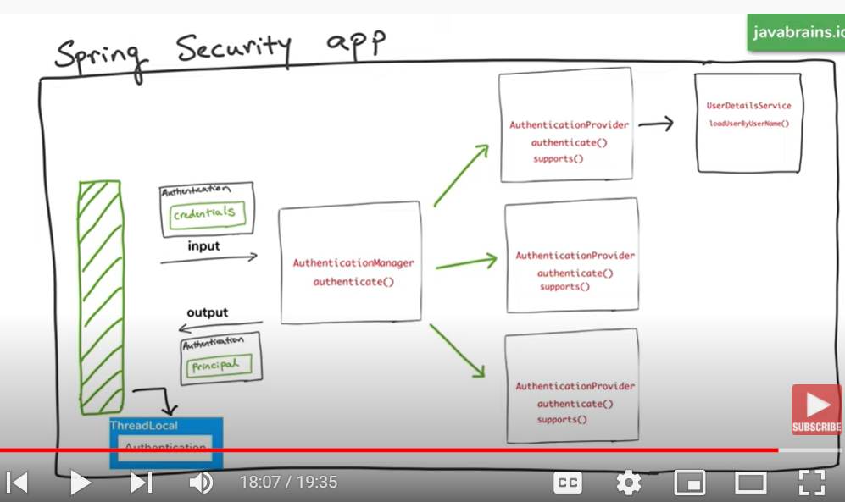

**Note :-**filter save the authentication object in threadLocal. Security context associated with current thread. As a result of successful authentication it will save in security context in thread local object

Which is sued for authorization.

**Note :--- security context also allow to associated with session and that is done by another filter.**

**It takes the authentication principle and manages with user session and that’s the reason we don’t need to authenticate for every subsequent request**

**How to set up jdbc authentication with spring security**

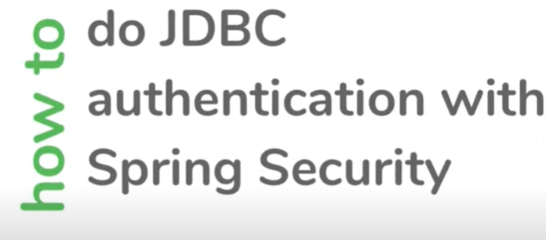

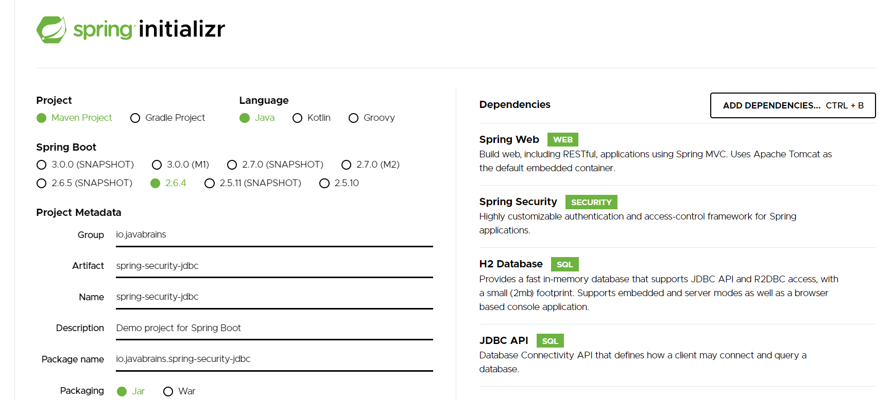

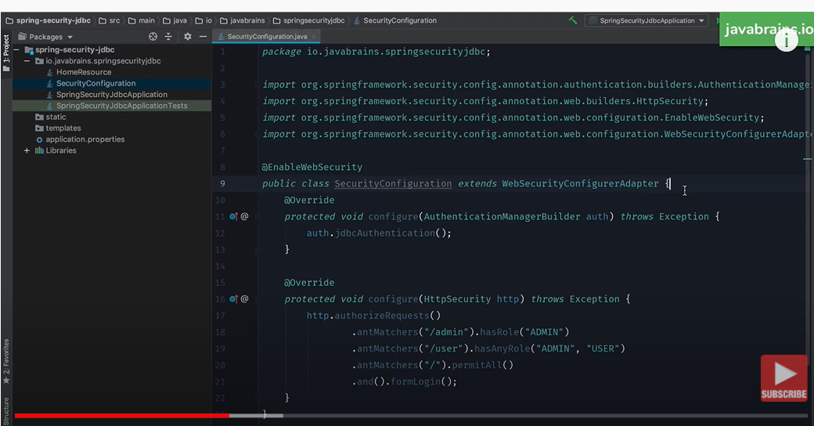

Step 1:- authentication and authorization is ready.

Hey spring security I have got user info i.e un and pw now lookup db when someone is trying to authenticate

Query:-- how to tell spring security where db is configured

Ans :---is by configuring data source bean

**Note:--- when we use embedded database like h2 spring boot is smart enough to create DataSource for us.**

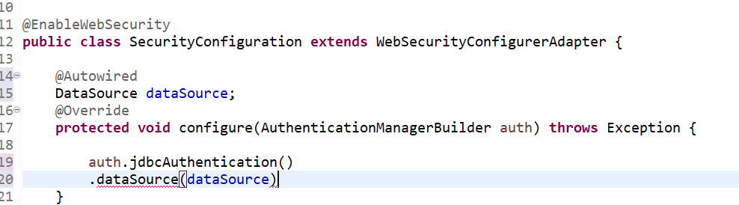

By using this we configured spring security point to h2 database

**Step 2:- create schema and user info into external database, how to do that**

Spring security has some default schema for user.

Spring security says if u will give me datasource , u don’t need to create user table and authority table.

And we can also tell spring security to create some default user

**Lets try default option first**

**withDefaultSchema:-----**

spring security will create user table and authority table and set it into h2 d/b

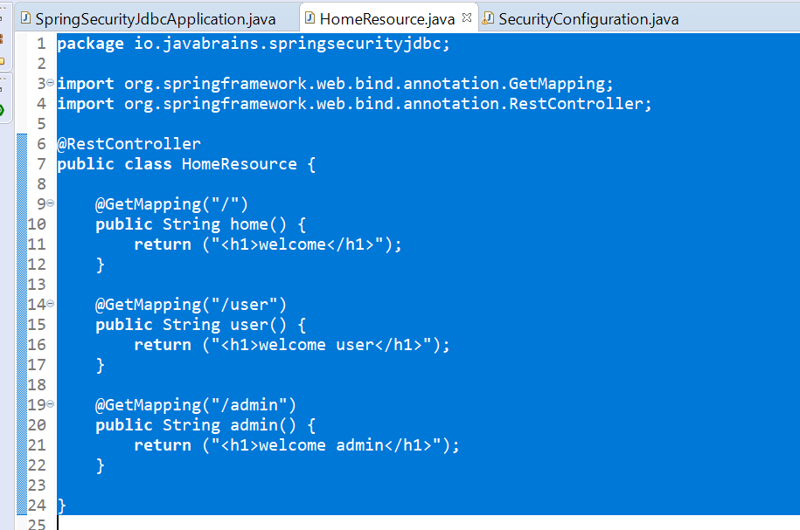

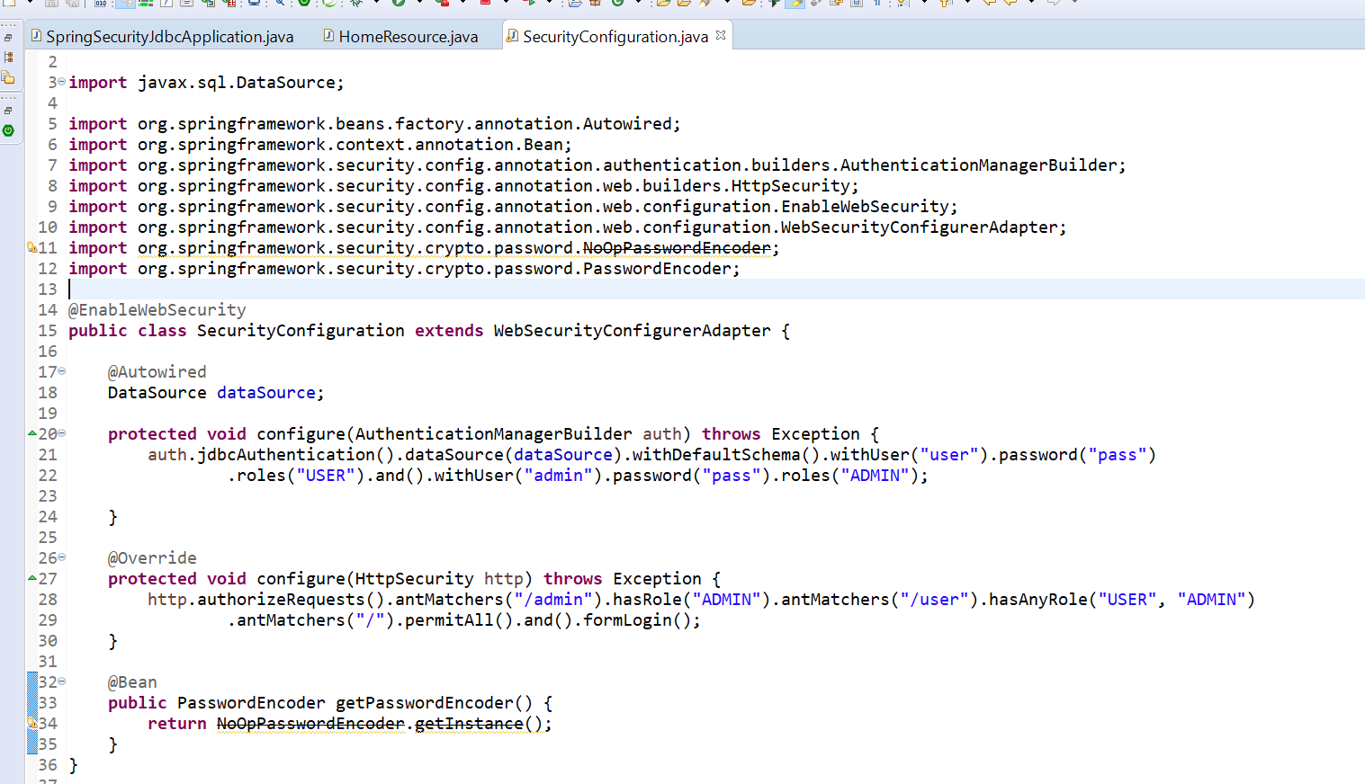

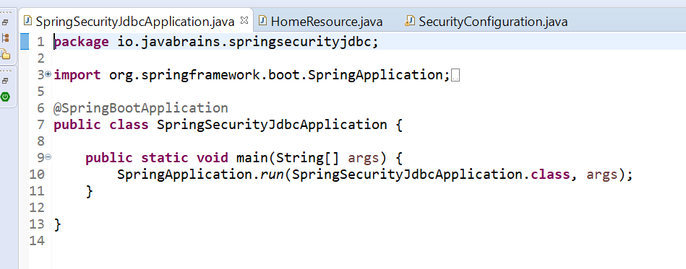

But this is not realistic scenario for production since we are using h2 database and we don’t use default schema

**Step :--- let try to get rid of schema**

**This should be ideal state in real world application**

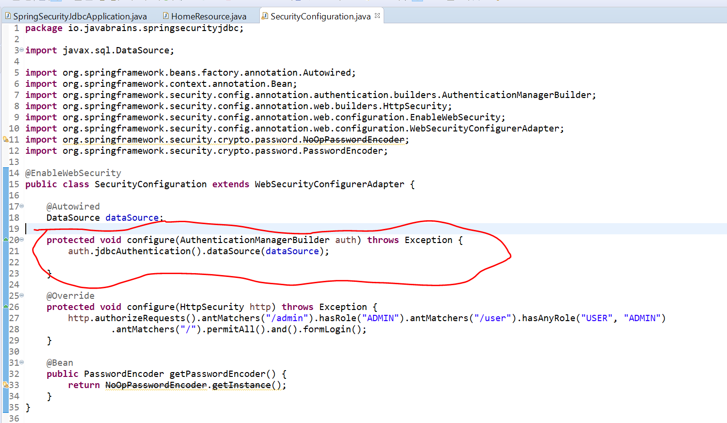

**Note: this is the schema which spring security expect so we ne to point to datasource**

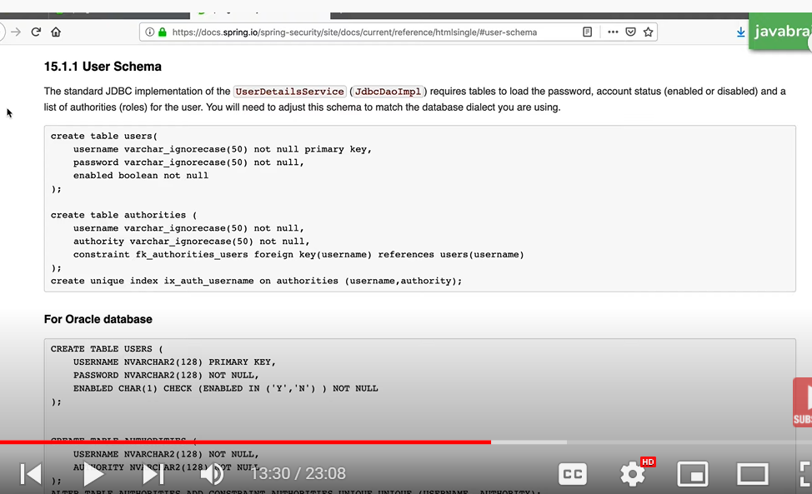

**Requirement :--- will use above schema and tell spring boot to use this using embedded db,**

**Spring security don’t configure it automatically**

<https://docs.spring.io/spring-security/site/docs/3.0.x/reference/appendix-schema.html>

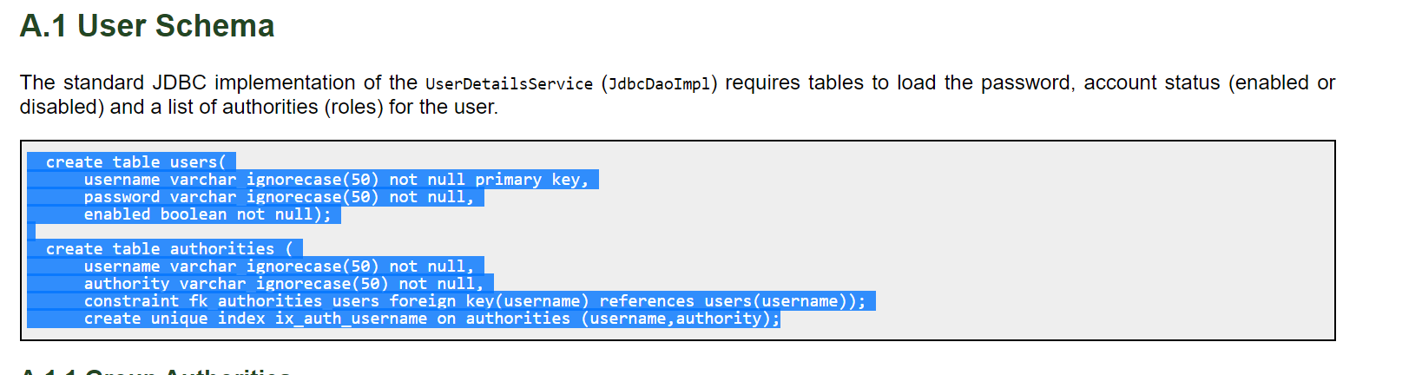

Note:-- schema.sql is a file that spring boot uses to set up schema

Basically it is ddl statement and when spring boot start application then it will run those command

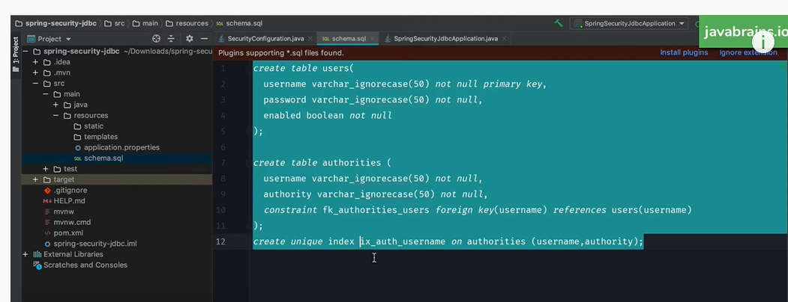

I am telling spring run these command when application starts

**Note created schema and data which spring security does by default**

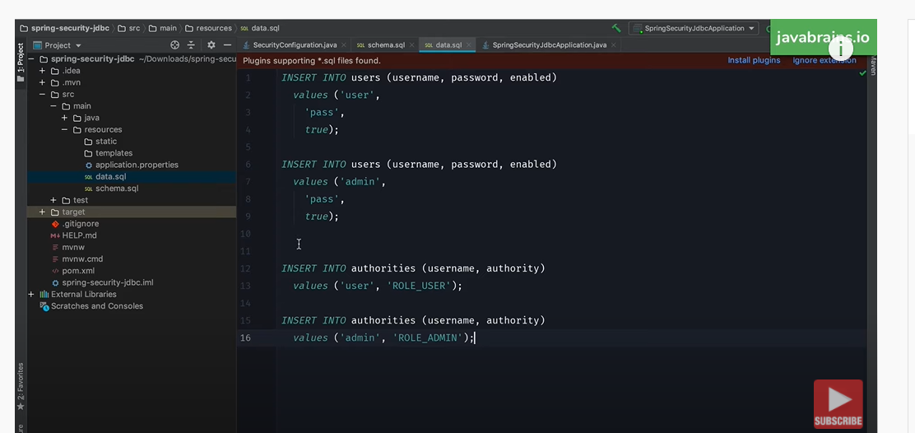

======================================= 5 file================================

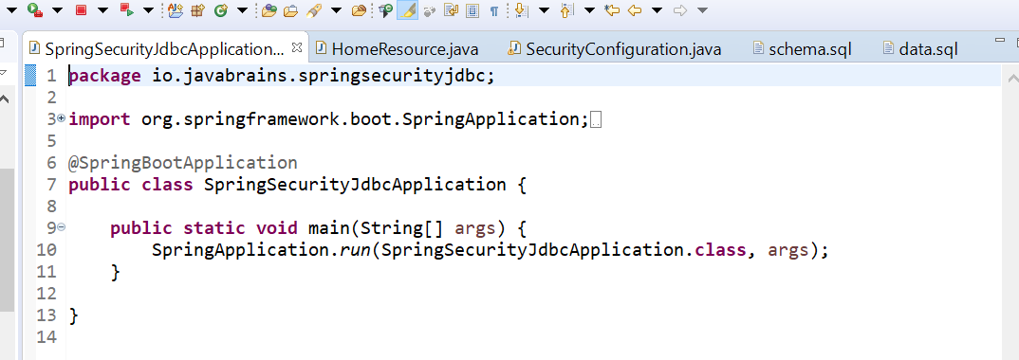

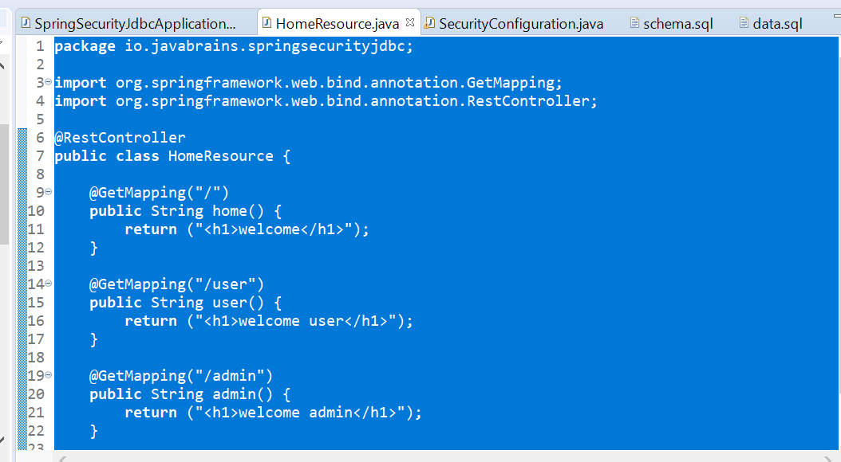

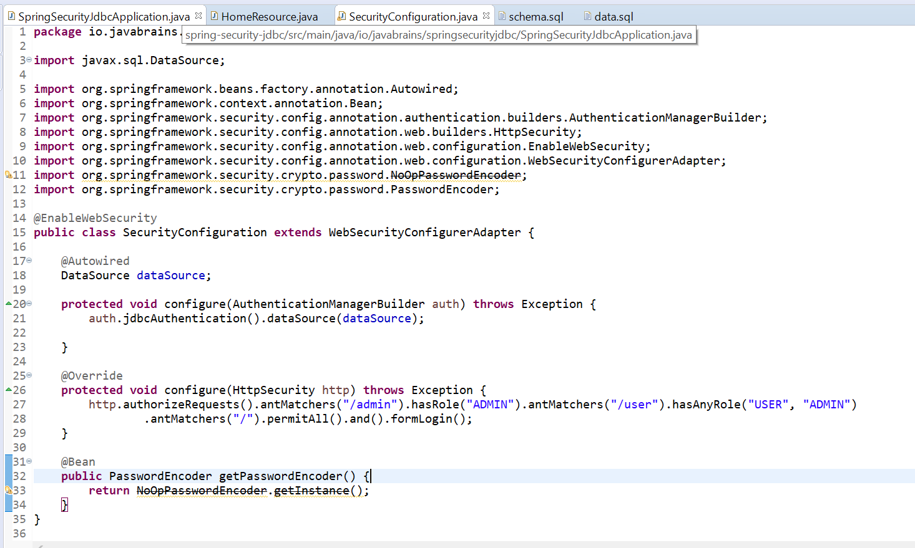

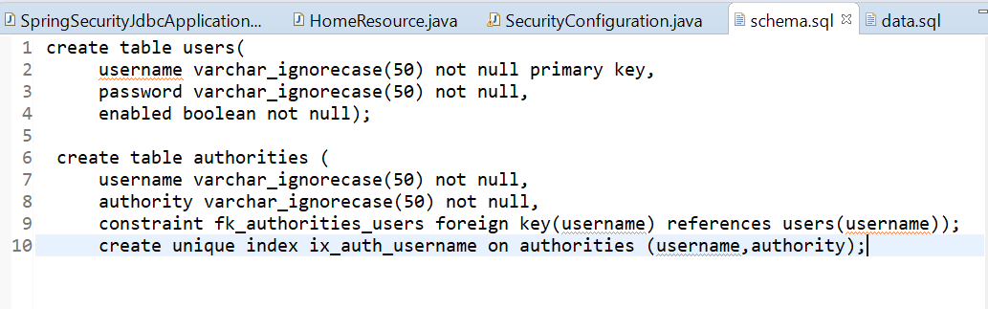

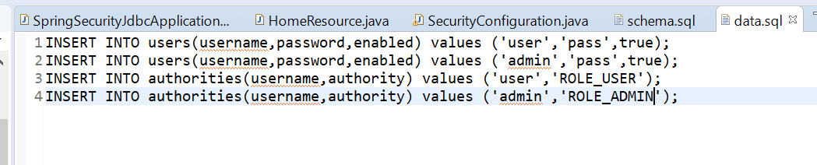

===========================still able to login=======================

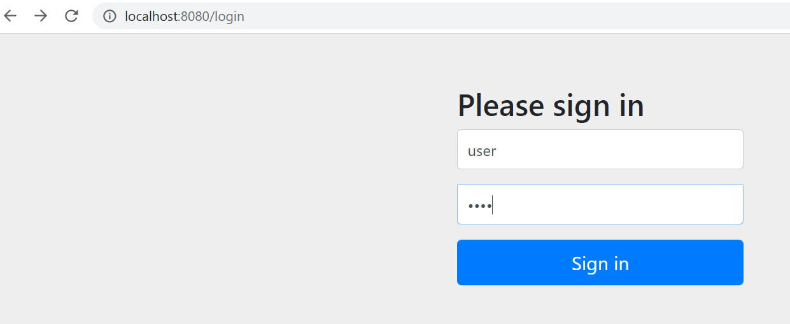

Note:----- **we don’t to tell spring explicitly that user is created, user is already create and spring security will verify it**

**Requirement:----- this is with h2 database now we need to work with real database**

**Point 1:----**

what happens if the schema is different.

Now how to tell spring security to use different schema rather using default.

If we have different schema we need to tell spring security that different schema is used .

**The way to do this is**

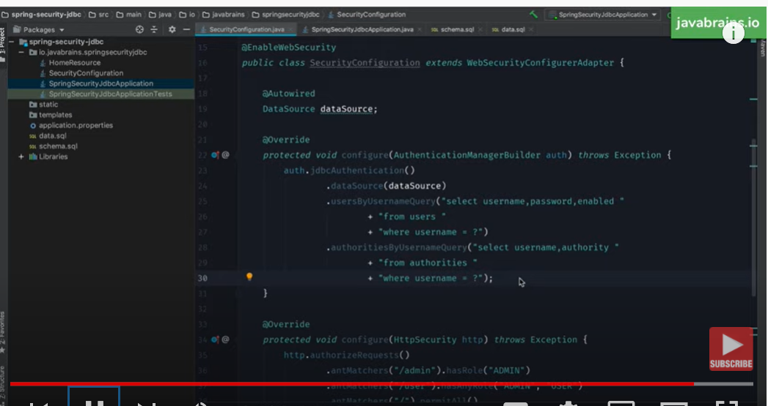

**We need to use these two query**

**External database**

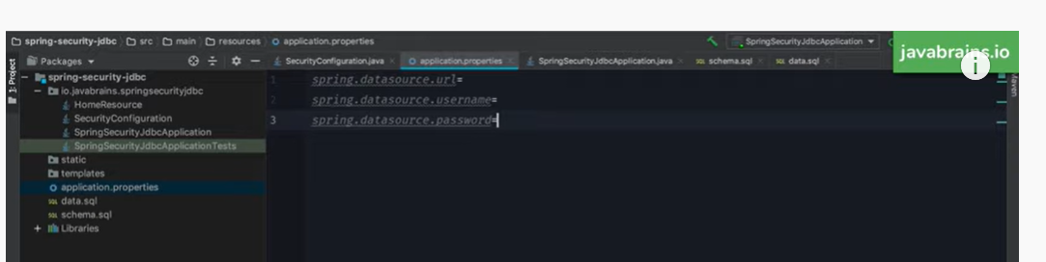

Spring Boot + Spring Security with JPA authentication and MySQL from scratch

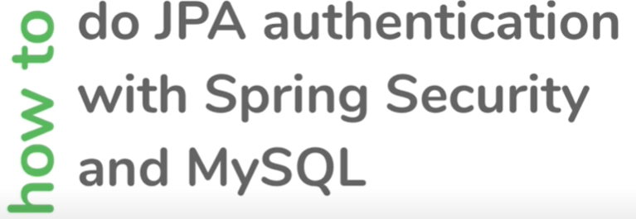

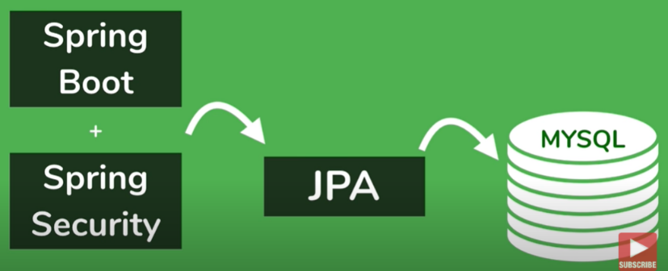

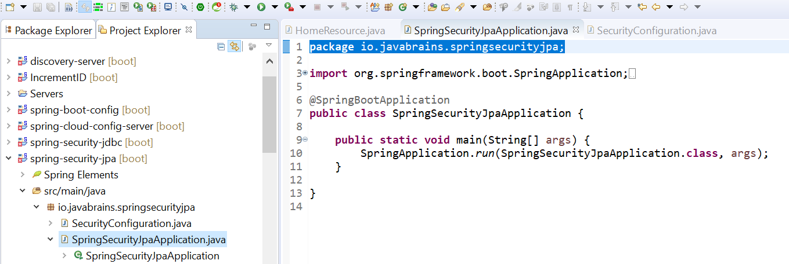

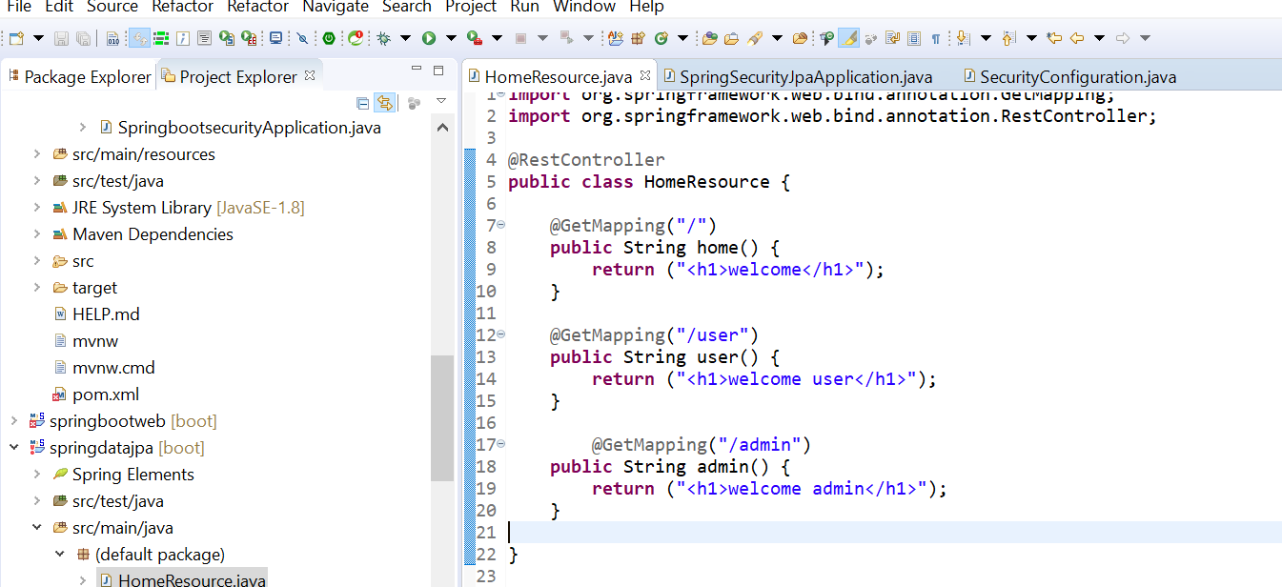

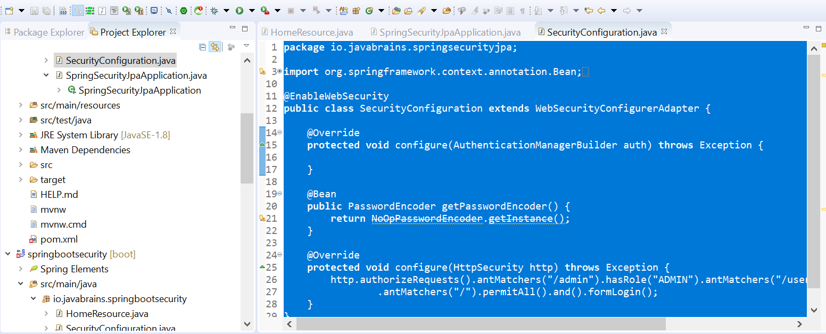

**Now how to set up authentication using spring security jpa**

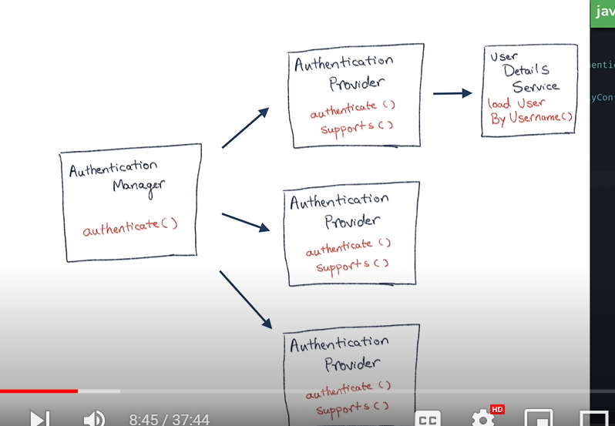

When someone try to login spring security will ask give me details of user and spring security will

Authenticate it

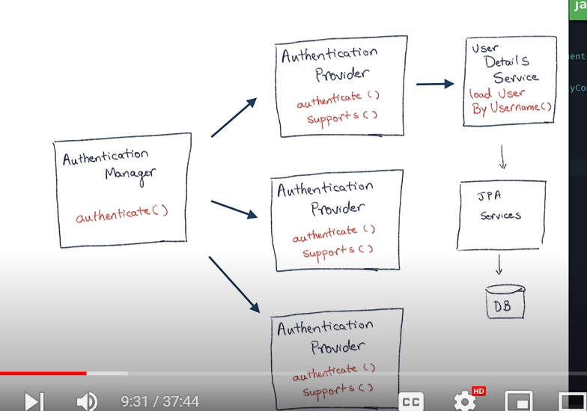

**Note: userDetailsService is not depend on jpa . It can read from text file also.**

**Note:-** the way to work spring security to jpa we need to create UserDetailsService

**Step 1:---**

Create a UserDetailsService which will return hard coded user has nothing to do with jpa specifically

Query:-- how to create implementation of UserDetailsService

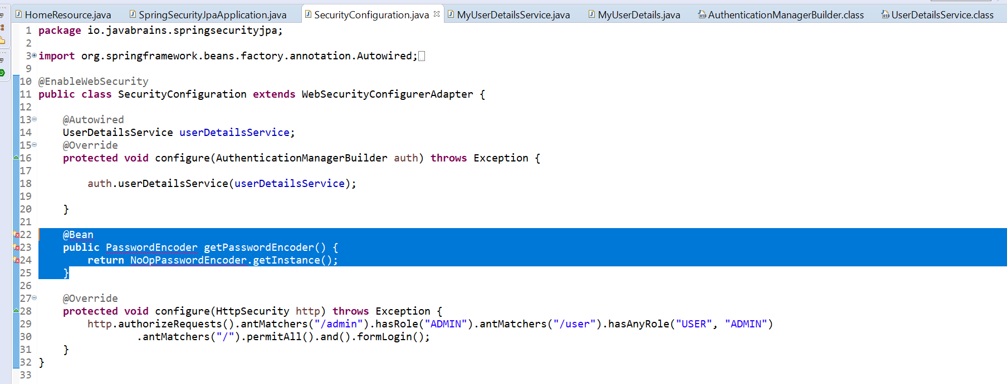

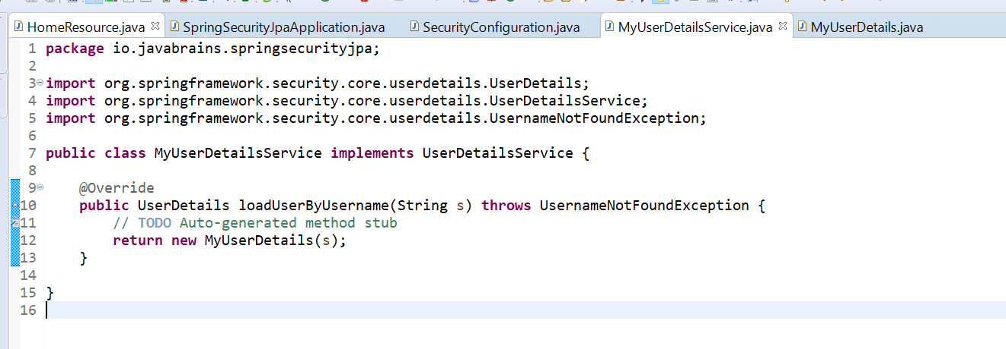

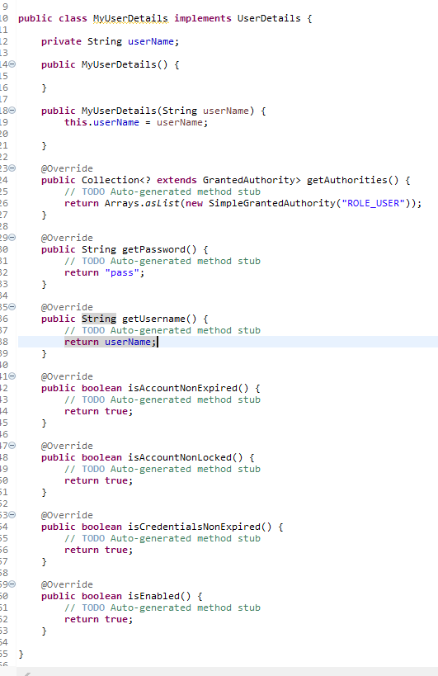

**Note:---- UserDetails will return by UserDetailsService**

**Note:**

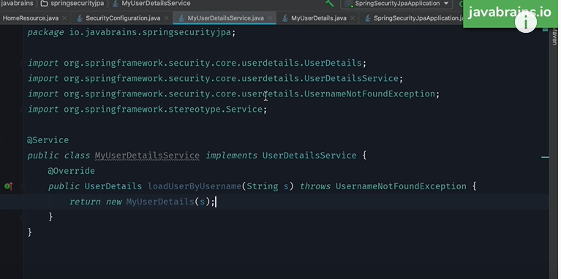

loadUserByUserName will connect to some data source and it will return UserDetails to spring security

=====================================**===connect using jpa====================**

**How does it know where the database lies**

**Spring jpa needs to know where the database is**

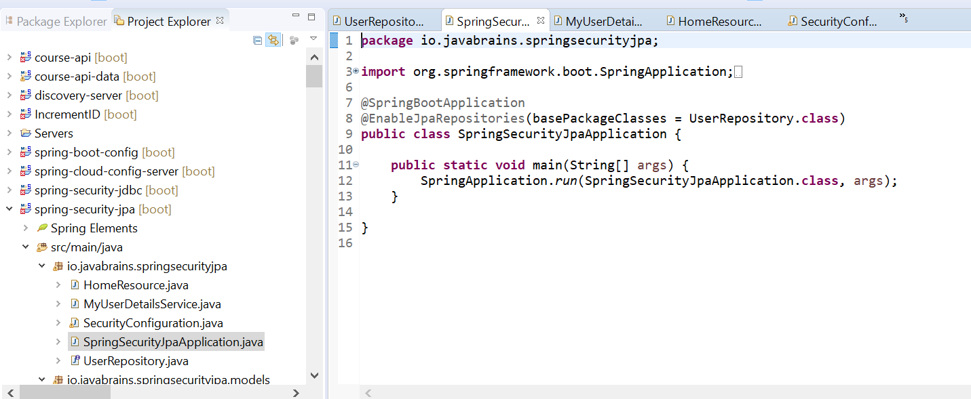

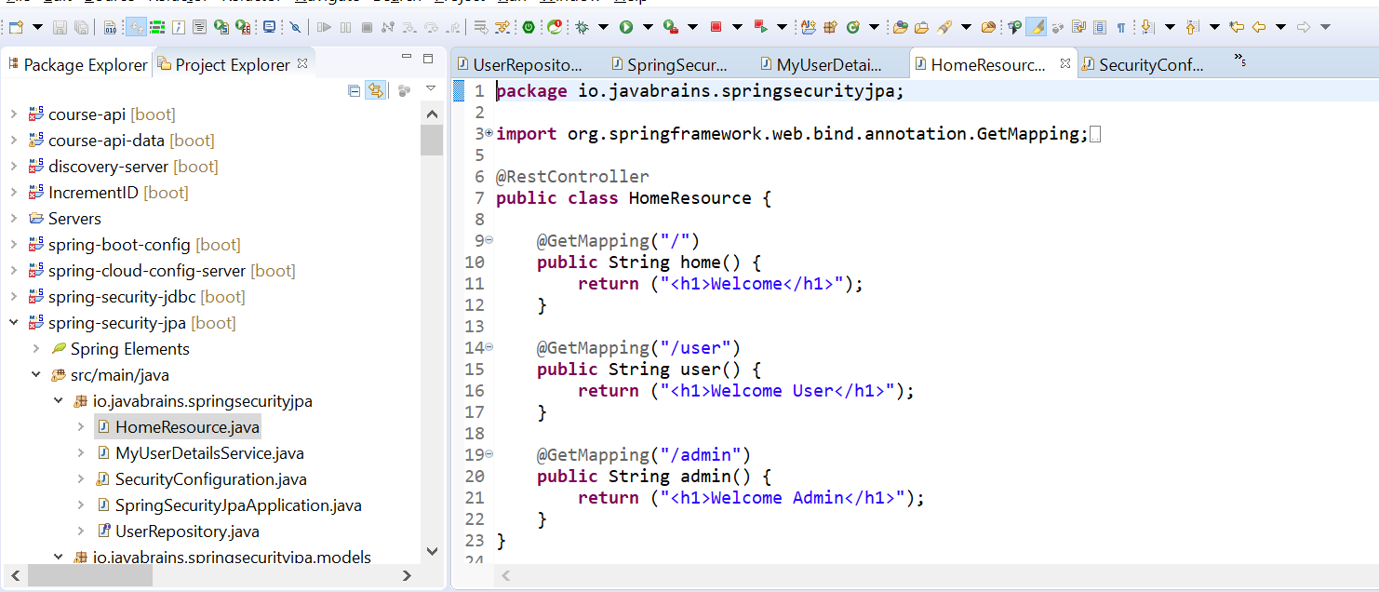

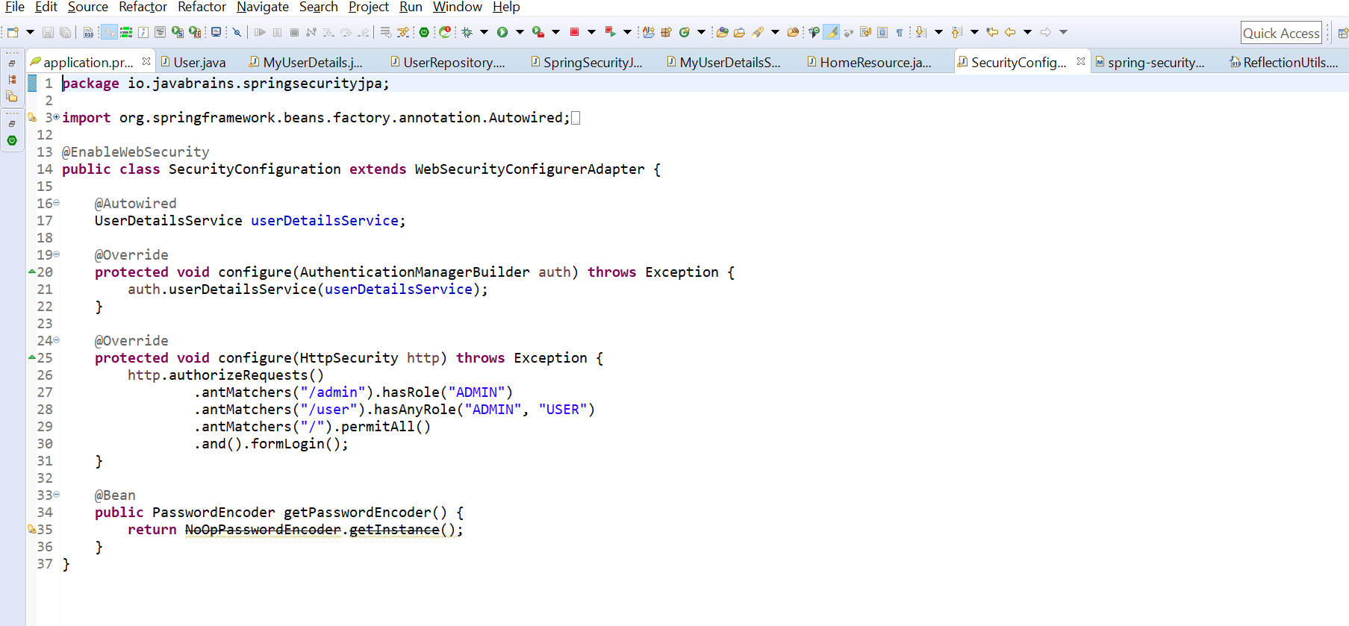

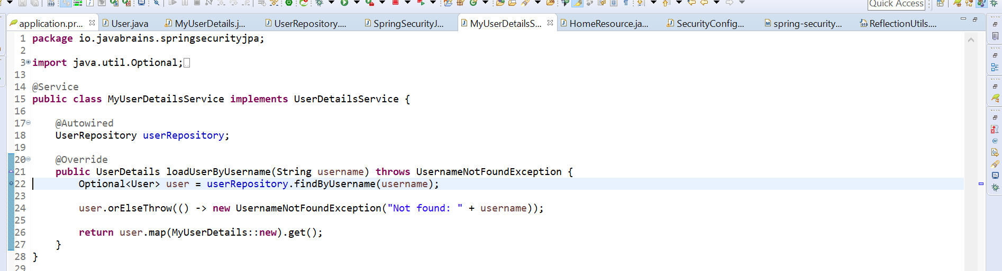

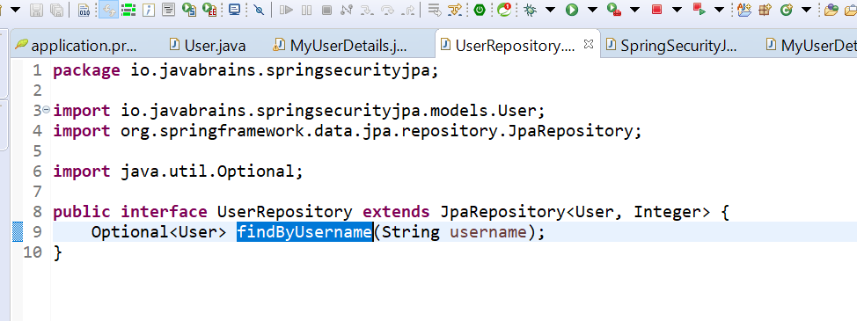

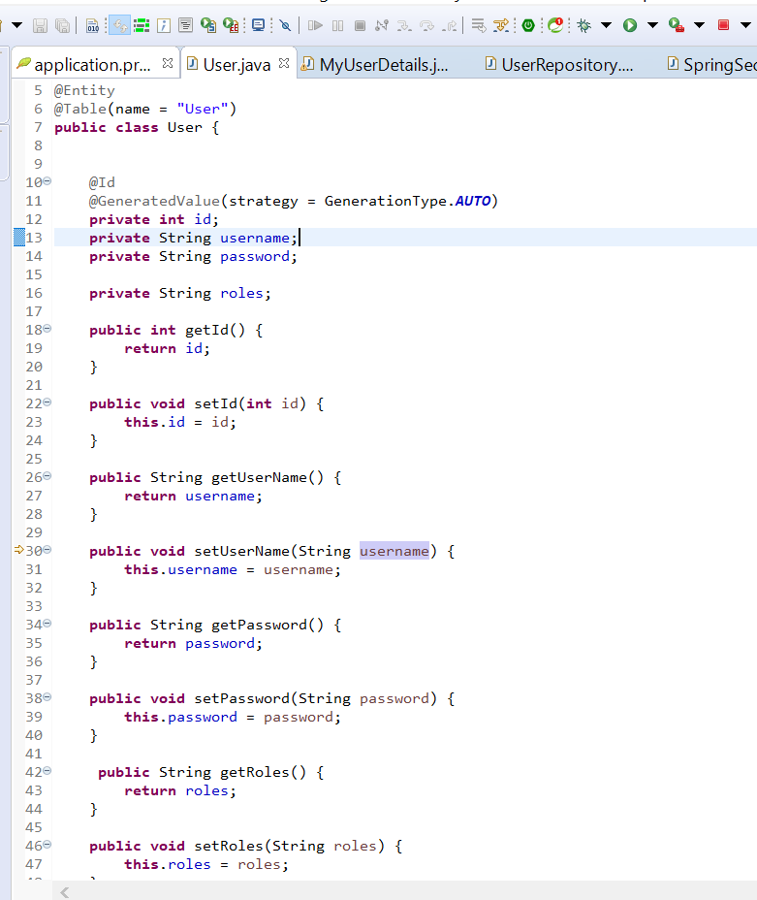

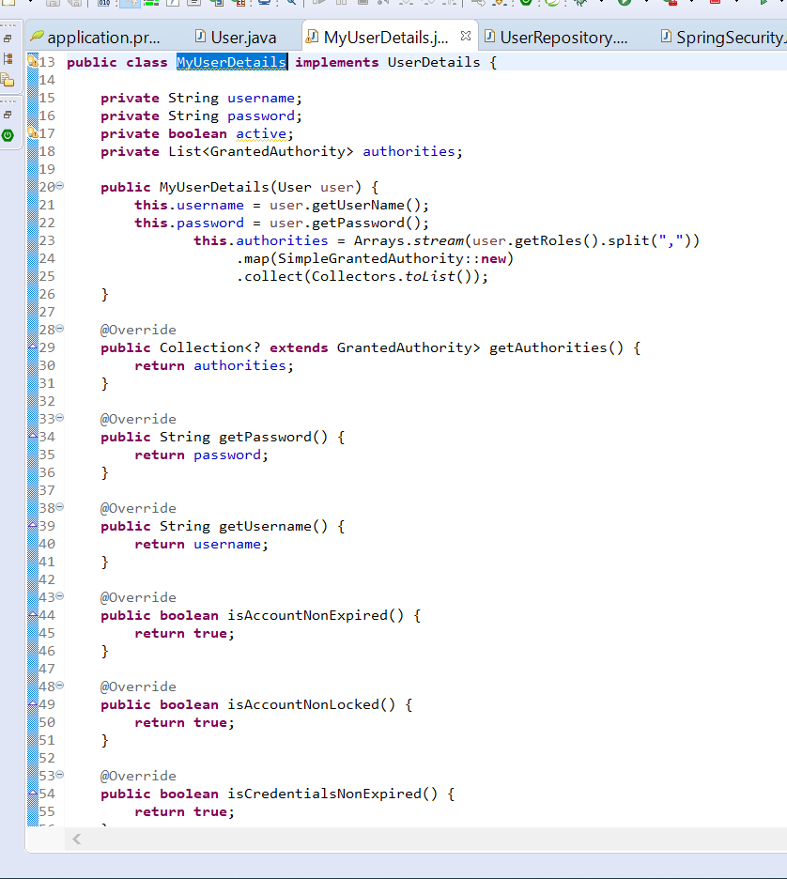

We need to return UserDetailsService to spring security and data from jpa will set to UserDetails which will return to spring security and spring security will match it then for authentication

Spring security ldap

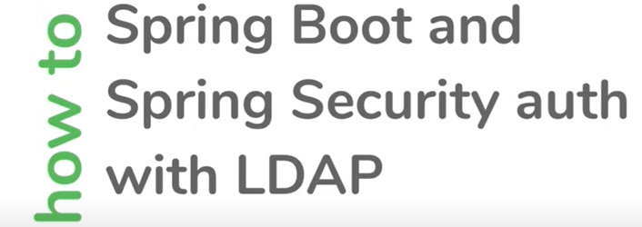

LDAP :- lightweight directory access protocol

Typically used for storing department info

Ldap:--- a directory of user to authenticate and authorize

LDAP (**Lightweight Directory Access Protocol**) is an open and cross platform protocol used for directory services authentication. LDAP provides the communication language that applications use to communicate with other directory services servers

**Requirement :-** spring security to connect to ldap server to get user info from ldap and authenticate against ldap

Note:--- spring security know how to connect to ldap

**Step 1 :- adding dependency**

in order to connect with ldap server we need ldap server

Here we are using in memory ldap server

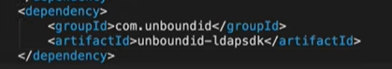

This will setup local instance of ldap

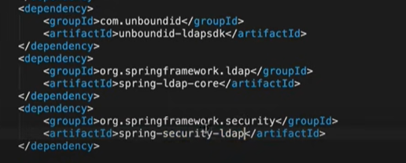

This represent a local instance of ldap is running but we also need to add some user to ldap

**Way to configure ldap instance to spring boot**

There are couple of properties we need to add in application.properties to tell ldap what need to do

1. Configure port number where local instance of ldap need to run

Ldif:----ldap data interchange format

**In ldif format we can add data**

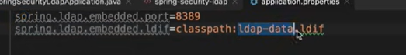

User data example link:--https://spring.io/guides/gs/authenticating-ldap/

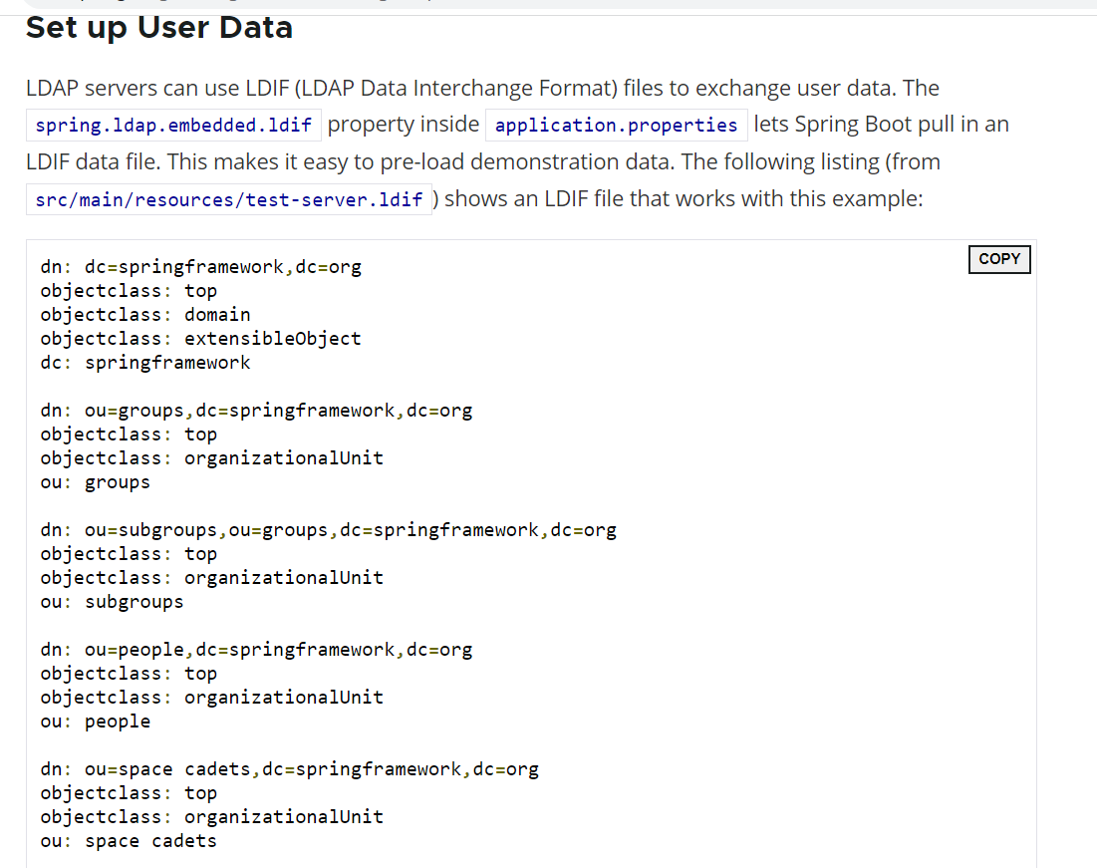

**Note:**

**We have encoded password , user name and user id**

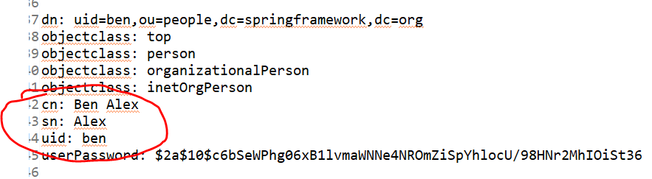

**Requirement:--- spring security will authenticate user against ldap data**

**Step 2:--- add in application.properties**

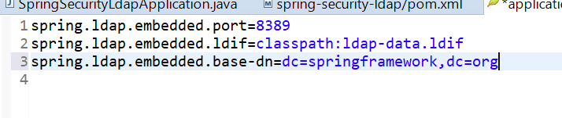

* Third property will tell ldap what the root node is think like that what is hierarchy like a tree

* Org is root node and springframework below it and everything is configured under that

* Dc value can be different also . It don’t carry any significance here

**Step 3:-**

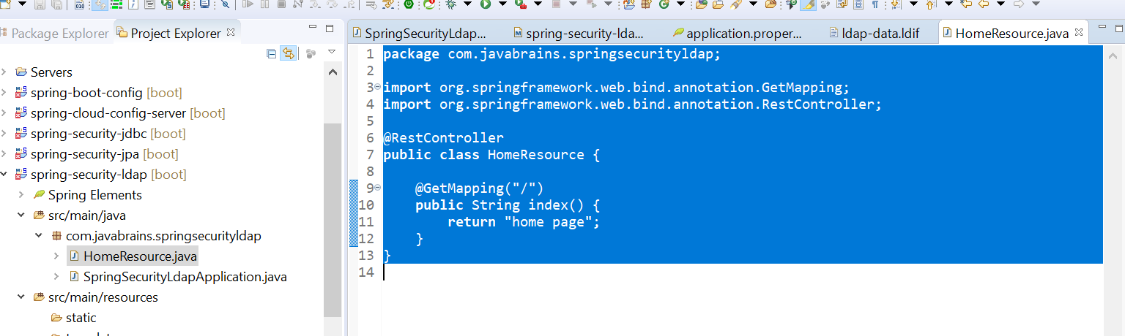

**Step 4- how to tell spring security to connect with ldap and authenticate it**

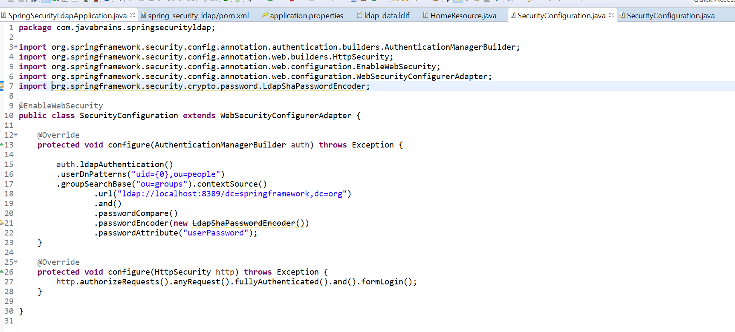

We are telling spring security how is ldap data structured

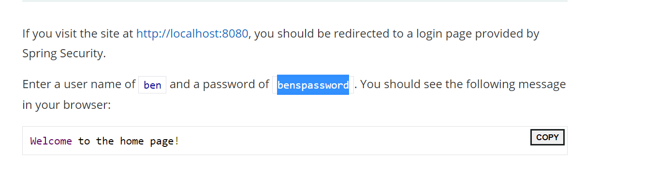

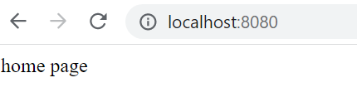

What is JWT authorization

**JWT :---- Json Web Token**

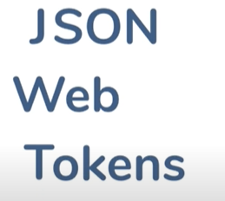

**JWT also become very popular in terms of MS**

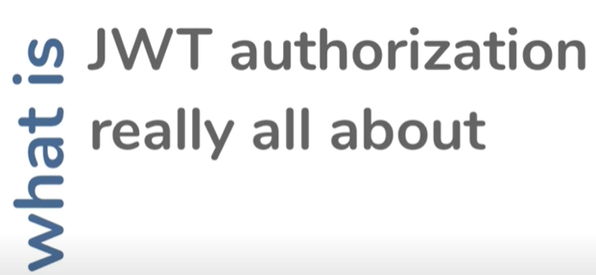

**JWT is usually pronounced as Jawt**

**The idea behind JWT to create a standard way for two parties to communicate securely**

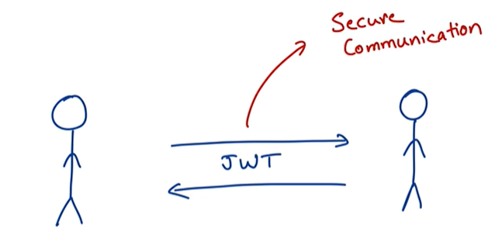



which outline how JWT should be structured

What RFC 7519?

[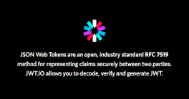](https://www.google.com/search?rlz=1C1GCEA_enIN806IN806&sxsrf=APq-WBtLLu_igCyh54-VNDS7P9lVvL-8AQ:1648627041322&q=What+RFC+7519?&tbm=isch&source=iu&ictx=1&vet=1&fir=GJG8_Ar2E9q8QM%252ChKfgMNIes8AESM%252C_&usg=AI4_-kR_GcV-zThXDKcVKp5xDAHj1oW3Vg&sa=X&ved=2ahUKEwjV0Kipru32AhX_zzgGHSGmDnMQ9QF6BAgUEAE#imgrc=GJG8_Ar2E9q8QM)

**JSON Web Token (JWT)** is an open standard (RFC 7519) that defines a compact and self-contained way for securely transmitting information between parties as a JSON object. This information can be verified and trusted because it is digitally signed.



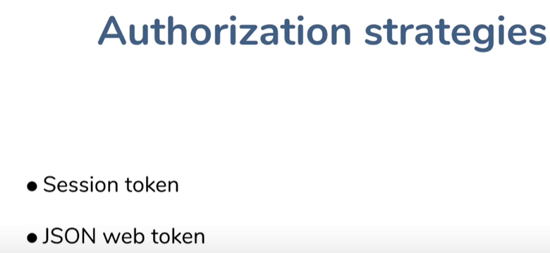

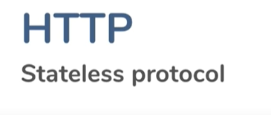

No state is maintained over network

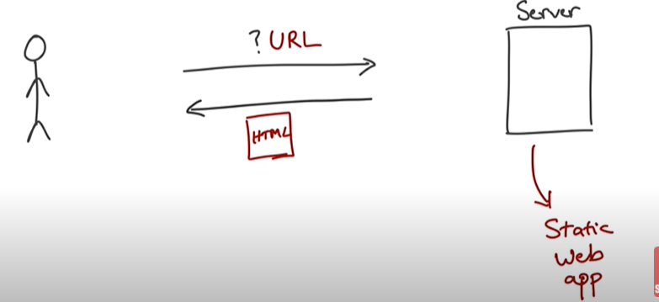

**Here server don’t need to remember the previous request in this state.**

**If the sever page is static no problem**

**Problem:-----** when the server response is dynamic and it depends who the user is

**In this case we need to tell the server who we are**

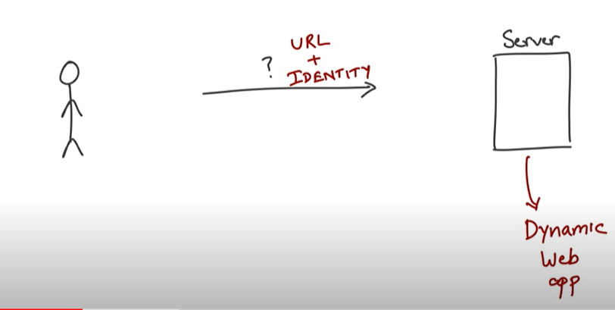

**Example**

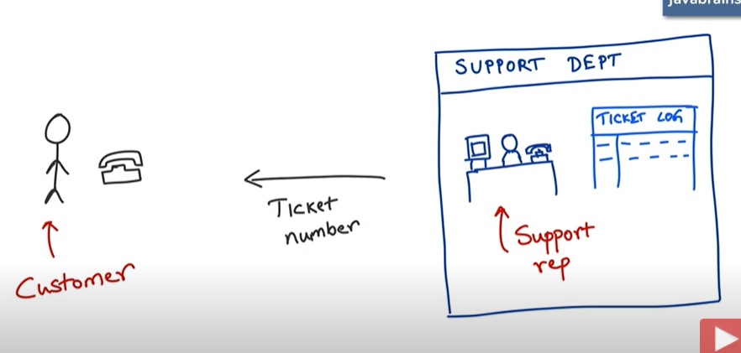

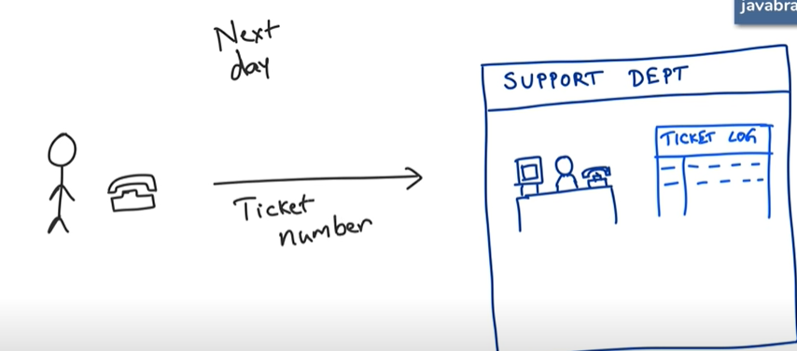

**Support team will give ticket number to customer. Next time customer will ask from support team using ticket number**

**JWT example :---- authentication using session token**

**When u authenticate a server create a session and keep track of itself, it create a session id associate with that session and give back to u**

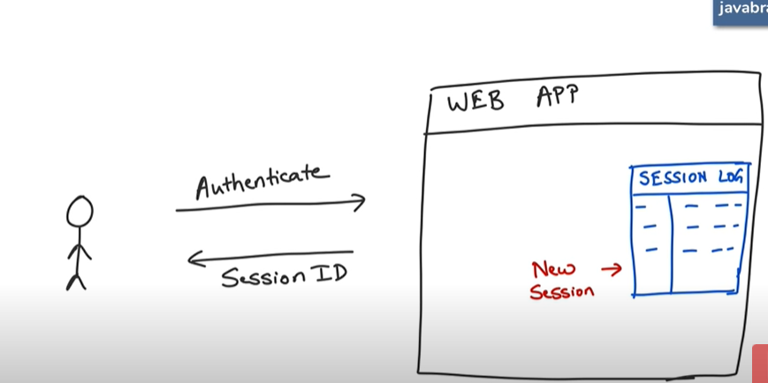

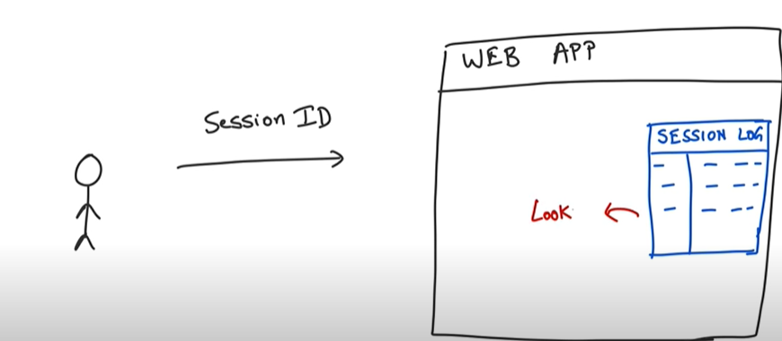

**Client passes this session id with every request and the server know who the client is**

**Note:---- sent back session id as cookie so session id automatically get added to session header**

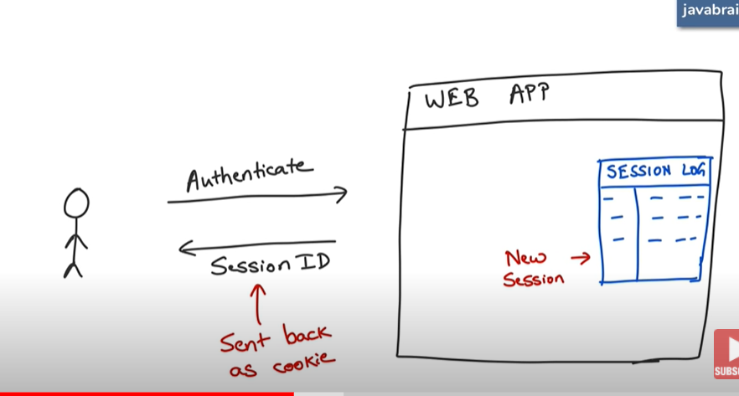

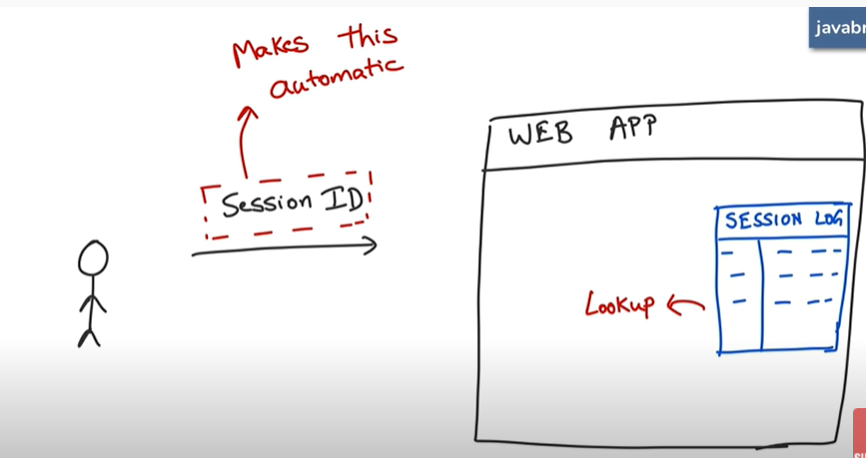

**There are few problem with this approach and that’s why jwt comes in**

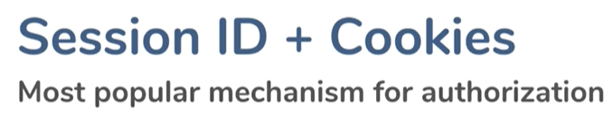

Lets understand wt the problem is

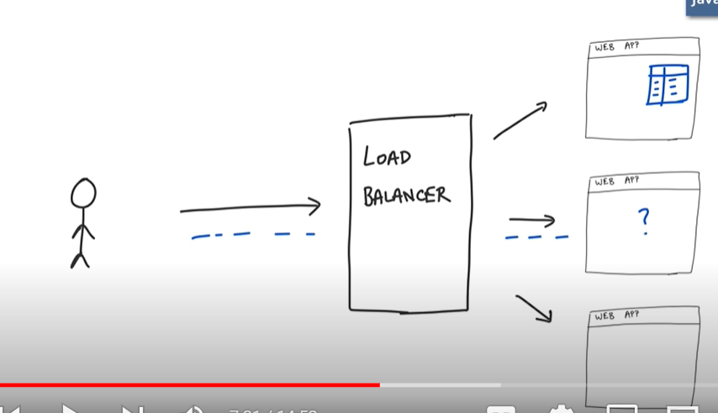

Load balancer will route the request to server 1 and sever 1 have session details of client but next time load balancer route the request to server 2 now server 2 don’t have details of client 1 so this is the problem

**Solution :-**

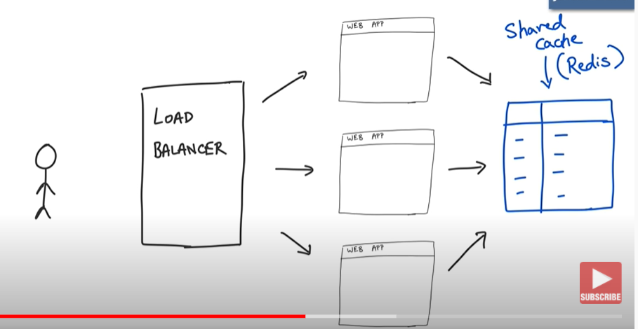

**All these server saved session to cache and they lookup session id from cache.**

**Drawback:-**

**If the redis instance down all the session will get down**

**Note**

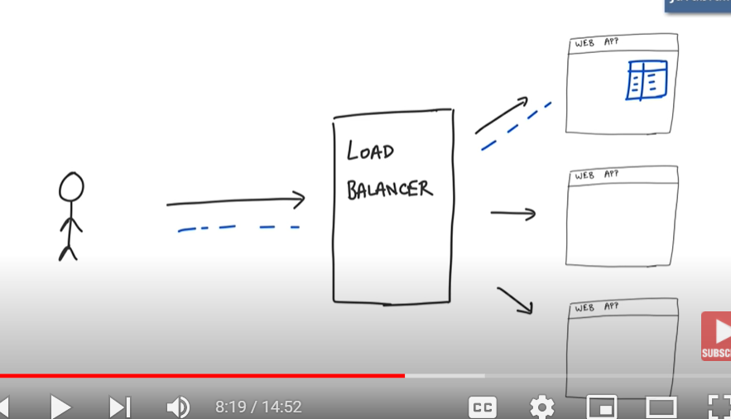

**They follow sticky session pattern**

Sticky session refers to **the feature of many commercial load balancing solutions for web-farms to route the requests for a particular session to the same physical machine that serviced the first request for that session**.

Load balancer remember the session id of server and it redirect the request to that particular server

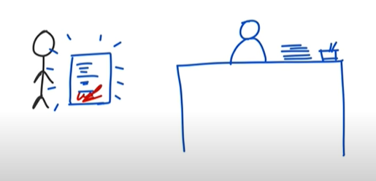

**Customer will get a piece of paper with signature and next time he need to show it**

What is JWT token?

JWT, or **JSON Web Token,** is an open standard used to **share security information between two parties — a client and a server**. Each JWT contains encoded JSON objects, including a set of claims. JWTs are signed using a cryptographic algorithm to ensure that the claims cannot be altered after the token is issued.

**JWT**

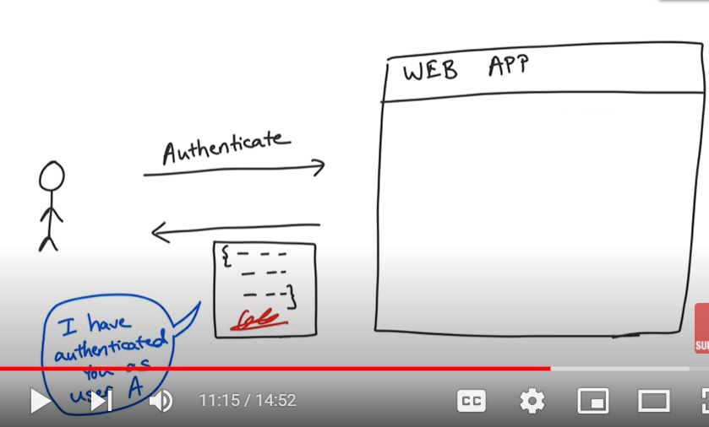

The token is json object which has all information here not id . This we called JSON web token

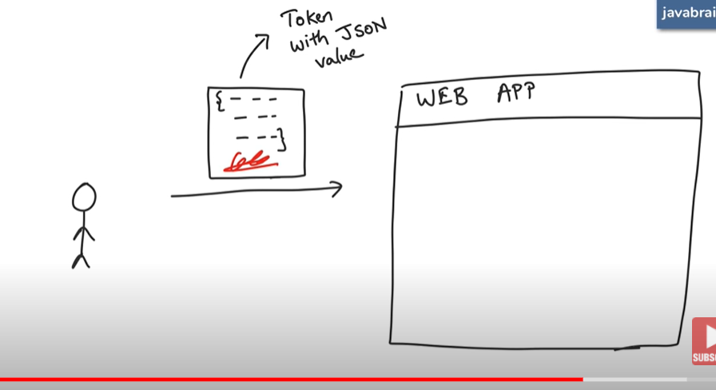

**Solution:--- the problem is solved here by signing the signature next time client request sever verfy the signature**

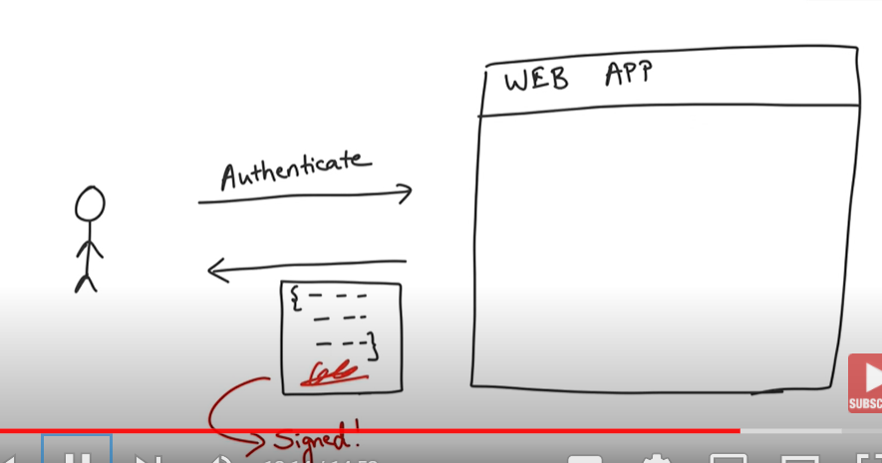

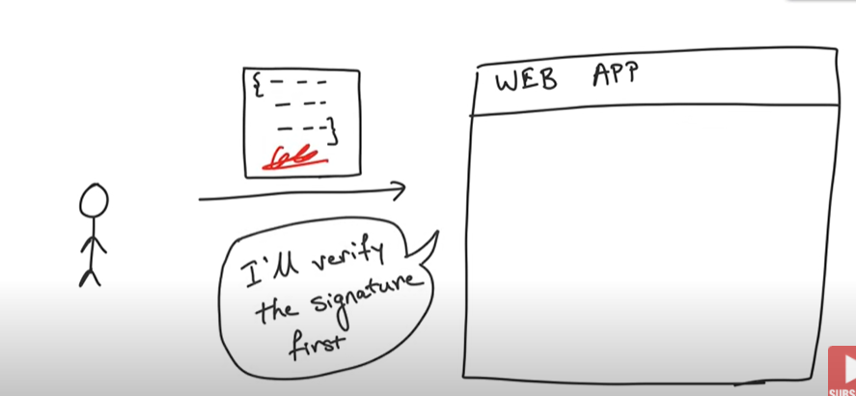

**Note:-** in jwt server will not remember info of each client

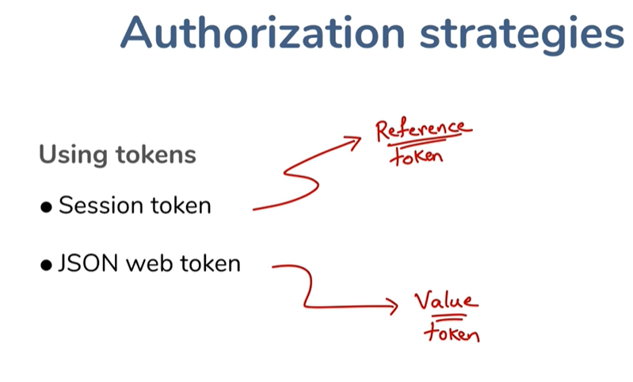

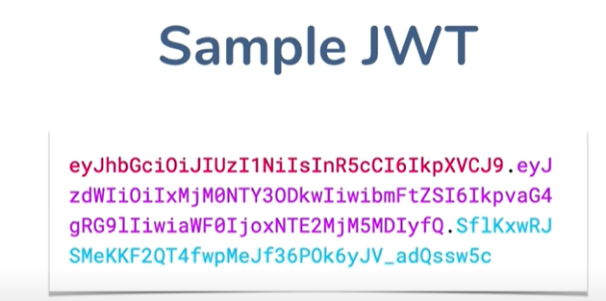

**What is structure of JWT**

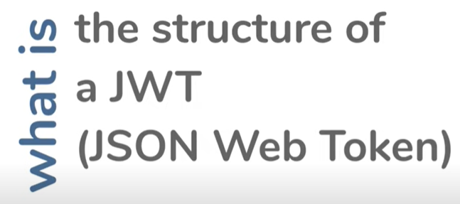

**JWT :--- token with json value**

**Note:--**- most diff jwt seperated with period and three different colur indicates three parts

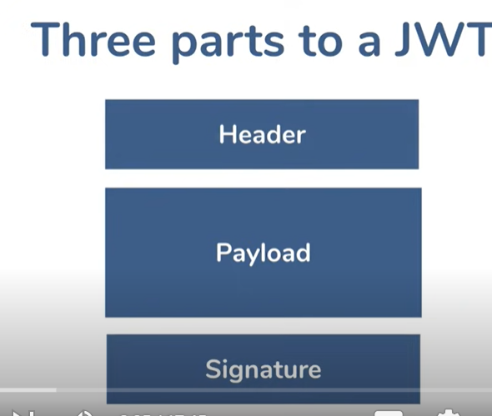

<https://jwt.io/>

Note:--- jwt is a value token

Note middle value is base 64 ecoded

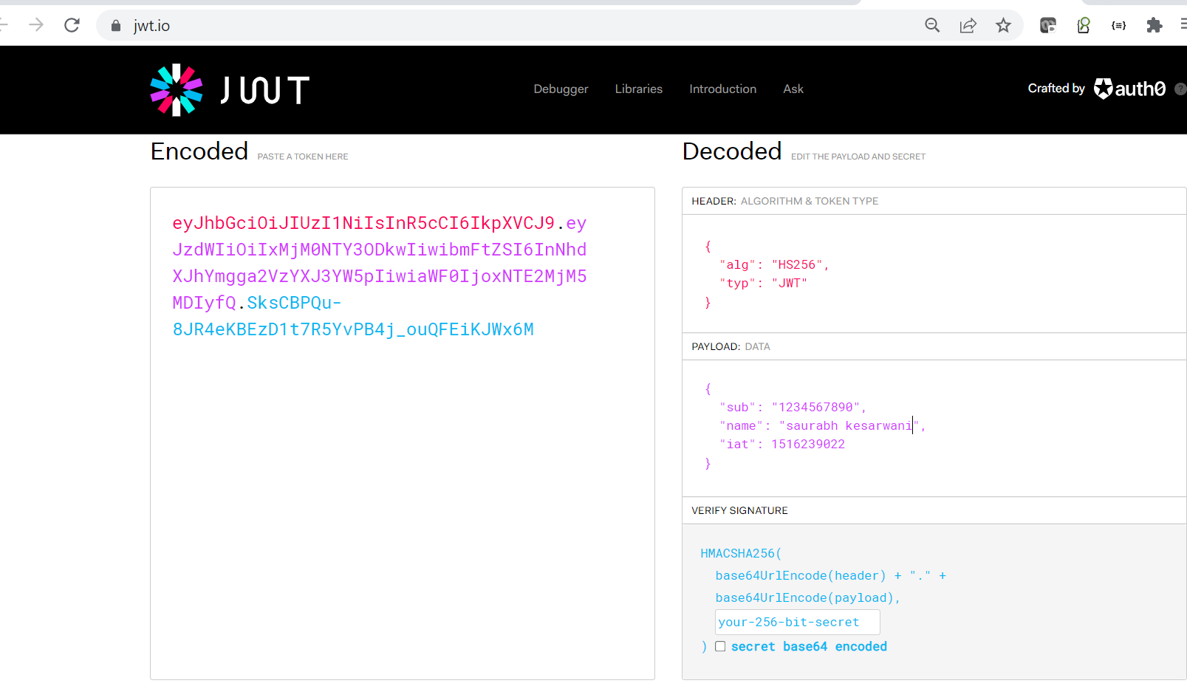

**Note:----**

* header :----- first one :---- this will tell how this value is signed-----algorithm used for sign in
* Header and payload are visible in plain text . Anyone can get it
* Signature is for the server which validates and it will attach with jwt if payload change then it is invalid since signature attached with payload now become changed

**Query:--- how to create a signature and how to validate the signature.**

**Note algorithm require a secret key which only server has**

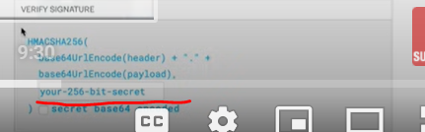

**Note:-----** the third portion only server can do.it will use header and payload and using secret it will create signature and attached to jwt which only can be validate in server only

Note:---- this is jwt which creates when authentication happens and client send it back for every subsequent request

**Let see the flow how jwt is created and exchanged**

**Remember :---**

JWT is not for authentication, jwt comes in picture for further interaction.

JWT come in picture only when the authentication is complete

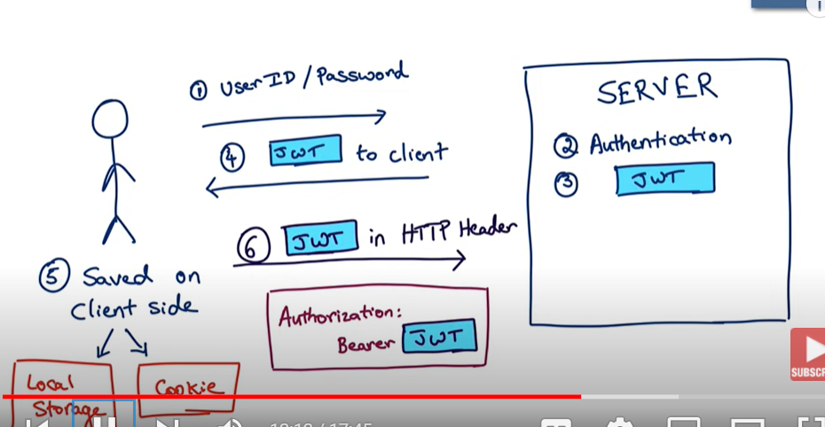

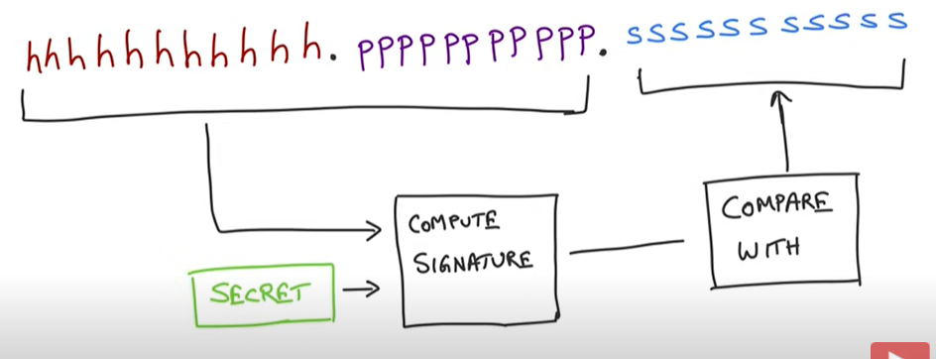

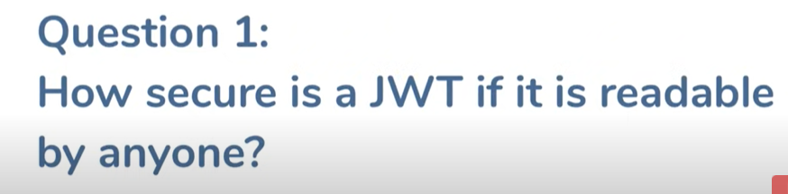

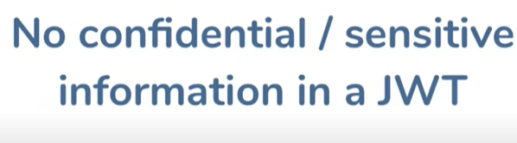

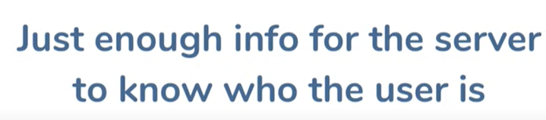

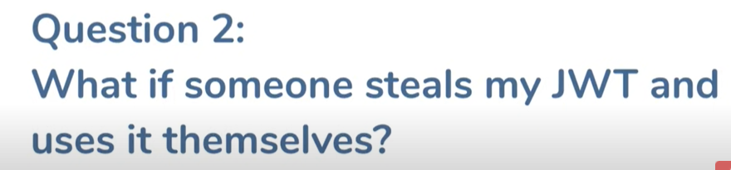

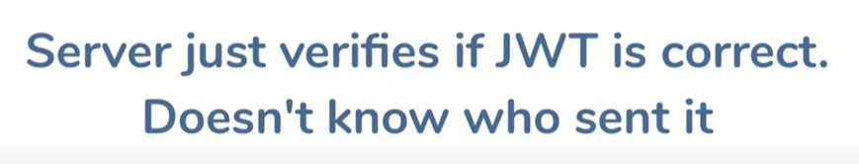

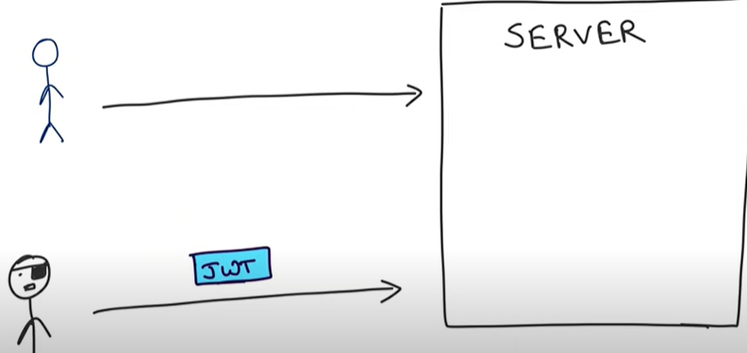

Someone can steel jwt and technically it will work we need to be careful

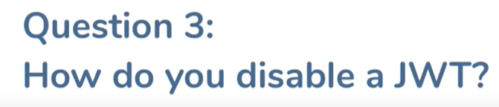

**d/a of jwt :--- visiblity is not private**

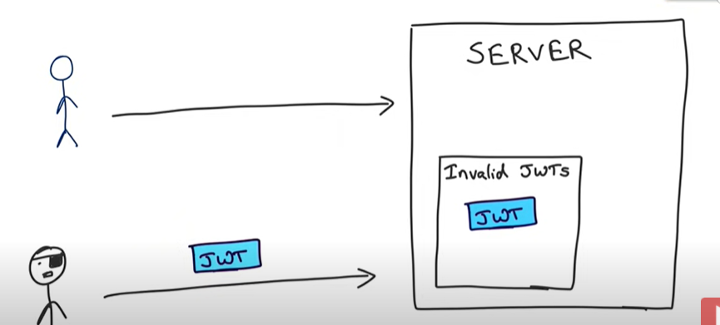

Spring security jwt from scratch

**We expose a public POST API for the authentication, and upon passing the correct credentials, it will generate a JWT**. If a user tries to access the protected API, it will allow access only if a request has a valid JWT. Validation will happen in the filter registered in the Spring Security filter chain.

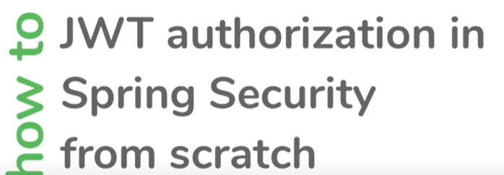

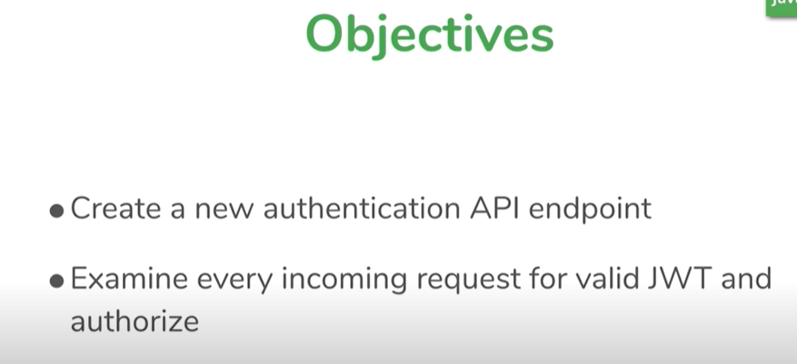

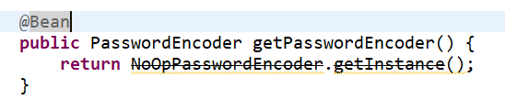

Above line means don’t do any hashing with password

**Step 1:---- so far we done basic user credential authentication**

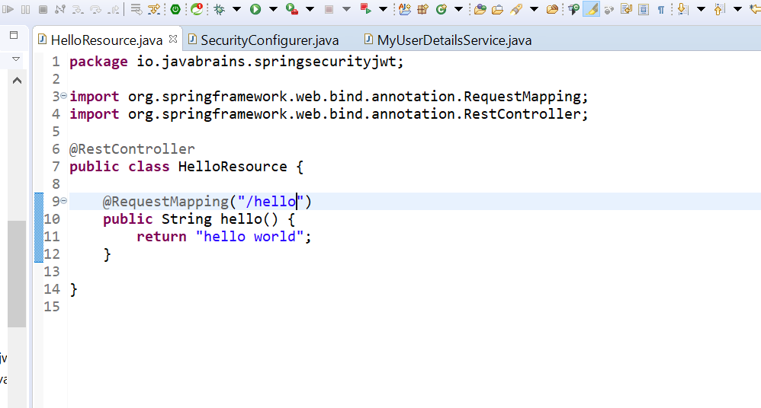

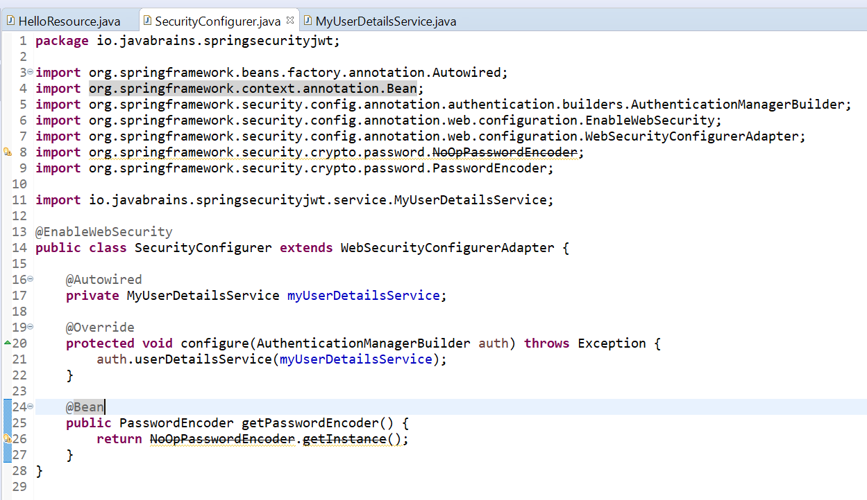

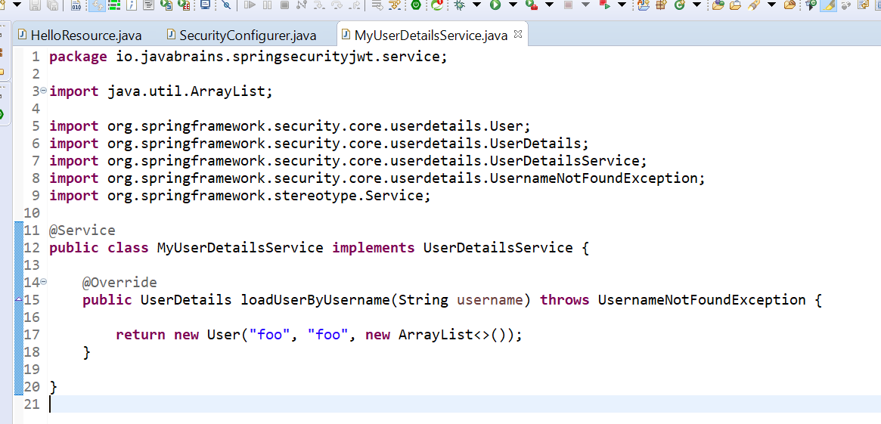

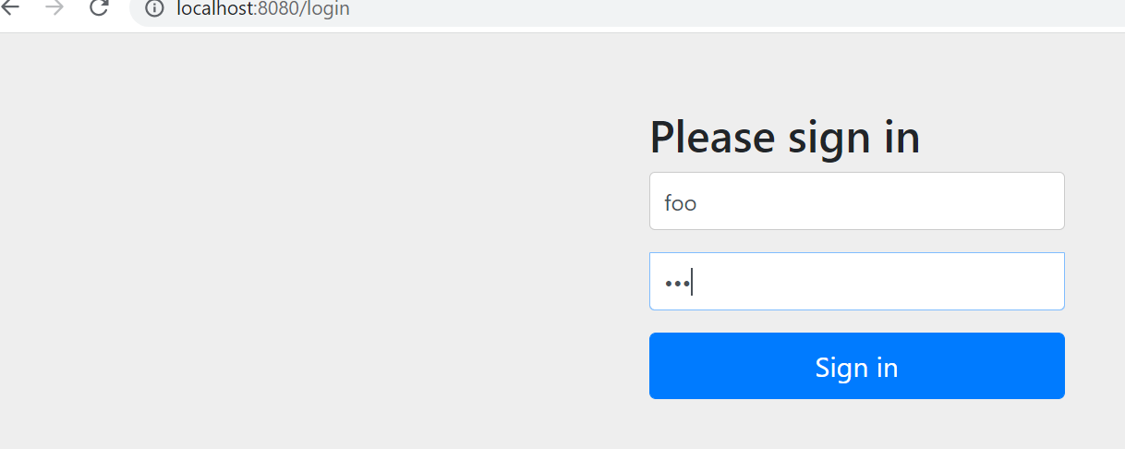

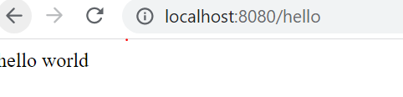

**Note:---- this is spring security project without JWT ,now we have to add JWT**

**Now we need to add jwt**

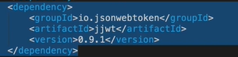

This will create jwt and also validate jwt

**Step 4**

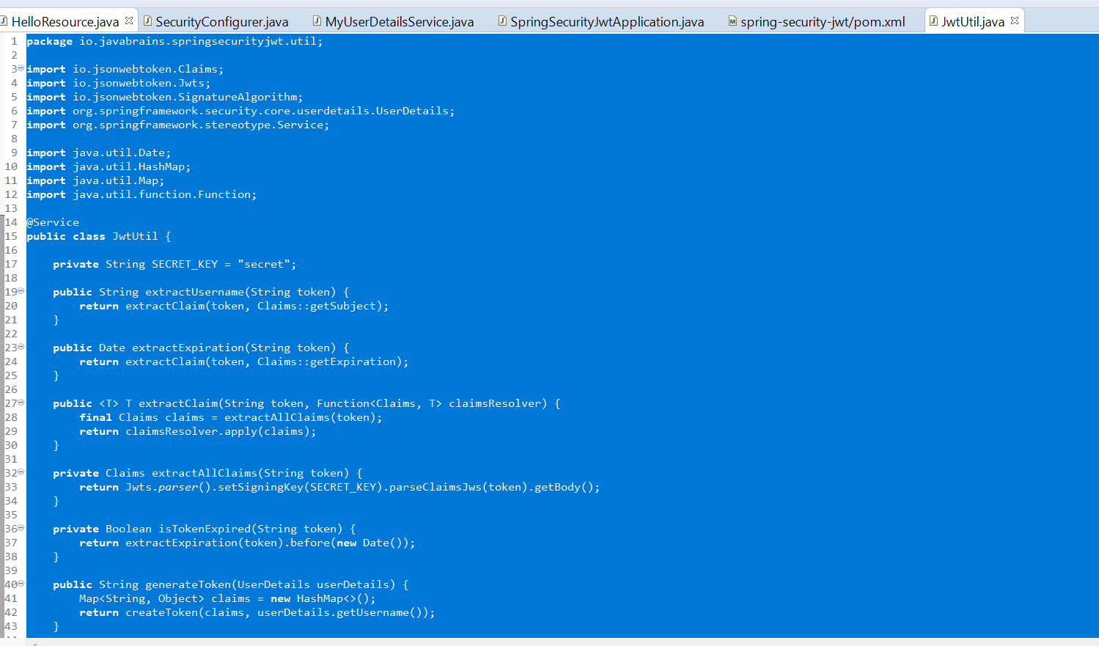

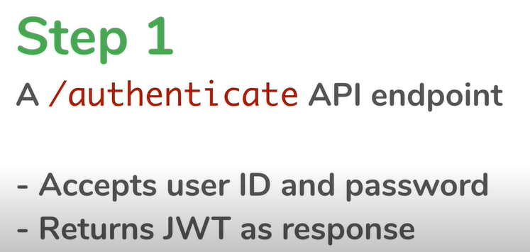

**Input structure**

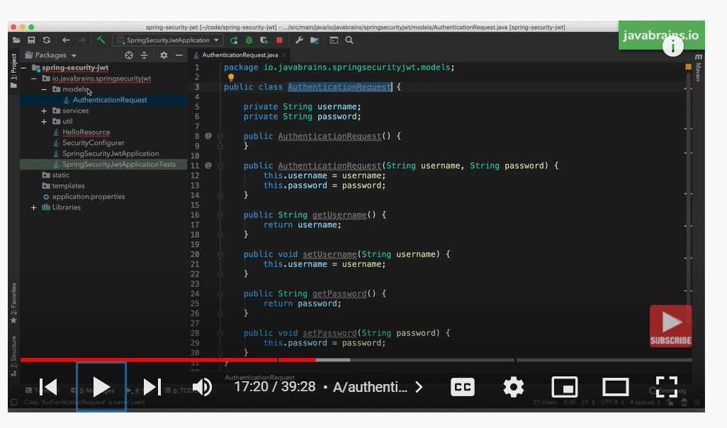

Above class will use for input parameter and also we need no arg constructor which is required for serialization

**Output structure**

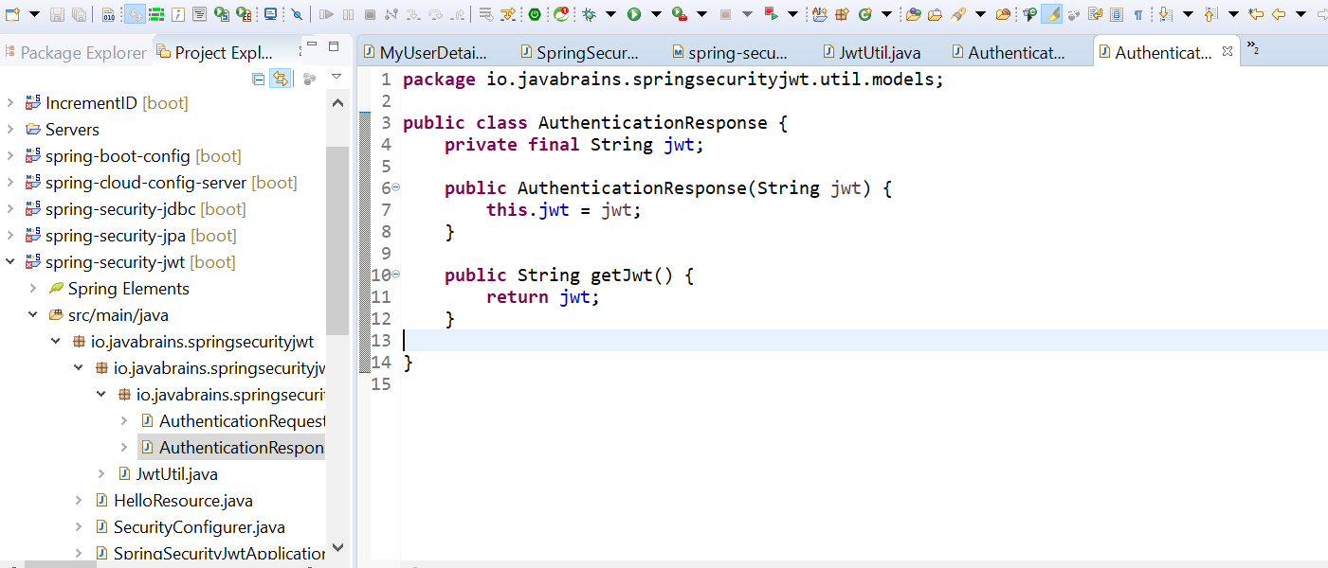

**Note :-- if the authentication is passed we need to create a jwt .in order to create jwt we need to get**

**Userdetails and that will fetch from userdetailsservice**

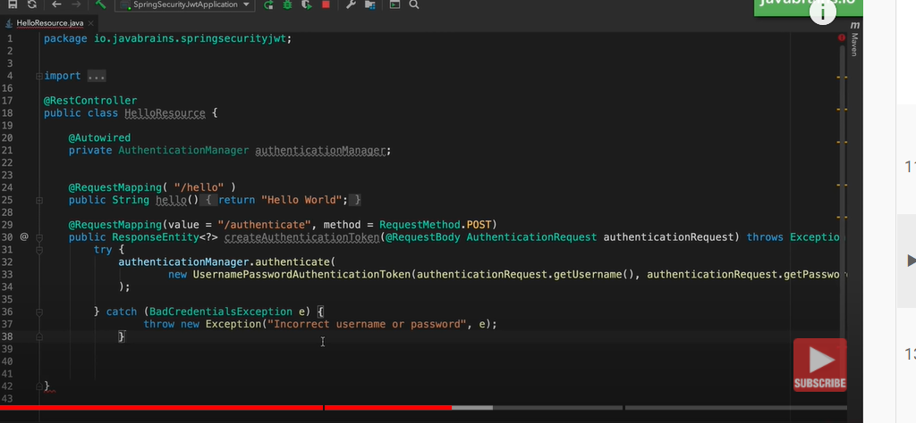

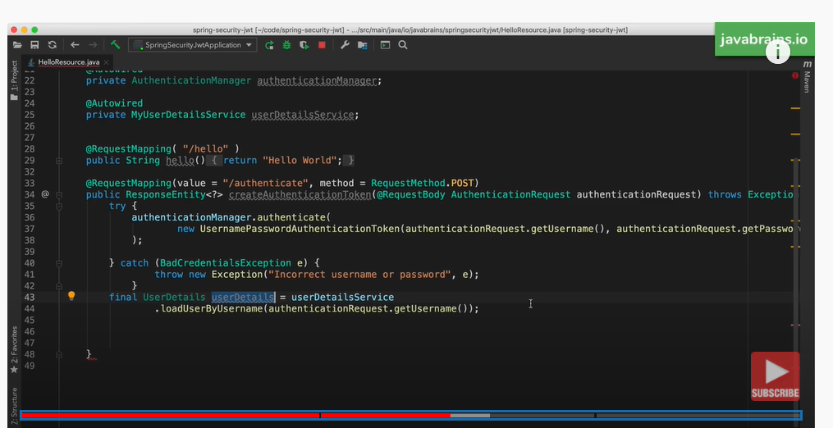

**Now we have user details we can use jwtUtil to get jwt**

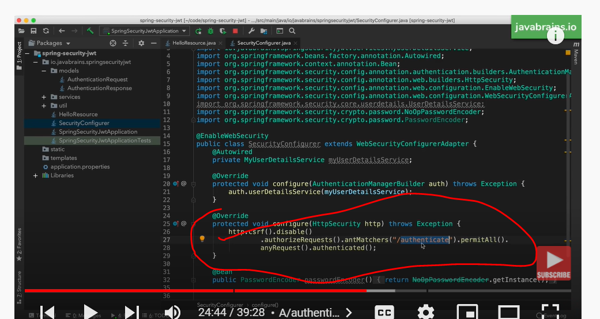

This means don’t authenticate if someone calls authenticate api and any other request need to be authenticated

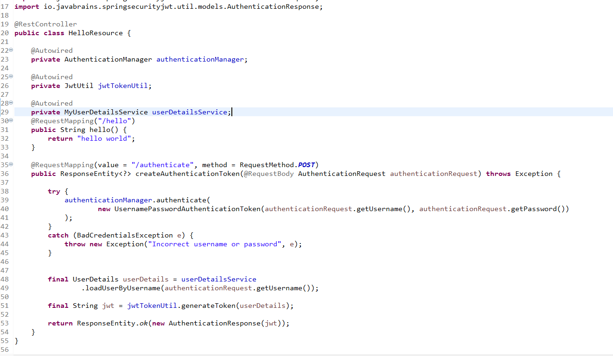

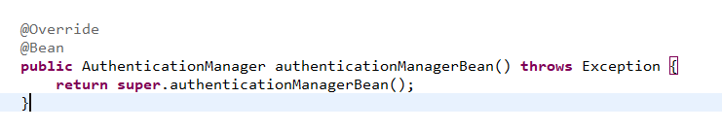

**Note: we need to use this bean in securityConfigurer in order to use AuthenticationManager in HomeResource class**

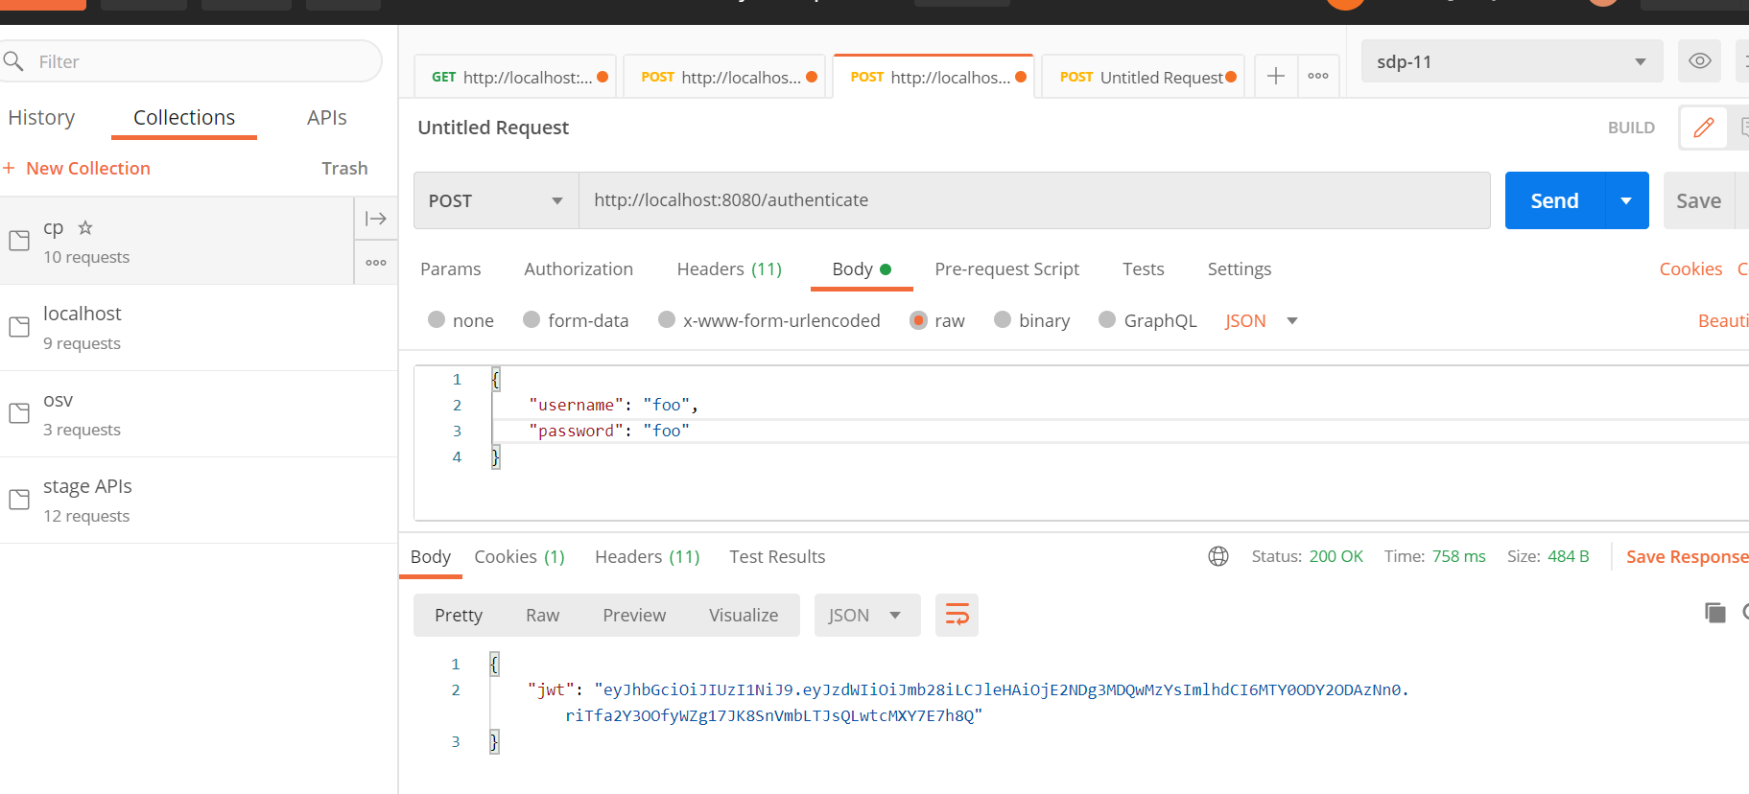

**Note:--- we pass un and pw and got a jwt response**

**Now this jwt client will hold either in local or cookies and it passes to an api on subsequent request**

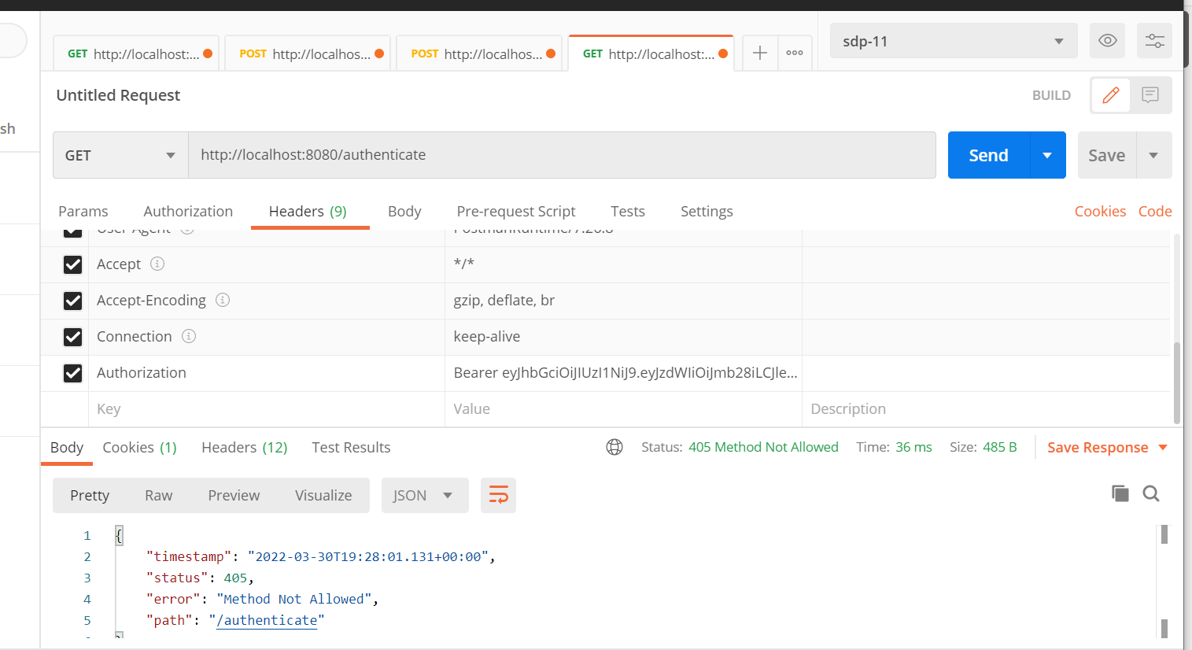

**This should work once we implemented jwt support . As of now it return jwt value but it has nothing to do with spring security**

**Now I need to tell spring security listen every request for this particular authorization**

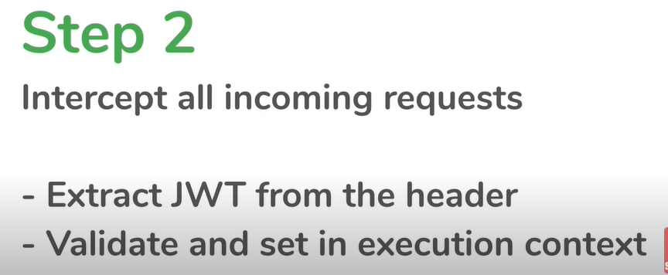

**How to do that ?**

The way to intercept request and look at header is by creating filter

Note:--- this filter will intercept every request just once and examine the request

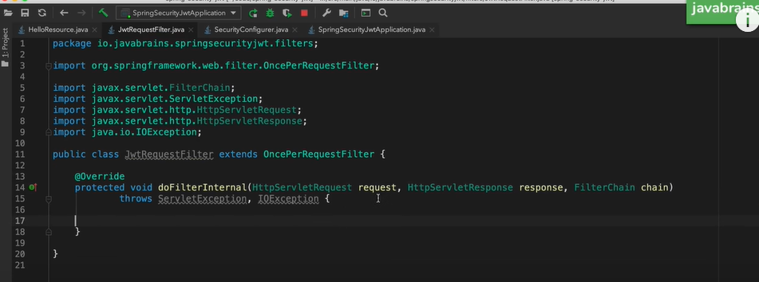

This filter will examine incoming request for jwt in the header and see if jwt is valid . If it is valid

It will get userdetails from userdetailsservice and save in securitycontext

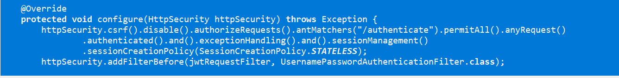

This we are saying don’t create session. Jwt should be stateless and use filter chain

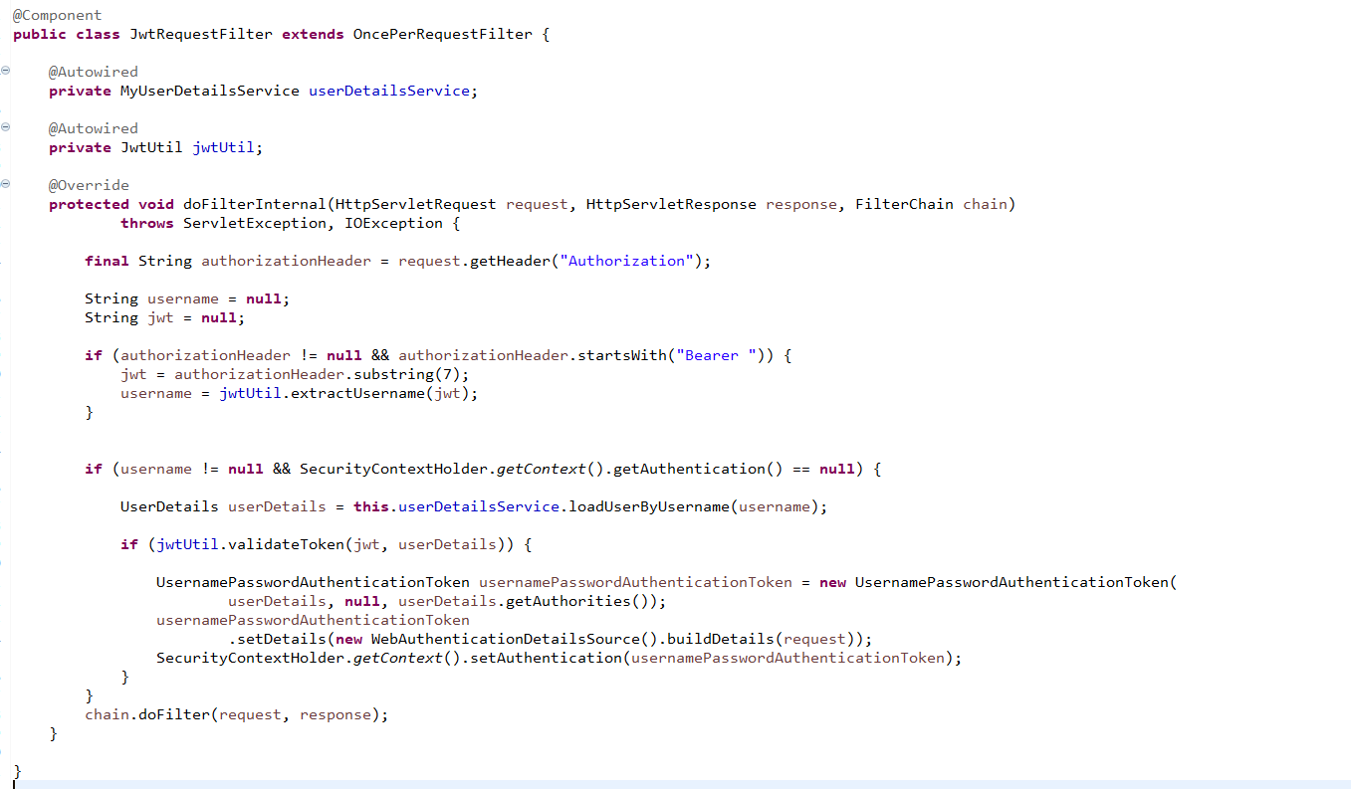

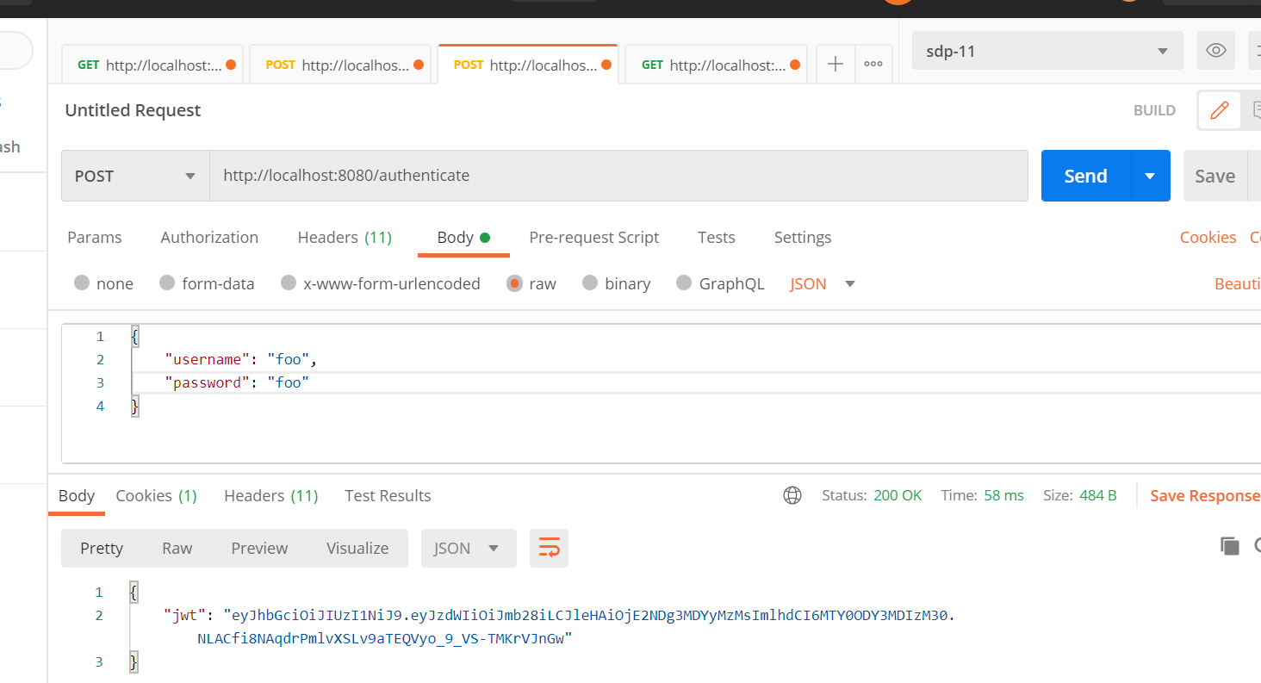

**This time it works hello api**

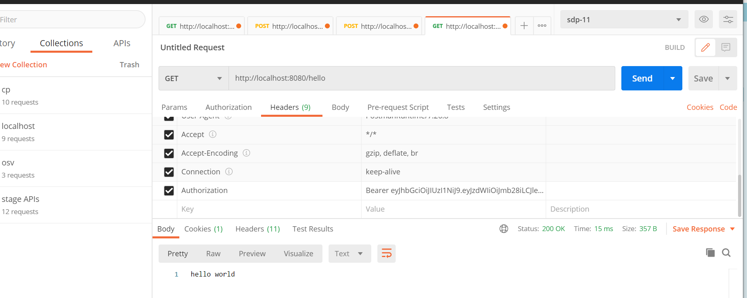

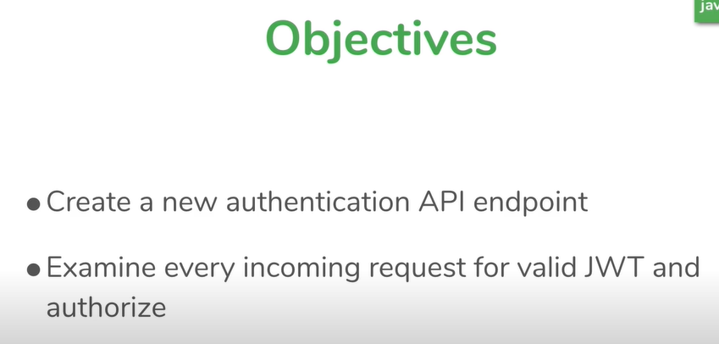

The SecurityContext is **used to store the details of the currently authenticated user, also known as a principle**. So, if you have to get the username or any other user details, you need to get this SecurityContext first. The SecurityContextHolder is a helper class, which provide access to the security context

Set jwt in security context so that rest of spring security framework doesn’t know the diff

**Oauth Tutorial**

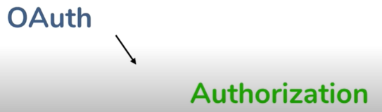

Oauth is meant for authorization not authentication

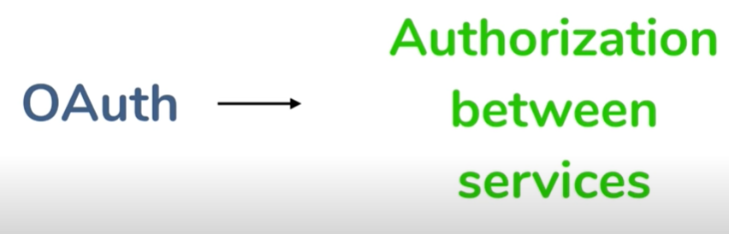

Oauth meant for service authorize to another service

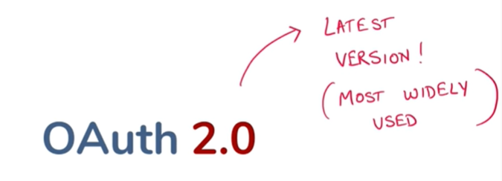

The OAuth 2.0 authorization framework is **a protocol that allows a user to grant a third-party web site or application access to the user's protected resources, without necessarily revealing their long-term credentials or even their identity**

**Example** :---photo frame website want access user photo upload in google account then using oauth it will access it

**Query :how does Oauth works**

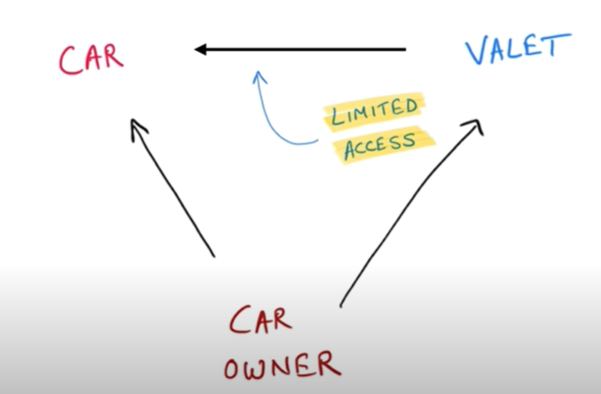

Car owner give valet person to valet key not master key and valet person have limited access.

He can only start and stop car. This is how oauth works



Step 1:--

* User can access both service
* Both service want to interact with each other but gd will not allow to Photo print app since it don’t have User credential

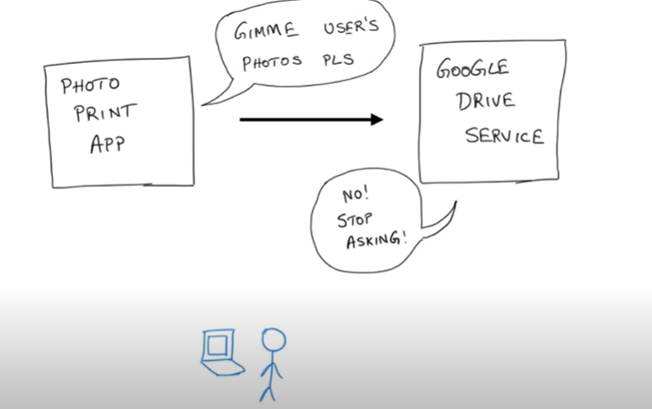



However if both the Oauth implemented the situation is little different

Google drive check with user that this person pinging me for photo access and user will allow it then google drive will send token to photo person with limited access.

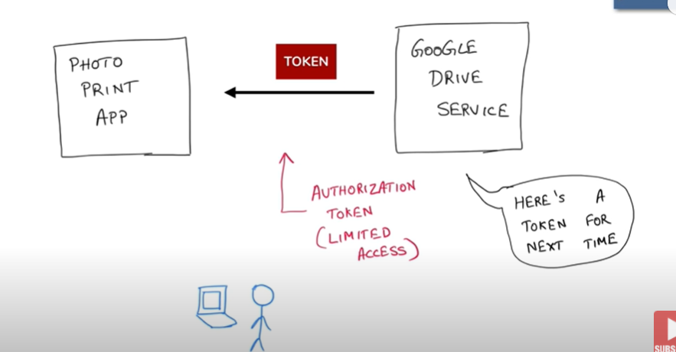

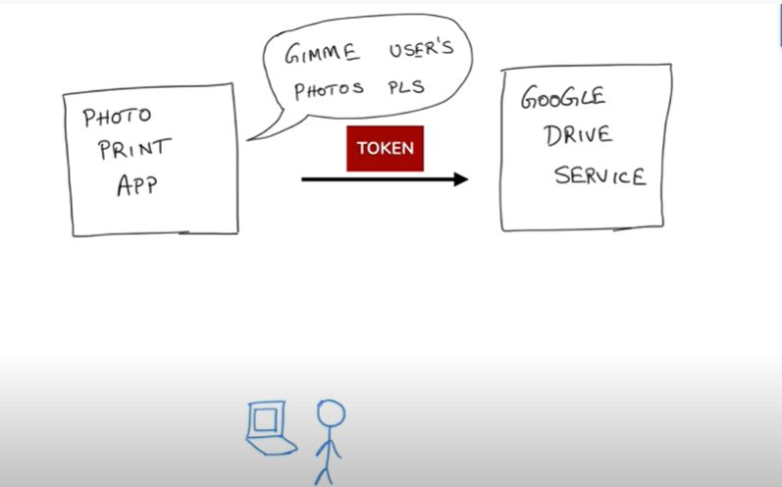

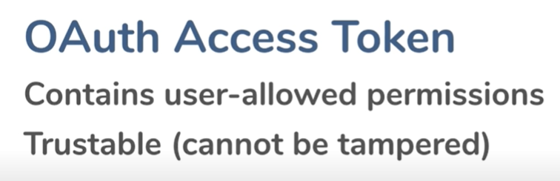

**Note:--- the token can be verified but not modified. The token format is called JWT**

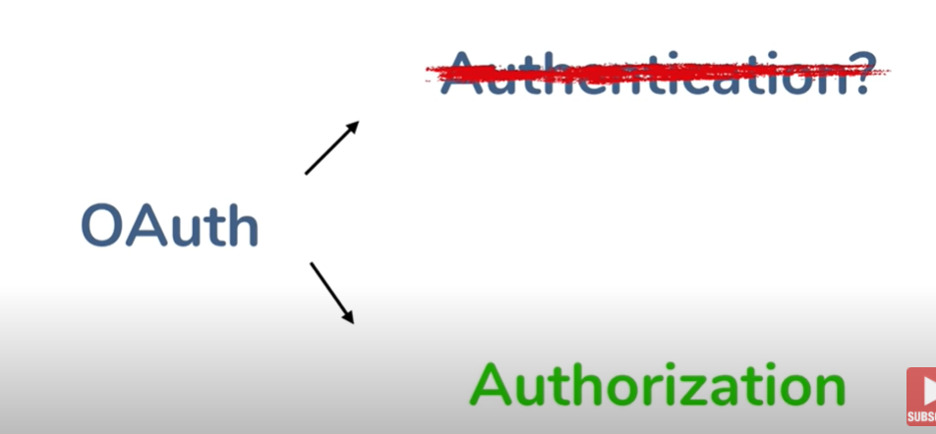

Since both the service are already authenticated. The problem is not how to authenticate.

The problem is how one service authorize to another service

Oauth Terminologies and flow explained

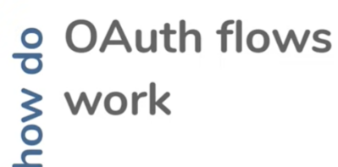

**Scenario :---**

user from one service i.e photo printing service want to access photo from another service which is google driver

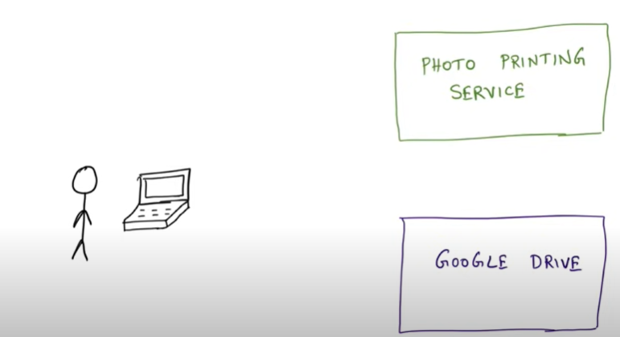

**Let see some of terminology wrt Oauth**

**1-**



In this case photo is protected resource which is not access by everyone

**Note:--**- Oauth need to allow user to access resource

2-



Resource owner is the person who has the access to photo right now.

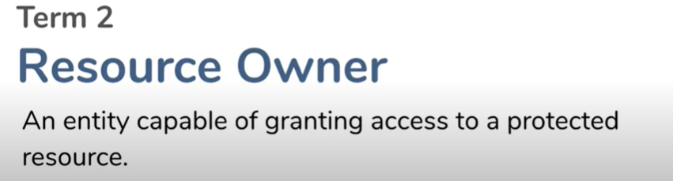

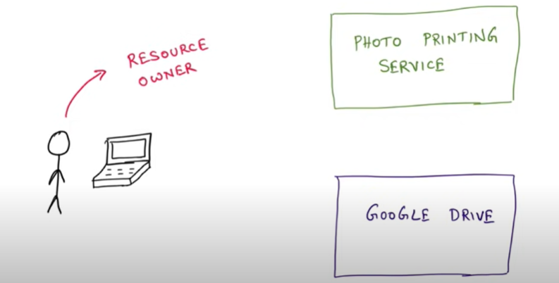

3-

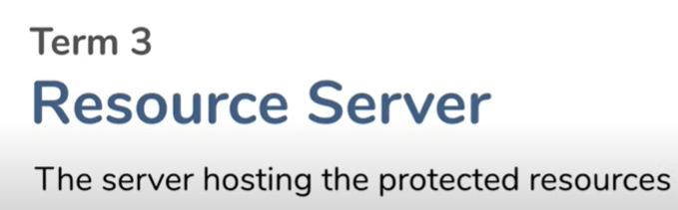

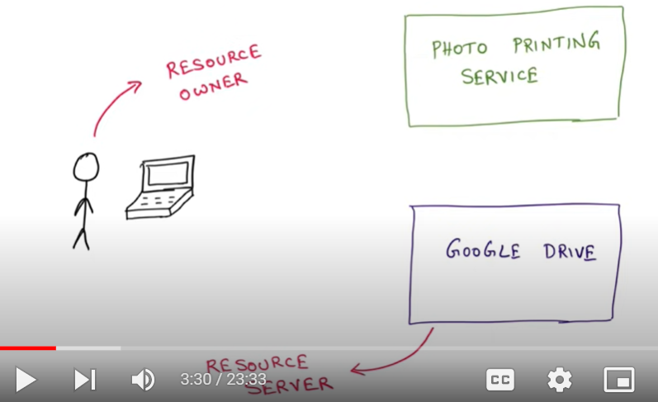

4-

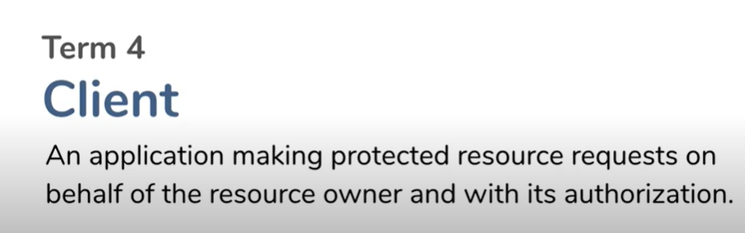

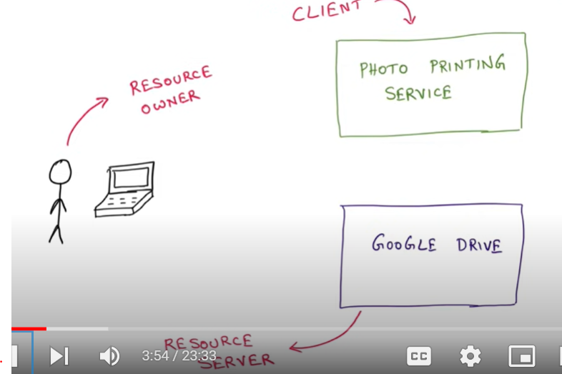

Resource owner saying , hey client get me the protected resource and so something with that

**Query**



**Solution:- the person who has the resource**

**Typically google implement Oauth.**

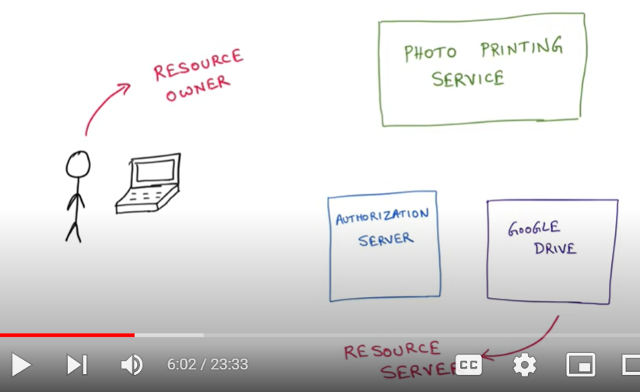

* Google implement authorization server which takes care of authorization
* Resource server and authorization server are usually coupled
* Authorization server could be separate server or it could be along with resource server

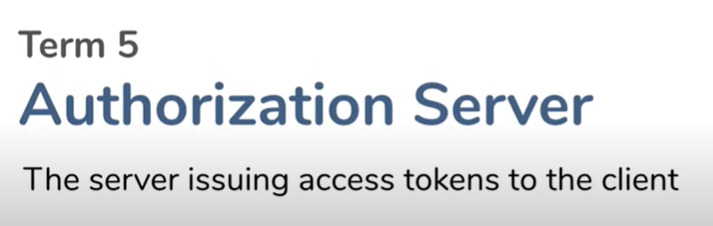

**Note : Many flow Oauth are there**

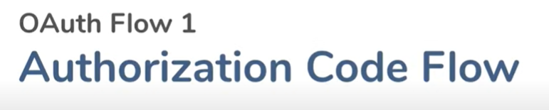

This will dance between resource owner , client and resource server



**Step 1:---**

user logged on photo printing service and tell hey my photo is on google drive .

Can you please access it and print it.

So this is resource owner telling the client access the resource in my resource server.

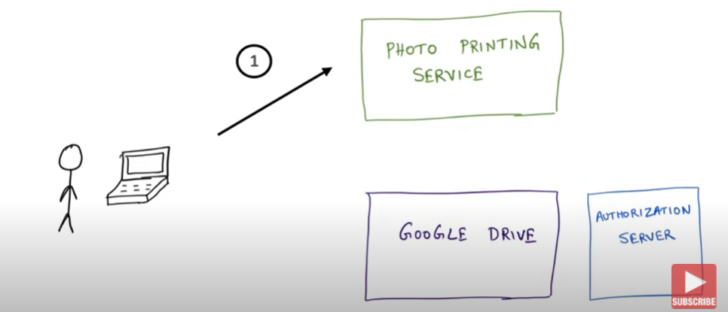

**Step 2**

Client(photo printing service) will tell I know this resource server, this guy doesn’t get me access directly, this guy uses oauth so I know that there is authorization server so first let me talk to Authorization server. Client saying to authorization server hey it me user want to access resource from resource server.

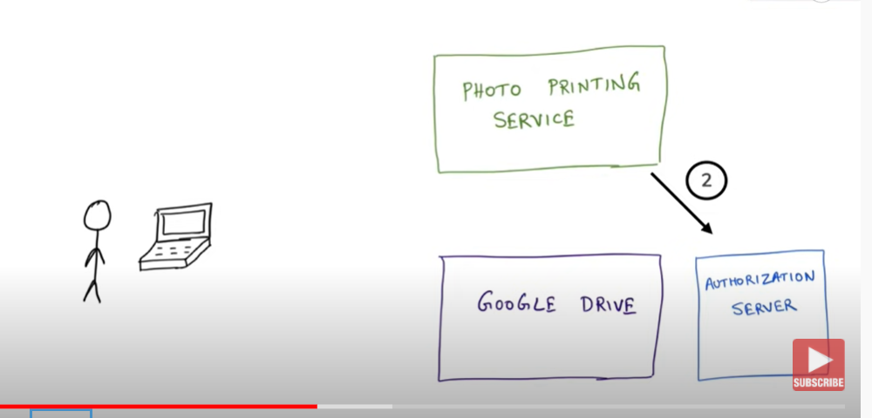

**Step 3**

Authorization server saying to client I don’t trust on u let me check with resource owner .

Authorization server asking resource owner that client want to access your file. R u cool with that, do u want to do it, it will ask not only access bit also client what all permission they want( like download photo). Resource owner will say , I have actually allow the client so go ahead and allow it

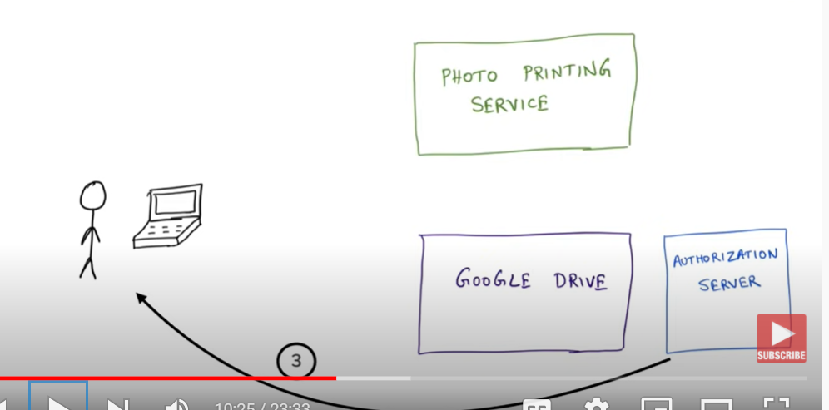

**Step 4:--**

Authorization server say now I have confirmation from resource owner

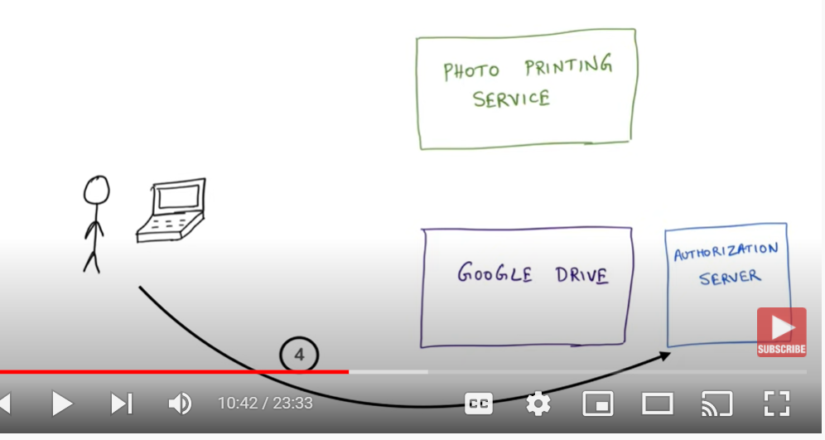

**Step 5-**

Now Authorization server can give access to client for resource. Authorization server send client auth token

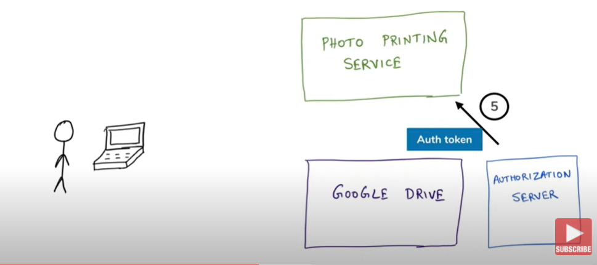

**Step 6:-**

Client uses this Auth token and sent back to authorization server and can u please give me access token

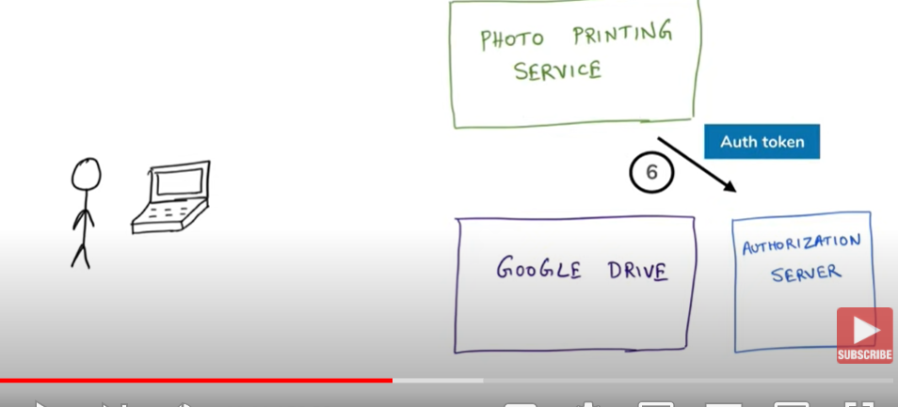

**Step 7**

authorization server says now we have done both type of exchange auth token and now we fully trust on you and I will give u this access token. Go ahead and use this access token to access resource from resource server

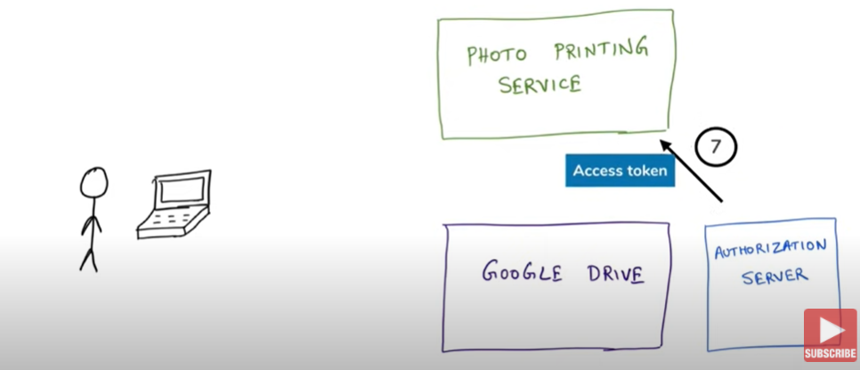

**Example :**

A person book the hotel room and receptionist give key which act as access token for room .any time u want to access it u can use key

**Step 8:--**

Now photo printing service can call the api directly with the key. Since it have access token

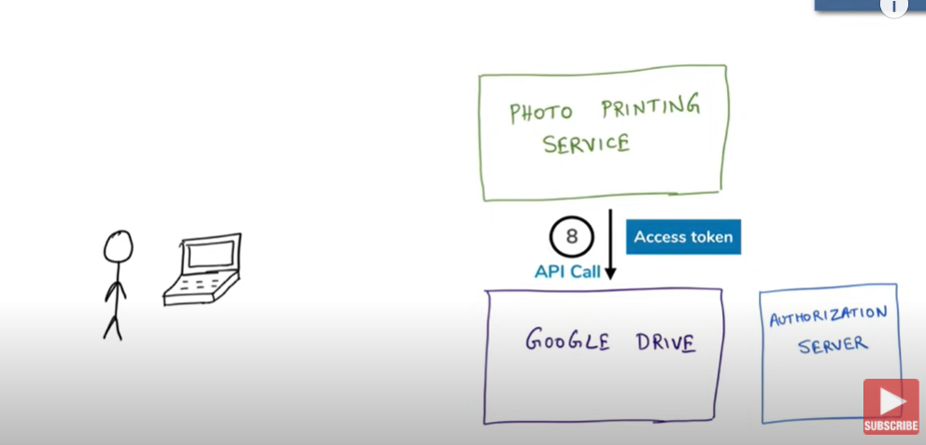

**Step 9**

Google drive validate the token and it provide the resource to client

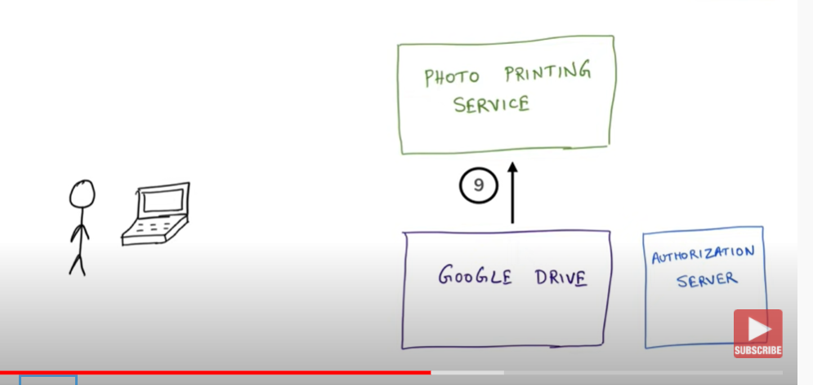

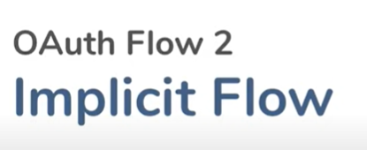

This is very similar to flow number 1 but it little bit simplified



**Note:- step 5 is different. This time authorization server send the access token directly rather then sending auth token**

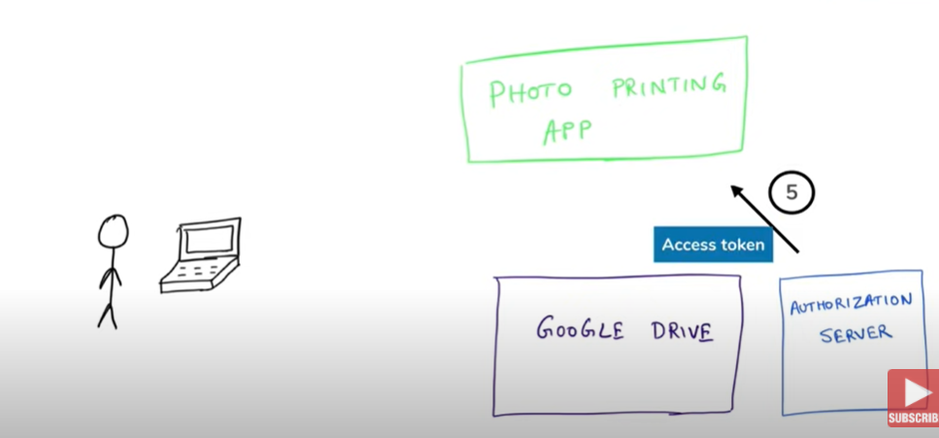

**This comes with drawback :--- access token can be stolen**

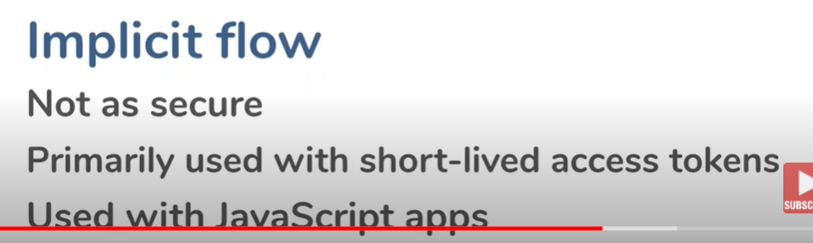

**Third flow :-**



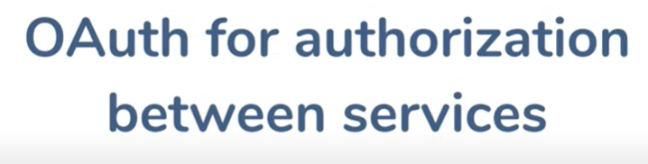



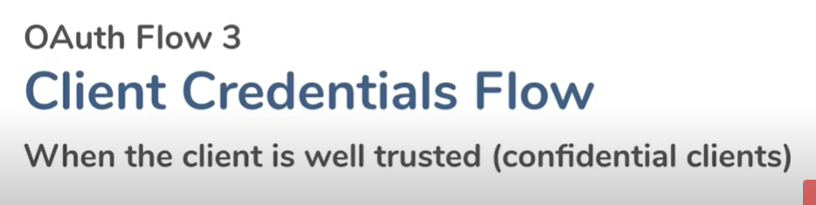

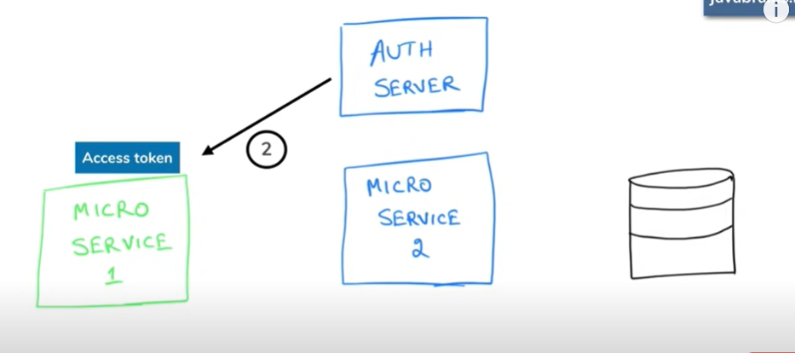

Implement login with facebook and github

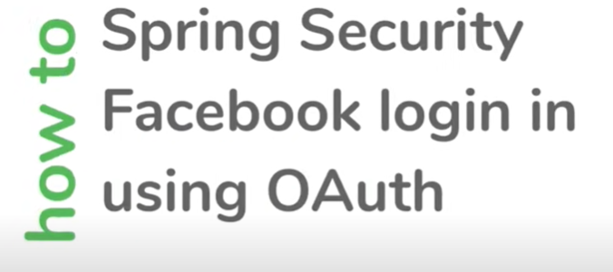

The @EnableOAuth2Sso annotation **enables OAuth2 Single Sign On (SSO)**. By default all the paths are secured. We can customize it using WebSecurityConfigurerAdapter in our Spring Security Java Configuration. We can configure Spring Security OAuth2 using application

**Step 1:--**

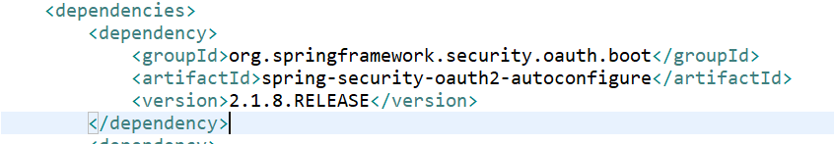

Step 2:--

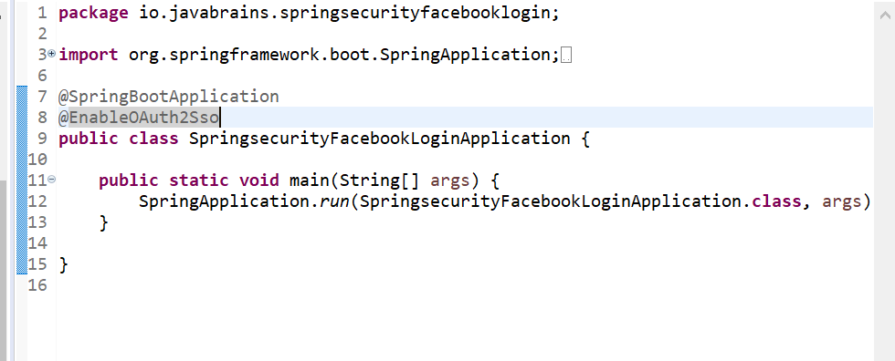

**How spring security will get external info**

**Github oauth:--- when we run api it will do oauth with github and login into url**

